桃園市立觀音國民中學107學年度第1學期 第一次定期考 七年級英語科題目卷
班級：________座號：________姓名：________
第一部分：聽力測驗
一、聽CD，選出所聽到的字詞。（每題2分，共10分）
- （ ）(A) pie (B) picture (C) pencil
- （ ）(A) cheese (B) police (C) classmate
- （ ）(A) classmate (B) cheese (C) cute
- （ ）(A) legs (B) same (C) great
- （ ）(A) radio (B) video (C) world

二、辨識句意：每題均有三張圖片，請依據所聽到的句子，選出符合描述的圖片。（每題2分，共10分）
- （ ）(A) (B)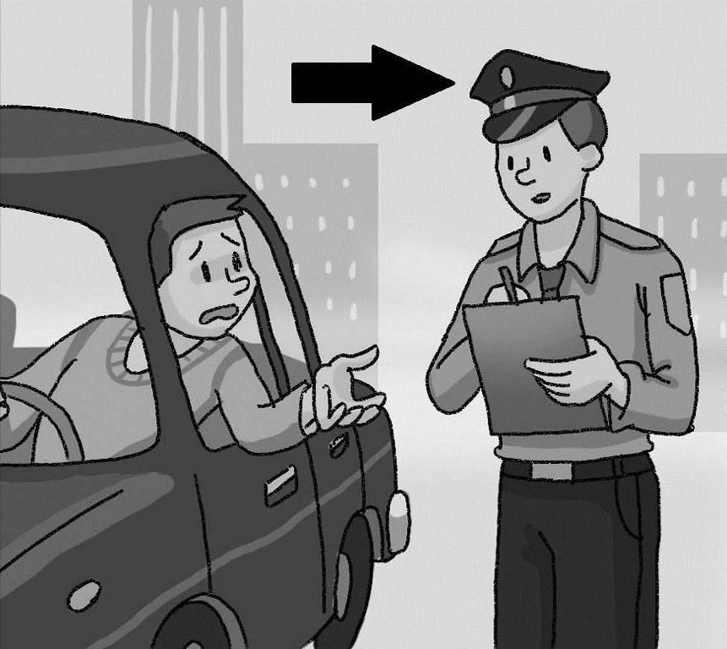 (C)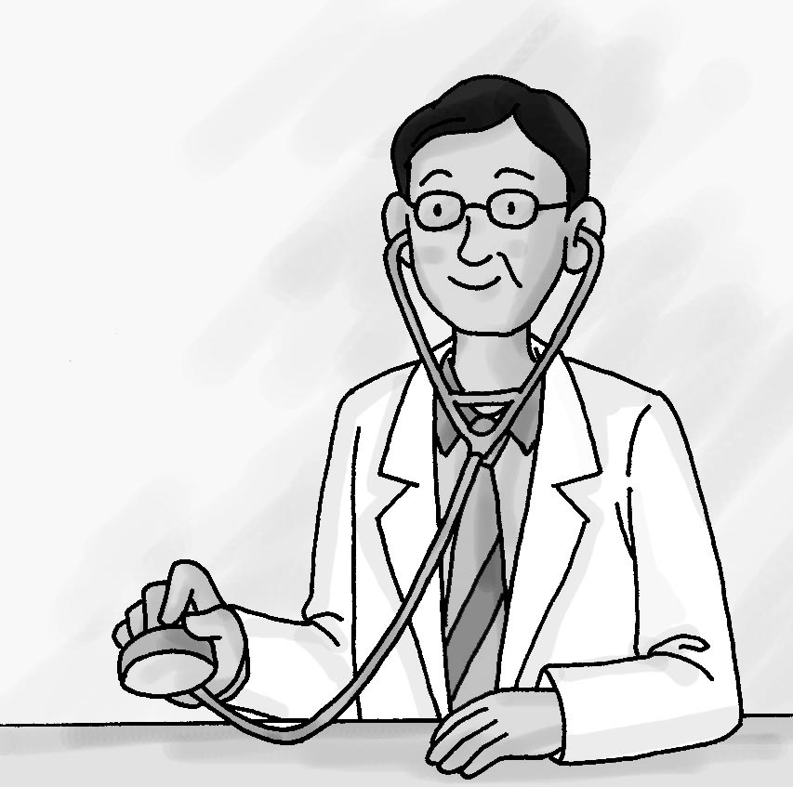
- （ ）(A)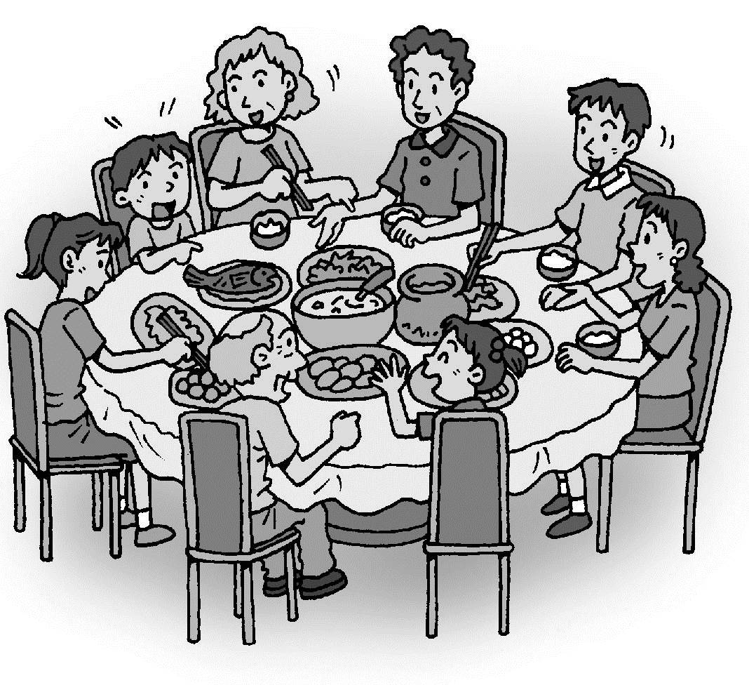 (B)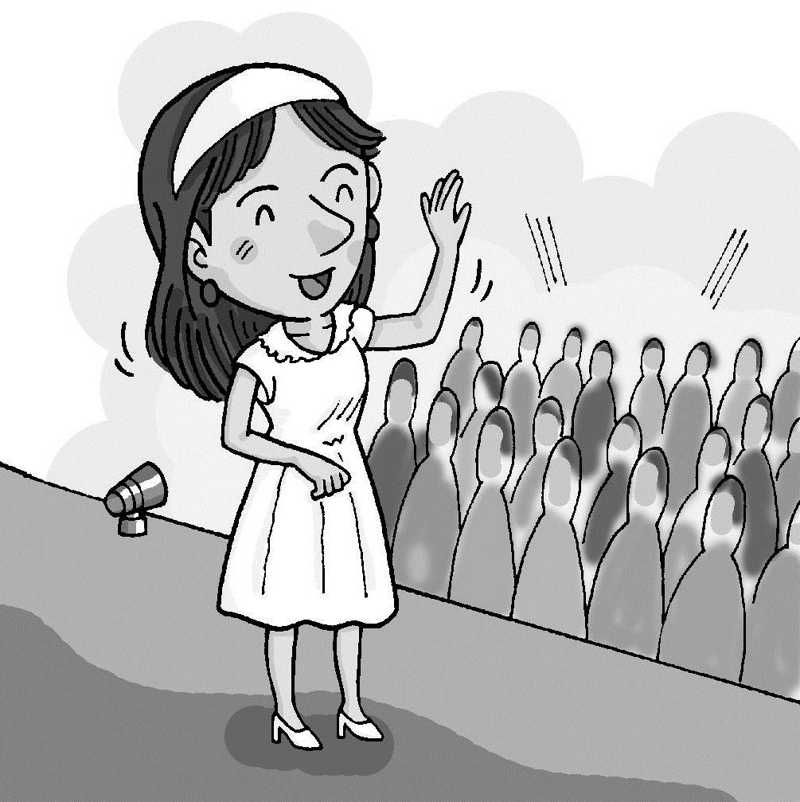 (C)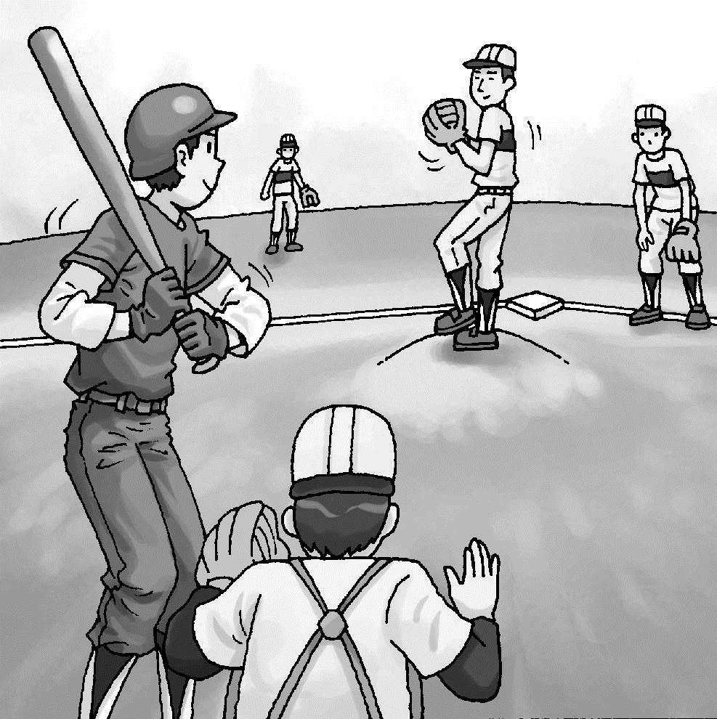
- （ ）(A)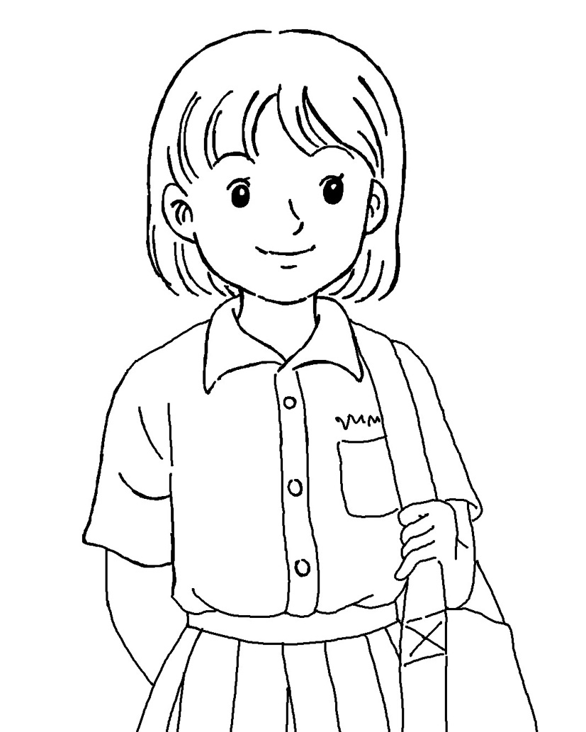 (B) (C)
- （ ）(A)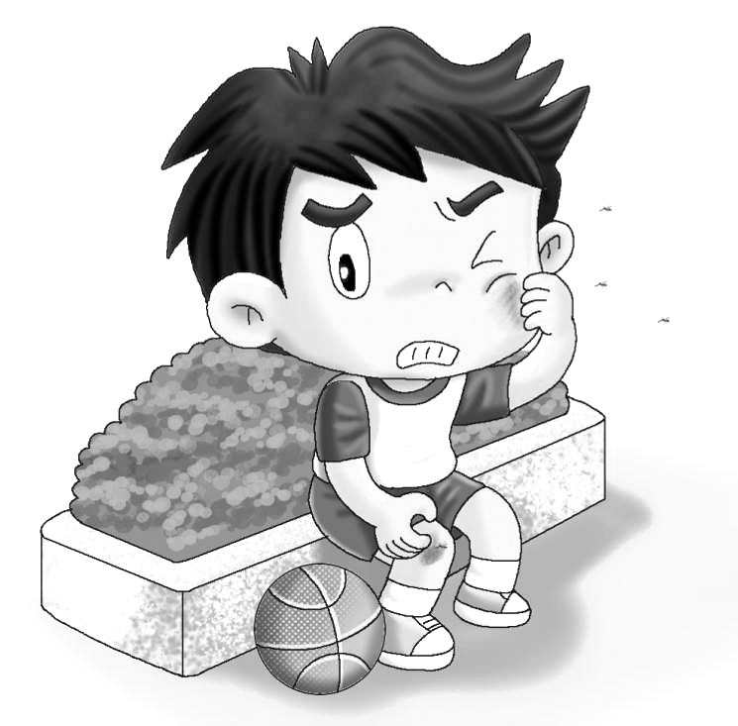 (B) (C)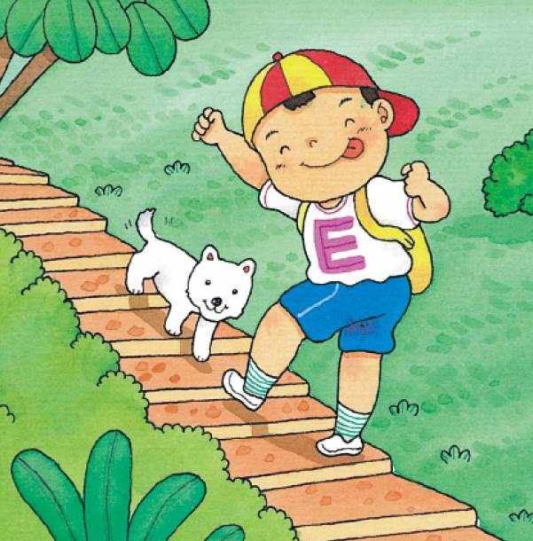
- （ ）(A)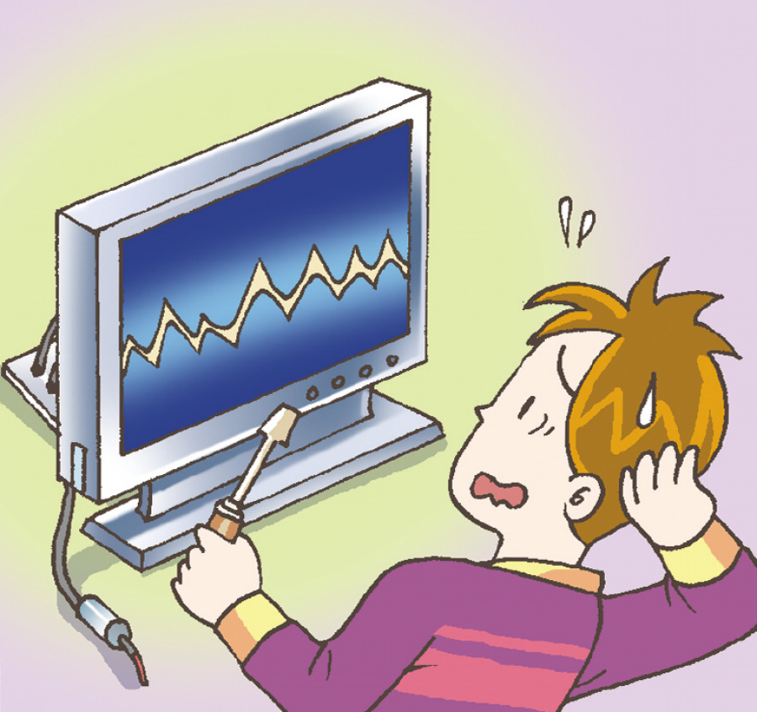 (B) (C)

三、基本問答：每題均有三個選項，請依據所聽到的內容，選出一個最適合的回應。（每題2分，共10分）
- （ ）(A) No, it’s not. (B) No, I’m not. (C) No, you’re not.
- （ ）(A) Welcome, my boy. (B) Thank you. (C) Nice to meet you.
- （ ）(A) These posters are cool. (B) They are my favorite posters. (C) We’re friends.
- （ ）(A) Really? (B) How come? (C) What is it?
- （ ）(A) Yes, she is my sister. (B) No, my sister is a waitress. (C) Yes, that waitress is my friend.

第二部分：讀寫測驗
- 單題（每題2分，共30分）
16.（ ）Harry: What’s your phone __________? Hermione: It’s 0912-345678.
- number (B) picture (C) name (D) family
17.（ ）Sharon is my English teacher. She is young and __________.
- old (B) same (C) beautiful (D) wrong
18.（ ）Peter and Amanda are __________. They are both in Class 704.
- teachers (B) classmates (C) brothers (D) sisters
19.（ ）James is a cook. Curry is a cook, __________.
- also (B)not (C) really (D) too
20.（ ）Gina: Hey! I just found (找到) 2000 dollars (元) in the classroom.
Penny: __________? Let’s take it to our teacher.
- How (B) Where (C) Why (D) Really
21.（ ）Sam: __________ Linda: I’m fine. Thank you.
(A)Good evening. (B) Good-bye. (C) What’s your name? (D) How are you?
22.（ ）__________ her eraser.
- It (B) Its (C) It’s (D) Its’
23.（ ）Sarah: __________ is that on the desk? Hank: It’s a red pen.
- What (B) What’s (C) How (D) How’s
24.（ ）Nash is my best friend. __________ is smart and nice. __________ eyes are blue.
- He; He (B) His; His (C) He; His (D) His; He
25.（ ）Ted: Are you a housewife? Emily: __________
- Yes, you are. You are a housewife. (B) Yes, I am. I am a housewife.
- No, you aren’t. You aren’t a housewife. (D) No, I am not. I am a housewife.
26.（ ）Jolin: Good morning, Andy. This is Katy, my little sister. Andy: __________
- What’s your name? (B) Is Jolin a teacher? (C)How are you, Jolin? (D) Nice to meet you, Katy.
27.（ ）This __________ my apple, and those __________ Helen’s bananas.
(A)is; is (B) is; am (C) is; are (D) are; are
28.（ ）Those ________ are nice!
(A) person (B)actor (C)people (D)bus
29.（ ）A: _______________ B: They are toy cars.
(A) What’s that? (B) This isn’t a robot. (C) What are those? (D) They are my toy cars.
30.（ ）A: Is it a cheese cake on the table? B: No, it’s an __________.
(A) papaya milk (B)milk tea (C)apple pie (D)banana cake
- 題組（每題3分，共18分）

Wendy: Hello, Jim. What’s that on the desk?
Jim: It is my mother’s picture.
Wendy: Wow! Is your mom a police officer?
Jim: Yes, she is. My father is a police officer, too.
Wendy: Cool! Do you want to be a police officer in the future?
Jim: No, I want to be an actor.
- want想要 future未來
31.（ ）What is on the desk?
(A) Wendy’s mother’s picture. (B) Wendy’s father’s picture.
(C) Jim’s mother’s picture. (D) Jim’s father’s picture.
32.（ ）Which is true?
(A) Wendy’s mother is a police officer. (B) Wendy’s father is an actor.
(C) Jim’s mother is a police officer. (D) Wendy’s father is an actor.
II.
Lebron James | 4736542
Stephen Curry | 4761489
Kevin Love | 4753981
James Harden | 0965852641
Steve Nash | 0971328465
33.（ ）His phone number is four seven six one four eight nine. What’s his name?
(A)Lebron James. (B)Stephen Curry. (C)Kevin Love. (D)James Harden.
34.（ ）A: My phone number is 0971328465. And you? B: It’s 4753981.
Who are they?
(A)Steve Nash and Lebron James. (B) James Harden and Kevin Love.
(C)James Harden and Stephen Curry. (D) Steve Nash and Kevin Love.
III.
Lucky is missing!


We are looking for our pet, Lucky. She is a cute puppy. She has short black hair.
She wears a bell on her neck. We miss her so much. We are worried about her.
If someone finds her, please call Mr. or Mrs. Lin at 02-26874154. Thank you so much!
October 11th
- missing失蹤的 look for尋找 worried擔心的 find找到

35.（ ）What’s the notice（告示）for?
(A) looking for a pet (B)selling a dog (C)having a party (D)making some money
36.（ ）When you find Lucky, how can you tell the Lin family?
(A) by mail (B)by e-mail (C)by phone (D)by telling someone else

第三部分：寫作測驗
六、引導式翻譯（每題2分，共16分）
1. 我是一個學生。我的書包是藍色的。I am a student. My __________ is blue.
2.大家都很歡Tina的魔術秀。Everyone likes Tina’s __________ show.
3. 你的兒子好可愛。Your son is so __________.
4. 歡迎來到台灣！__________ to Taiwan!
5. 這部電影是我的最愛。This movie is my __________.
6. Una昨天買了一台新的電腦。Una bought a new __________ yesterday.
7. 我的車有點不對勁。Something is __________ with my car.
8.公園裡有很多人。There are many __________ in the park.

七、依提示作答（每題3分，共6分）
1. Are those your pencils? （以否定句簡答）
＿＿＿＿＿＿＿＿＿＿＿＿＿＿＿＿＿＿＿＿＿＿＿＿＿＿＿＿＿＿＿＿＿＿＿
2. Is Peter a teacher? （先肯定簡答，再詳答）
＿＿＿＿＿＿＿＿＿＿＿＿＿＿＿＿＿＿＿＿＿＿＿＿＿＿＿＿＿＿＿＿＿＿＿

＃＃＃第一部分和第二部分請用2B鉛筆畫卡，第三部分請用藍筆或黑筆書寫於答案卷上＃＃＃

