桃園市立觀音國民中學 107 學年度 第1學期 第一次定期考八年級 英文科 題目卷
班級：________ 座號：________ 姓名：________
第一部分:聽力測驗(每題2分，共15題30分)

一、辨識句意：根據聽到的內容，選出符合描述的圖片或符合圖片的描述。
- （ ）
(Ａ) | (Ｂ) | (Ｃ)
 | 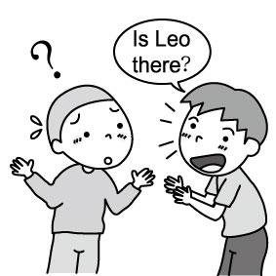 | 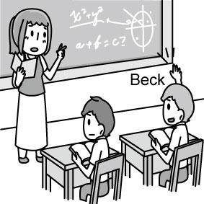
- （ ）
(Ａ) | (Ｂ) | (Ｃ)
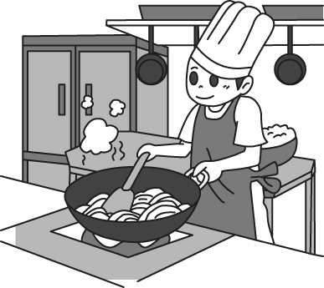 | 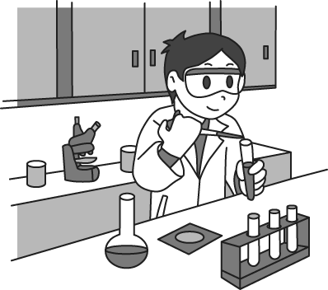 | 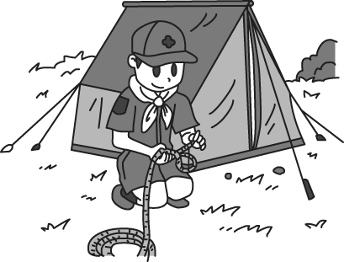
- （ ）
(Ａ) | (Ｂ) | (Ｃ)
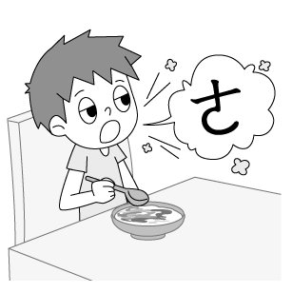 | 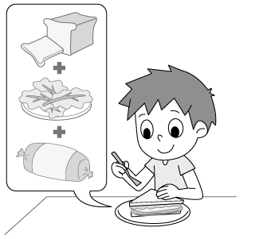 | 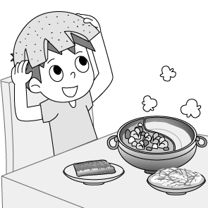
- （ ）
(Ａ) | (Ｂ) | (Ｃ)
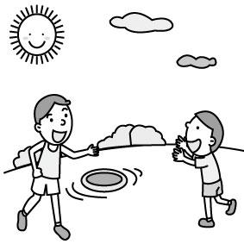 | 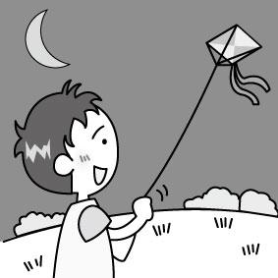 | 
- （ ）
(Ａ) | (Ｂ) | (Ｃ)
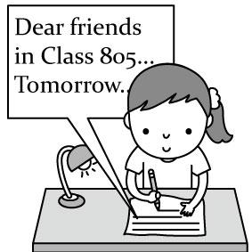 | 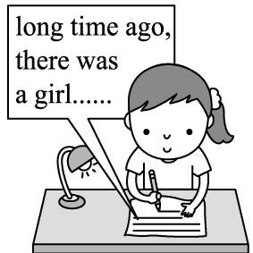 | 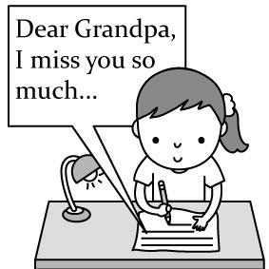

二、基本問答：根據聽到的內容，選出一個最適合的回應或最適合的問句。
- （ ）
(Ａ)I walk my dog every day.
(Ｂ)I watched a baseball game on TV.
(Ｃ)Yes, I did my homework last night.
- （ ）
(Ａ)He cleaned the kitchen.
(Ｂ)He is looking for his glasses.
(Ｃ)It rained an hour ago.
- （ ）
(Ａ)The tea was very expensive.
(Ｂ)It’s very cold. Let’s have hot tea.
(Ｃ)I did. I bought it from Meg’s grandpa.
- （ ）
(Ａ)Let’s visit him someday.
(Ｂ)Let’s buy him a cake.
(Ｃ)Let’s go together.
- （ ）
(Ａ)Poor you!
(Ｂ)You’re so generous.
(Ｃ)That’s a good idea.

三、言談理解：根據聽到的內容，選出一個最適合的答案。
- （ ）
(Ａ)Allen didn’t go out last weekend.
(Ｂ)Allen played table tennis with Jim.
(Ｃ)Allen didn’t like table tennis.
- （ ）
(Ａ)The girl is bad at math, and the boy is,
too.
(Ｂ)The girl doesn’t want to do her math
homework.
(Ｃ)The boy can teach the girl math.
- （ ）
(Ａ)The man doesn’t have a car now.
(Ｂ)The man sold his car because he didn’t
like it.
(Ｃ)The man sold his car because he wanted
to buy a new one.
- （ ）
(Ａ)The woman is putting the books in the box.
(Ｂ)The woman is generous and kind to the
children.
(Ｃ)The big box is from the man.
- （ ）
(Ａ)Because she’s good at making coats.
(Ｂ)Because her parents didn’t have coats.
(Ｃ)Because it’s cold in winter.
____________________聽力結束__________________
________________第二部分繼續作答______________
(請翻後一頁)

第二部分:
一、語法測驗: (每題1分，共20題20分)
16. ( )The love between Jay and Jolin was so great, but now they don’t love each other.
(Ａ) next (Ｂ) past (Ｃ) art
(Ｄ) history
17.( )Jenny is a vegetarian（素食者）. She never eats .
(Ａ) apples (Ｂ) noodles (Ｃ) rice
(Ｄ) meat
18.( )Mia: Don’t you like Lee?
Leo: Yes, she’s so nice to everybody.
(Ａ) Ms. (Ｂ) Mr. (Ｃ) Uncle
(Ｄ) Brother
19.( )Come on! Don’t my leg again!
(Ａ) drop (Ｂ) toss (Ｃ) pull
(Ｄ) ask
20.( )Dad is in a sleep. Let’s not wake him up.
(Ａ) poor (Ｂ) sound (Ｃ) true
(Ｄ) special
21.( )Jackson is very handsome. That’s why many girls with him at first sight（第一眼）. (Ａ) have a picnic (Ｂ) fall in love
(Ｃ) get together (Ｄ) take a walk
22.( )Amy: Is the doll your sister’s? Bob: Yes, it’s .
(Ａ) mine (Ｂ) hers (Ｃ) his
(Ｄ) yours
23.( )Mom, I cannot eat any . I’m so full now.
(Ａ) lot (Ｂ) some (Ｃ) many
(Ｄ) more
24. ( )Who you with last weekend, and you have a good time?
(Ａ) did; did (Ｂ) were; were
(Ｃ) did; were (Ｄ) were; did
25.( )David: Did you English last night?
Kevin: Yes, I English for an hour.
(Ａ) study; study (Ｂ) studied; studied
(Ｃ) study; studied (Ｄ) studied; study
26.( )We can the moon the binoculars from the 91st floor of Taipei 101. (Ａ) watch; through (Ｂ) see; with
(Ｃ) look at; for (Ｄ) read; from
27.( )Sam: Who bet you five hundred NT dollars?
Leo: Kevin .
(Ａ) does (Ｂ) is (Ｃ) did (Ｄ) was
28.( ) Maria was very busy last night, she did not go to Ella’s birthday party.
(Ａ) Because; × (Ｂ) Because; so
(Ｃ) ×; because (Ｄ) So; ×
29.( )Did Dad you anything for your birthday? (Ａ) sent (Ｂ) buy (Ｃ) gave (Ｄ) got
30.( )The classroom is , not .
(Ａ) your; his (Ｂ) her; mine
(Ｃ) my; your (Ｄ) Joe’s; Sue’s
31.( )The teacher is showing a picture the students.
(Ａ) for (Ｂ) of (Ｃ) to (Ｄ) with
32.( )That’s really kind you.
Thanks again everything.
(Ａ) for; of (Ｂ) for; for
(Ｃ) of; of (Ｄ) of; for
33. ( )Ted is not happy .
(Ａ) , so he is very sick
(Ｂ) , so he ate a lot
(Ｃ) because he only got 36 on the math test（考試）
(Ｄ) because he did very well on the math test
34.( )The boy wrote .
(Ａ) his dad a card on Father’s Day
(Ｂ) a belt to his dad
(Ｃ) a vest for his dad
(Ｄ) a thank-you card someday
35.( )Andy: How’s everything going at school?
Lisa:
(Ａ) Not bad. I like everything here.
(Ｂ) Let me send it to you.
(Ｃ) Of course not. Everything is not OK. (Ｄ) You like the new teacher, but I don’t.
二、閱讀測驗: (每題4分，共5題20分)

Ms. Love: Jason, why are you late again today?
Jason: My pet dog was very sick this morning, so I took him to a vet.
Ms. Love: OK. Then, where’s your math homework?
Jason: I didn’t finish doing it.
Ms. Love: Why not?
Jason: Because my dad went to a wedding, he got home very late. He didn’t help me do it.
Ms. Love: What?! Call your mom on her cellphone and ask her to come to school NOW.
（ ）(36) Why DIDN’T Jason do his math homework last night?
(Ａ) He was sick.
(Ｂ) He went to bed early.
(Ｃ) His father was busy, and he didn’t
have time to help him with it.
(Ｄ) His brother took it.
（ ）(37) Which is true about Jason?
(Ａ) He has a pet cat.
(Ｂ) He never takes his pet to a vet
because it’s too expensive.
(Ｃ) His teacher, Ms. Love, wants to talk
to his father at school.
(Ｄ) His dad often helps him do the math
homework.

（ ）(38) It’s 7:30 p.m. on October 31. Amy and Susan are at Happy Children’s Home. What are they doing there?
(Ａ) Donating their old clothes.
(Ｂ) Playing with the kids.
(Ｃ) Making some shoes.
(Ｄ) Talking with Ms. Chen.
（ ）(39) What do the kids at Happy Children’s Home need?
(Ａ) Shoes and clothes.
(Ｂ) Toy cars and bicycles.
(Ｃ) Old books.
(Ｄ) Good food and fruit.
（ ）(40) When is the Halloween party at Happy Children’s Home?
(Ａ) October 29. (Ｂ) October 30.
(Ｃ) October 31. (Ｄ) November 1.

第三部分:手寫題測驗(請將答案寫到作答卷上)
一、寫出英文單字(每題1分，共10題10分)

1.  驚喜 | 2.  打嗝 | 3.  可憐的 | 4.  親愛的 | 5.  表演
6.  數學 | 7.  營隊 | 8.  科目 | 9.  發生 | 10.  卡拉ok
二、寫出動詞的過去式(每題1分，共10題10分)

1.  see | 2.  watch | 3.  go | 4.  close | 5.  draw
6.  sleep | 7.  wrap | 8.  fight | 9.  worry | 10.  take

三、句型測驗(每題5分，共2題10分)

1.My belt is next to your volleyball.
(依畫線改成所有格代名詞)
2. Henry didn’t come to the contest because he was
sick .(依畫線造原問句)

!

交卷時，請交作答卷及畫卡紙

