桃園市立觀音國民中學107學年度第1學期 第二次定期考 七年級英語科題目卷
班級：________座號：________姓名：________
第一部分：聽力測驗
一、辨識句意：每題均有三張圖片，請依據所聽到的句子，選出符合描述的圖片。（每題2分，共10分）
- （ ）(A)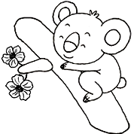 (B)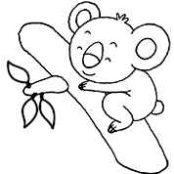 (C)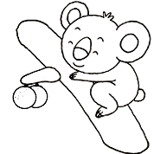
- （ ）(A)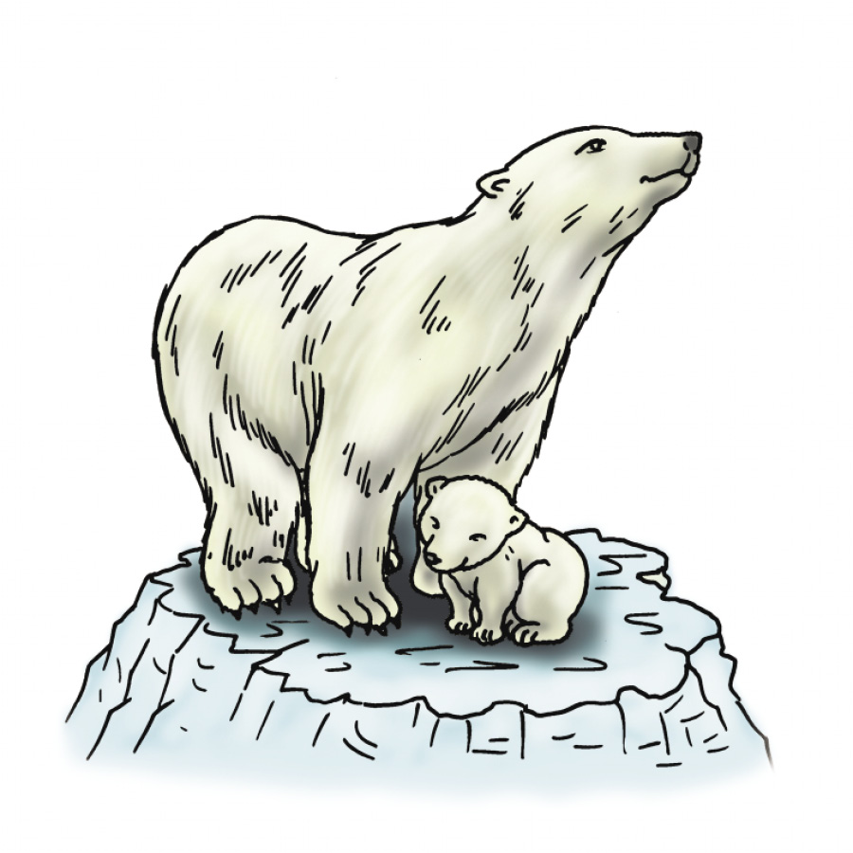 (B)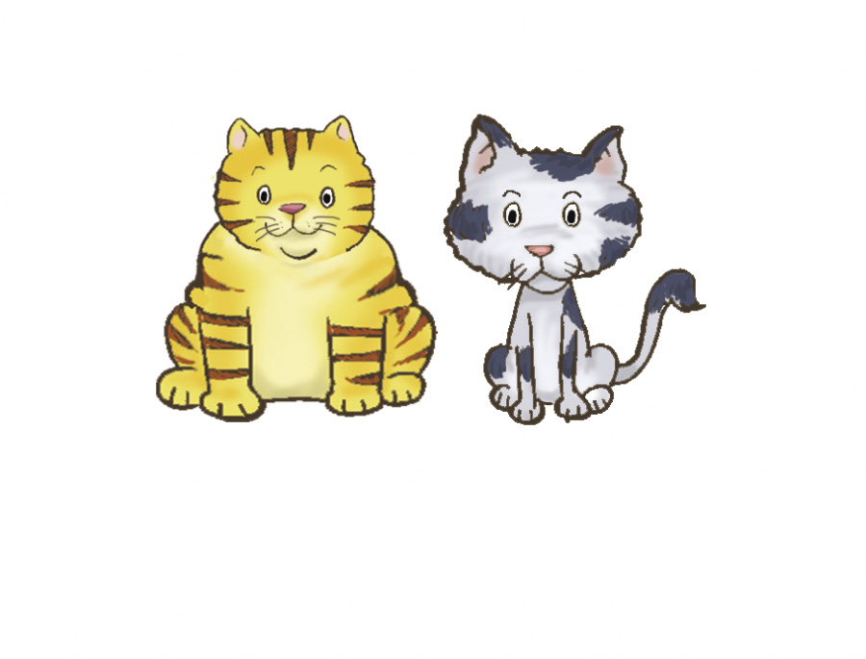 (C)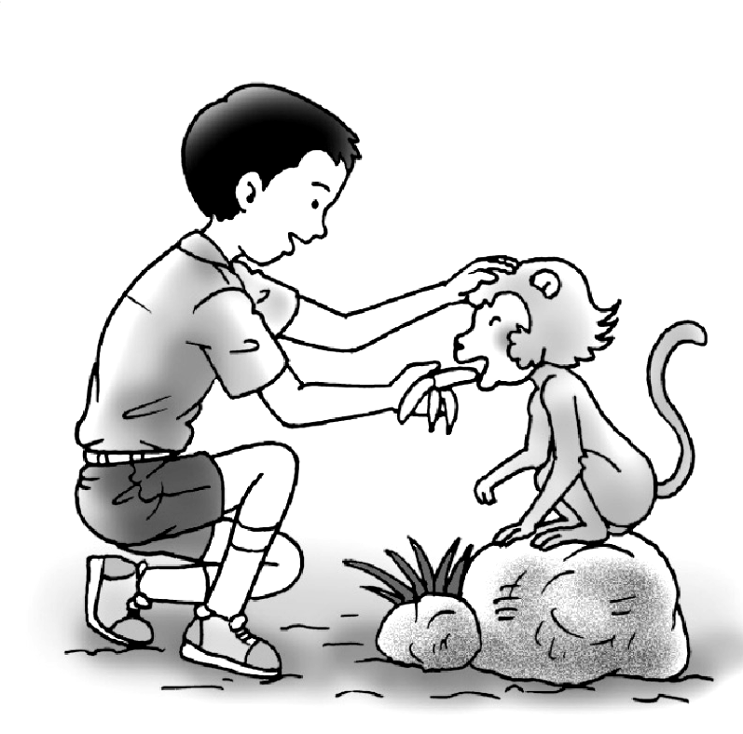
- （ ）(A)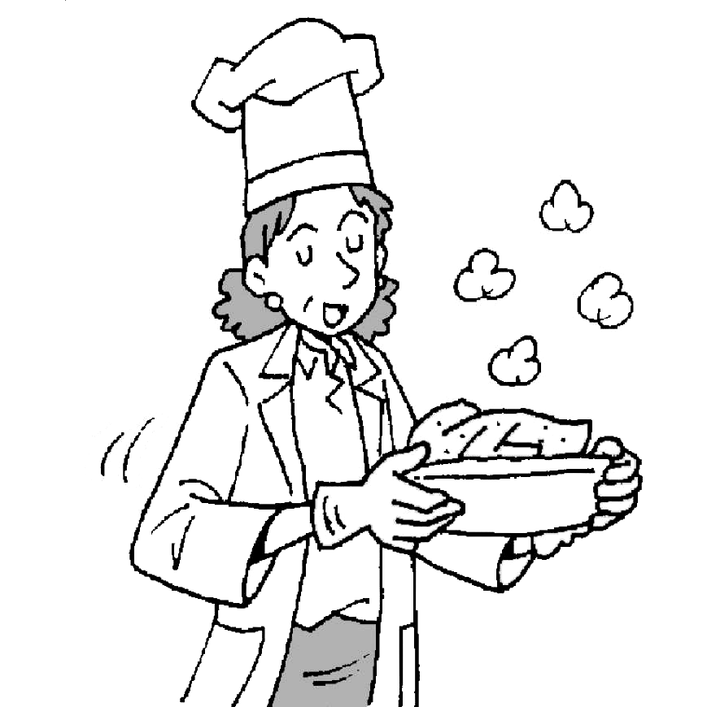 (B)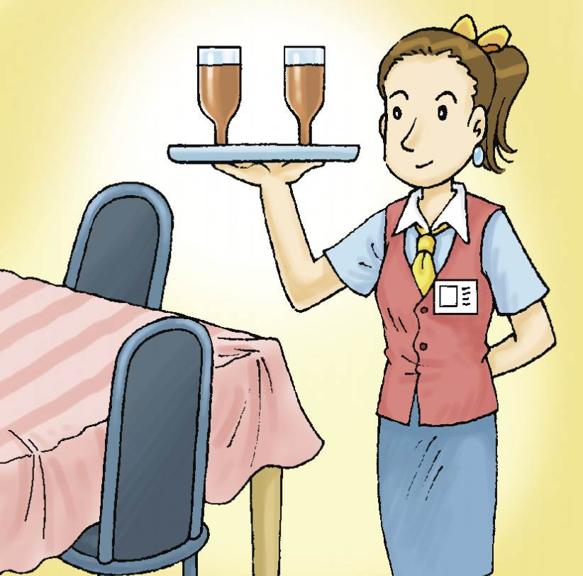 (C)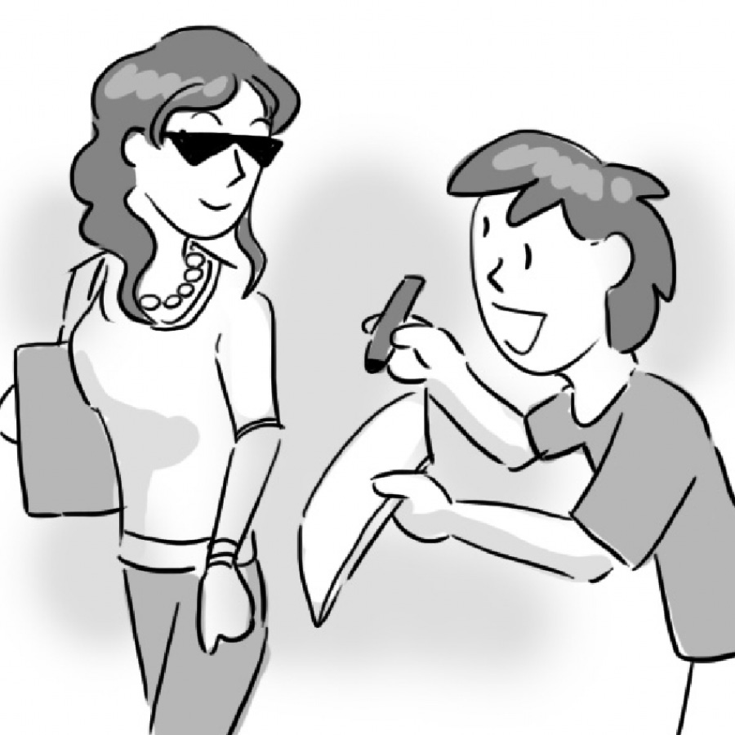
- （ ）(A) (B)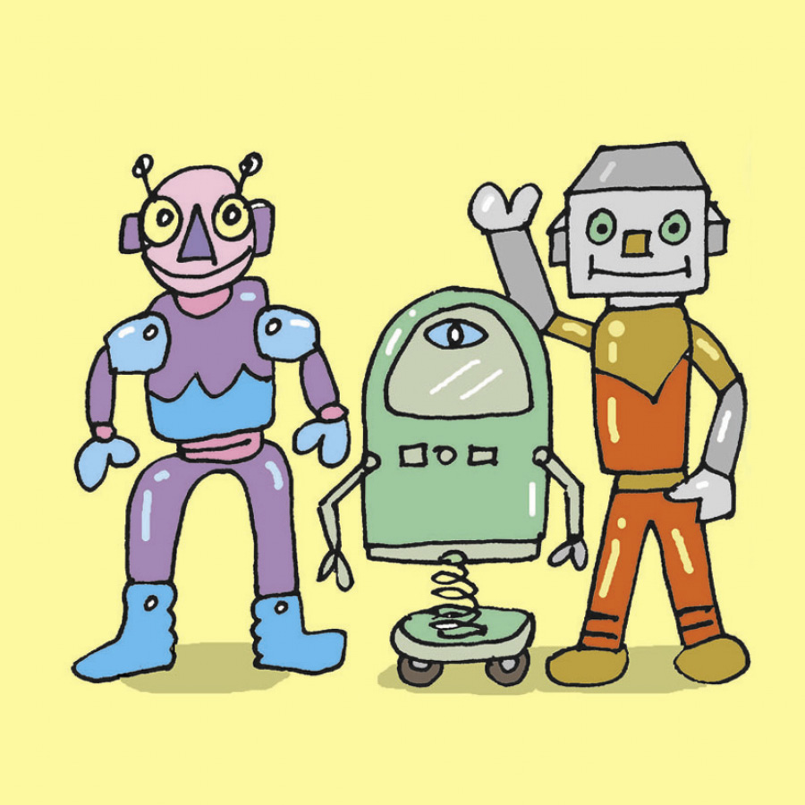 (C)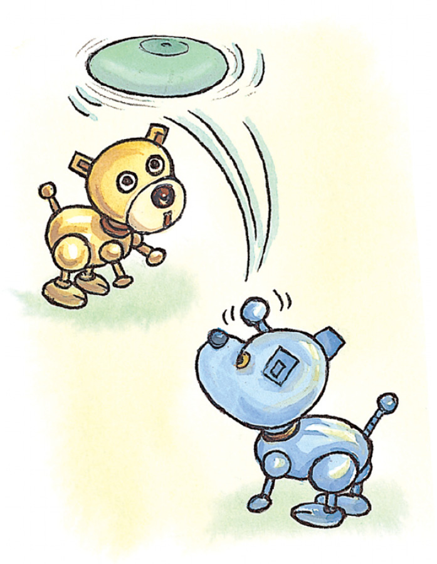
- （ ）(A)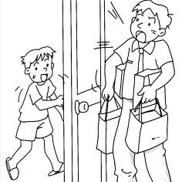 (B)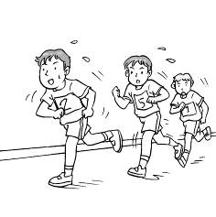 (C)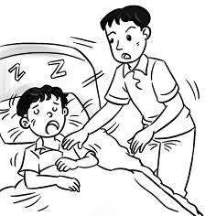
二、聽CD，配合圖片選出最適當的答案。（每題2分，共10分）
- （ ）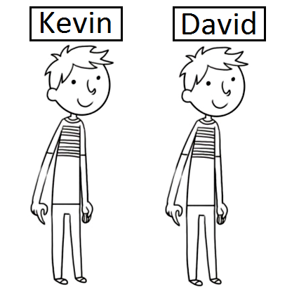
- （ ）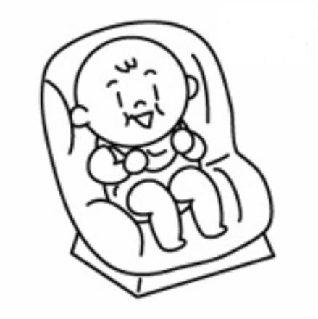
- （ ）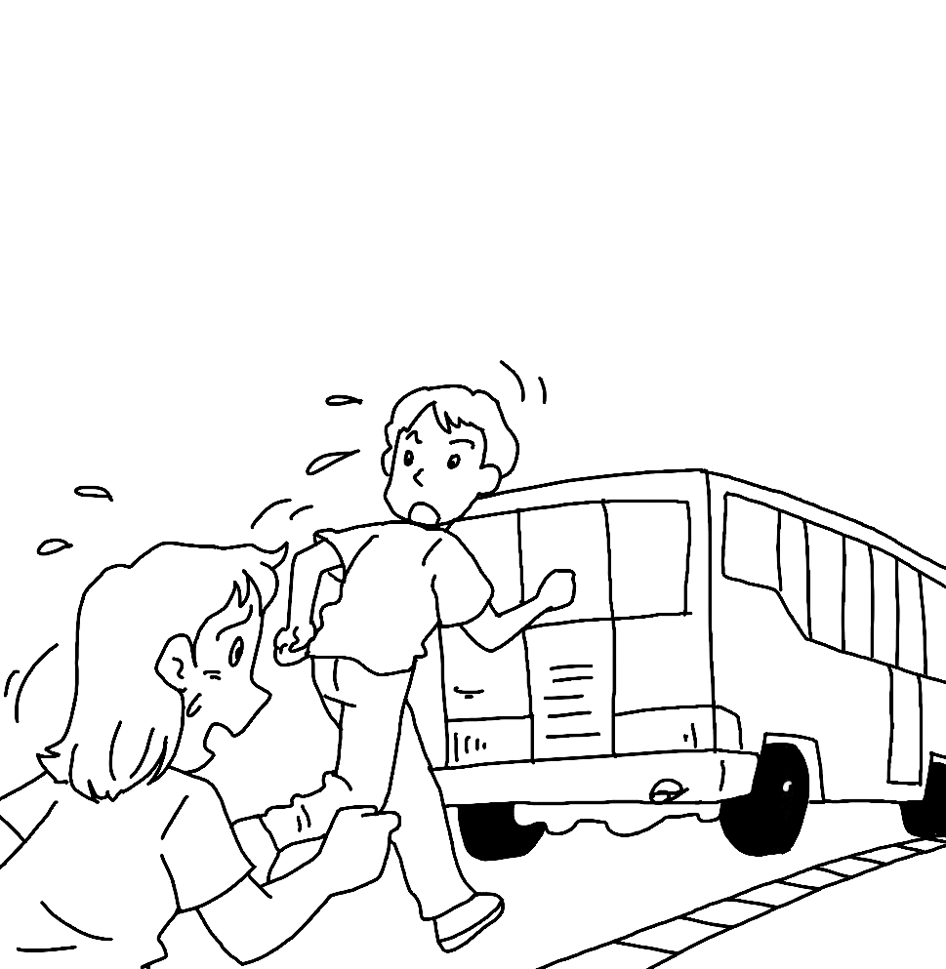
- （ ）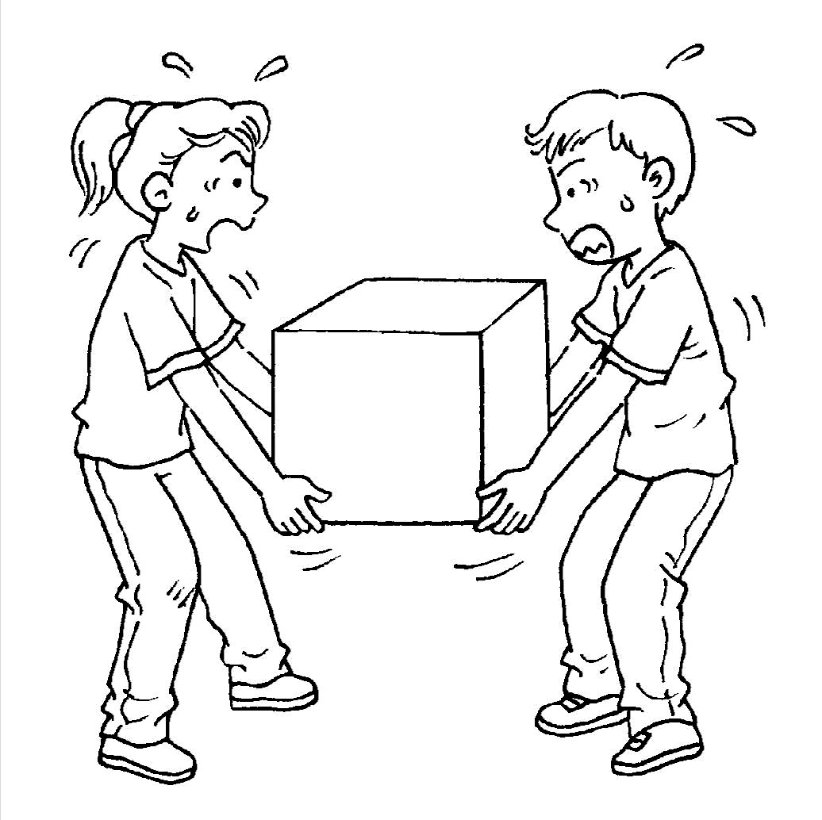
- （ ）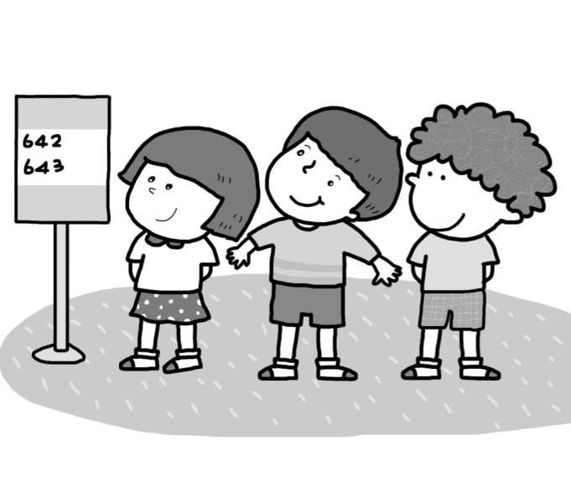
三、基本問答：每題均有三個選項，請依據所聽到的內容，選出一個最適合的回應。（每題2分，共10分）
- （ ）(A) It’s from the USA. (B) It’s three years old. (C) It’s not a swimmer.
- （ ）(A) Thank you. (B) Yes, it’s my key. (C) No, it’s over here.
- （ ）(A) It’s ugly. (B) It’s so late. (C) It’s over here.
- （ ）(A) Please follow the school rules. (B) OK. Let’s go. (C) Hey. Let’s be quiet.
- （ ）(A) Yes, be smart. (B) No, but he is a nice boy. (C) Don’t talk to the student.

第二部分：讀寫測驗
- 單題（每題2分，共30分）
16.（ ）The movie is __________. Let’s hurry.
- at (B) off (C) in (D) on
17.（ ）Peter: What do you eat for your lunch? Tina: A __________ and some apple juice.
- leaf (B) star (C) trash (D) hamburger
18.（ ）Jay: Oops! It is 7:50 now. I am __________ for school again. Dad: You had better run to school!
- popular (B) ugly (C) tall (D) late
19.（ ）Helen: Can you turn off the TV? I can’t study with the __________.
Troy: You can just go back to your room so you won’t hear it.
(A) noise (B) heat (C) power (D) light
20.（ ）Dora: __________ are you from? Mark: I am from Taiwan.
- What (B) When (C) Where (D) Who
21.（ ）The TV is ______. I can’t carry it by myself.
- so short (B) so heavy (C) short so (D) heavy so
22.（ ）Lucky, __________ a good dog.
- be (B) am (C) is (D) are
23.（ ）My little sister is only one __________.
- year (B) years (C) year old (D) years old
24.（ ）Mary: Is Sharon eighteen years old? Linda: Yes, __________.
- he is (B) he isn’t (C) she is (D) she isn’t
25.（ ）When your pet is sick, you take it to a __________.
(A) nurse (B) doctor (C) animal (D) vet

26.（ ）Amanda, please __________ your cellphone in the movie theater.
- turn on (B) turn off (C) turns on (D) turns off
27.（ ）Taylor Swift is a popular singer. Everyone loves __________.
(A) her voice beautiful (B) her beautiful voice (C) beautiful her voice (D) beautiful voice her
28.（ ）Let’s __________ talk in class.
- no (B) not (C) don’t (D) doesn’t
29.（ ）＿＿＿ the door, Jason.
(A) Open please (B) Please open (C) Please, open, (D) Please open,
30.（ ）Karen: Wow! Fanny is 180cm tall, but she is only eleven years old.
Frank: Her father and mother are both 190cm tall.
Karen: __________.
- It’s OK. (B) Let’s go (C) I’m sorry (D) No wonder

- 題組（每題2分，共18分）
I.

Every morning is a new _____31._____. People start their day in different ways. Some people pray. Others exercise. Some people also shower. Then they can feel fresh and clean. Many people also make the bed. They like a neat bedroom. Then people often eat _____32._____. It gives them _____33._____ for the day. It’s a very important meal. What do you do every morning?

31.（ ）(A) shopping (B) swimming (C) ending (D) beginning
32.（ ）(A) breakfast (B) lunch (C) afternoon tea (D) dinner
33.（ ）(A) pajamas (B) project (C) energy (D) disease
II.
  Hello, I am Kelly. I am twenty-seven years old. I am a writer. I come from Kaoshiung. (高雄) I have a great husband and a cute son. |   Hi, my name is Mark. I am a thirty-two-year-old teacher. I am Kelly’s husband. I come from Taipei. (臺北)
  Nice to meet you. My name is Alice. I am a beautiful cook. Kelly is my sister. I am twenty-six years old. |   Good morning. I am Sam. I live in Kaoshiung with my mom and dad, Kelly and Mark. It’s time for school.
34.（ ）Who is 26 years old?
(A) Kelly (B) Mark (C) Alice (D) Sam
35.（ ）Who is a teacher?
(A) Kelly (B) Mark (C) Alice (D) Sam
36.（ ）Which is true?
(A) Kelly comes from Taipei. (B) Mark is thirty-three years old.
(C) Alice is Kelly’s mother. (D) Sam is a student.

III.
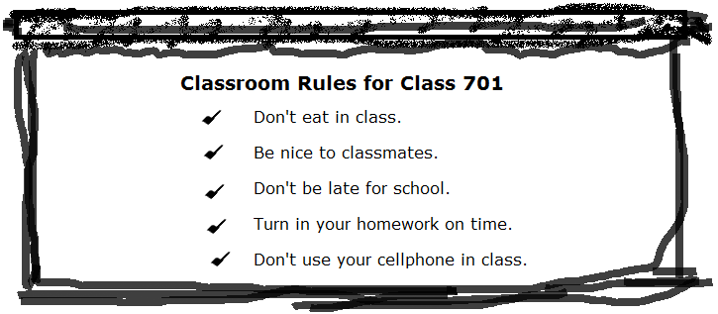
37.（ ）There are rules in Class 701.
(A) four (B)five (C)six (D)seven
38.（ ）Teacher: Don’t . Students: OK.
(A) be nice (B) follow the rules (C) use your cellphone (D) turn in your homework.
39.（ ）Which is NOT a rule in Class 701?
(A) Don’t do your homework in class. (B) Don’t be late for school.
(C) Don’t talk on a cellphone in class. (D) Don’t eat in class.

第三部分：寫作測驗
六、引導式翻譯（每題2分，共16分）
1. 加拿大是以楓葉聞名嗎？ Is Canada __________ for its maple leaves?
2. 在那邊的女人們來自日本。The __________ over there are from Japan.
3. 哇！Susan的聲音好特別。Wow! Susan’s voice is so __________.
4. Peter的小狗過重了。Peter’s puppy is too __________.
5. 不要在公車上留下垃圾。Don’t __________ your trash on the bus.
6. 這裡很暗，等等我！It’s dark here. __________ for me!
7. 男孩們女孩們，請安靜。Boys and girls, be __________, please.
8. 我們應該遵守校規。We should __________ the school rules.

七、依提示作答（每題3分，共6分）
1. How old is your mother?（用44歲詳答）
＿＿＿＿＿＿＿＿＿＿＿＿＿＿＿＿＿＿＿＿＿＿＿＿＿＿＿＿＿＿＿＿＿＿＿
2. This is a pencil. It is short.（合併句子）
＿＿＿＿＿＿＿＿＿＿＿＿＿＿＿＿＿＿＿＿＿＿＿＿＿＿＿＿＿＿＿＿＿＿＿

＃＃＃第一部分和第二部分請用2B鉛筆畫卡，第三部分請用藍筆或黑筆書寫於答案卷上＃＃＃

