桃園市立 觀音國民中學 107 學年度 第1學期 第二次定期考 九年級 英語科 題目卷
班級：________ 座號：________ 姓名：________

一、聽力測驗：每格2分、共20分
(一)辨識句意：根據聽到的內容，選出符合描述的圖片或符合圖片的描述。

- （ ）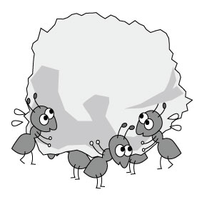
- （ ）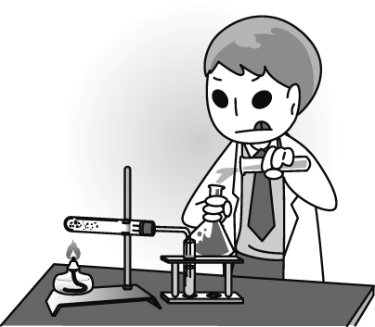
- （ ）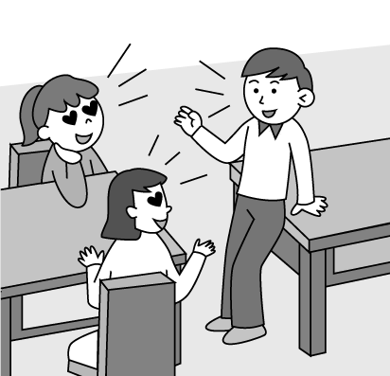
- （ ）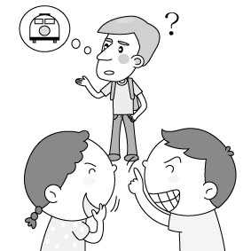
- （ ）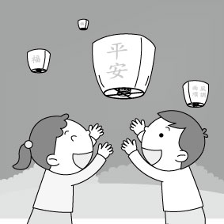

(二)基本問答：根據聽到的內容，選出一個最適合的回應或最適合的問句。
- （ ）
(Ａ) Sounds interesting.
(Ｂ) What an amazing sight!
(Ｃ) There aren’t many cars on the roads.
- （ ）
(Ａ) Every day except Sundays.
(Ｂ) I don’t know what day it is.
(Ｃ) Nothing special happened during the band practice.
- （ ）
(Ａ) She is very down.
(Ｂ) She is wearing a big smile.
(Ｃ) She doesn’t know how to tell her parents about her grades.
- （ ）
(Ａ) It’s pretty hard for me to decide.
(Ｂ) I’m in my twenties.
(Ｃ) Let me know if you will come.
- （ ）
(Ａ) Yes, and he agreed happily.
(Ｂ) Yes, he welcomed us with a great party.
(Ｃ) Yes, the trip to his farm was a great experience.

二、語法測驗：每格2分、共40分
( )11. Joe’s a big fan of Jolin. He ________ all of her albums(專輯).
(A)collects (B)notices (C)covers (D)crosses
( )12. The workers are ________ a new bridge over the river.
(A)raising (B)digging (C)building (D)bitting
( )13. Don’t worry. The problem has been ________.
(A)wondered (B)communicated (C)solved (D)quit
( )14. Taitung(台東) is in the ________ of Taiwan.
(A)west (B)east (C)north (D)south
( )15. I don’t know ________ we have another chance to come here.
(A)if (B)why (C)how (D)since
( )16. The cheese cake ________ by my grandmother. She’s really good at baking.
(A)baked (B)baking (C)was baked (D)was baking
( )17. Your report ________ in two days.
(A)must finish (B)must be finished (C)be finished (D)will finish
( )18. J.K. Rowling is known ________ a writer. She became famous because of Harry Potter.
(A)as (B)for (C)with (D)from
( )19. The doghouse ________ by my father two months ago.
(A)built (B)is built (C)building (D)was built
( )20. The boy doesn’t know ________ to ask for help. He doesn’t know anyone here.
(A)what (B)who (C)where (D)when
( )21. ________ a good dictionary is just the beginning of learning English.
(A)Buy (B)Buying (C)Bought (D)To be bought
( )22. I heard that we could do a lot of things ________ this machine.
(A)for (B)from (C)with (D)about
( )23. Jason wants to know who ________ him the gift.
(A)give (B)gave (C)is given (D)did give
( )24. Mr. Lin asked John ________ late for school this morning.
(A)why was he (B)why will he be (C)why he was (D)why he will be
( )25. My mother wants to know ________ you like the food or not.
(A)that (B)how (C)what (D)whether
( )26. You won’t believe ________ to my family last night.
(A)what did it happen (B)what happened (C)what was happened (D)how did it happen
( )27. Mr. Yang is ________ busy ________ he seldom has time to eat dinner with his family.
(A)so; to (B)too; to (C)so; that (D)too; that
( )28. Harry isn’t sure ________ he should invite Tina to the Christmas party.
(A)who (B)that (C)what (D)whether
( )29. The question was ________ difficult ________ nobody could answer it.
(A)so; to (B)too; to (C)so; that (D)too; that
( )30. Alison wants to know ________ his girlfriend likes chocolate or not.
(A)how (B)why (C)what (D)whether
三、對話測驗：每格2分、共10分
( )31. Son: What are we going to eat for dinner?
Mother: I am too tired, so I don’t want to prepare dinner. How about ordering a pizza?
Son: ________
(A)No. Pizza is delicious. (B)Great. Making a pizza is easy. (C)Good idea. I like pizza.
(D)Pizza is popular in many countries.
( )32. Darcy: To play Pokémon GO, you have to walk out.
Elizabeth: ________ Is it a kind of sport?
(A)Is it famous? (B)What do you mean? (C)I’ll tell you more. (D)I can’t walk right now.
( )33. Ben: Hey! ________ You almost hit the car.
Sam: Don’t worry! I am watching at it. I always drive the car carefully.
(A)What a treat! (B)That is close. (C)I don’t know how to buy it. (D)You can say that again.

( )34. Hanna: My uncle will visit us this weekend. Will you come to my home?
Laurel: ________ I will talk to my mom about it.
(A)I’m not sure whether I can go or not. (B)I’m glad he will buy me some flowers.
(C)I hear that you won’t be at school. (D)I am afraid that he won’t call me.
( )35. Harry:Please tell me ________ to find the answer to the question.
Peter: No way! You should listen carefully in class.
(A)why (B)what (C)when (D)where
四、克漏字測驗：每格2分、共8分
Nowadays, parents are usually too busy (36) time with their children. Therefore, most children spend their time on TV or the Internet. They can get a lot of (37) from TV and the Internet. However, they seem（似乎）to have difficulties thinking or reading. Besides, they can’t focus on（專注）their schoolwork. What’s worse, some teenagers enjoy making friends with (38) on the Net. It can be quite dangerous because it’s not easy for teenagers to tell (39) their online friends are good people or not. Parents should pay more attention to（注意力）what their children are doing and who their children are making friends with.
( ) (36) (A) spend (B) spent (C) spending (D) to spend
( ) (37) (A) voice (B) stamps (C) nothing (D) information
( ) (38) (A) radios (B) callers (C) strangers (D) envelopes
( ) (39) (A) that (B) who (C) what (D) whether

五、閱讀測驗：每格2分、共22分
- Henna’s going to a potluck（便餐）party. At the party, everyone has to prepare a dish. She isn’t good at cooking, so she tries to find an easy recipe on the Net. She looked for the recipe for a while and got the one she thought she could make. Here is the recipe:
Steps:
1. melt（融化）the butter
2. add the chicken to the melted butter
3. sprinkle（撒）salt, garlic powder, and onion powder on the chicken
4. fry about 10-15 minutes on each side of the chicken
( ) (40) What might a potluck party be like?
(A) Every guest needs to prepare a pot. (B) All the guests have to cook at the party.
(C) Each guest must bring his/her own dish. (D) The host will prepare everything for the guests.
( ) (41) Which of the following is NOT needed to make garlic chicken?
(A) Salt. (B) Flour. (C) Butter. (D) Chicken.
( ) (42) Which is true?
(A) Henna is good at making garlic chicken. (B) Henna is going to have a party at home.
(C) It takes more than 20 minutes to make garlic chicken. (D) One needs to prepare more
than 7 ingredients for garlic chicken.
- Judy: Dear, I just bought a new bookshelf（書櫃）this morning. It looks modern and cute. I think we
can put it in our living room.
Mick: In the living room? Don’t you think the noise will bother（打擾）your reading?
Judy: How about putting it close to the balcony in our bedroom?
Mick: I don’t think we can do that…. In that way, we cannot open the window unless（除非）we move
the bookshelf away.
Judy: Then, I don’t know where I can put it in the bedroom now. On the left side of our bed?
Mick: Well…. The right side of it are the TV between the closet（衣櫥）and the old bookshelf. We

already have a bookshelf in our room. That will be too crowded（擁擠的）to put both of them in
one place.
Judy: OK. Let’s put it in the dining room! I can grab（抓住）a book to read when I eat or drink.
Mick: I understand what you want, baby! But it is easy to make the book dirty if you are not careful with
it. It is better to do so in the study room.
Judy: But we don’t have one. That’s the problem.
Mick: We will have one after we move to a bigger apartment.
Judy: Then can you tell me what I should do with the bookshelf now?
Mick: It would be better to return（歸還）it to the store and tell them we don’t need it!
( ) (43) What may be the picture of their bedroom?
(A) 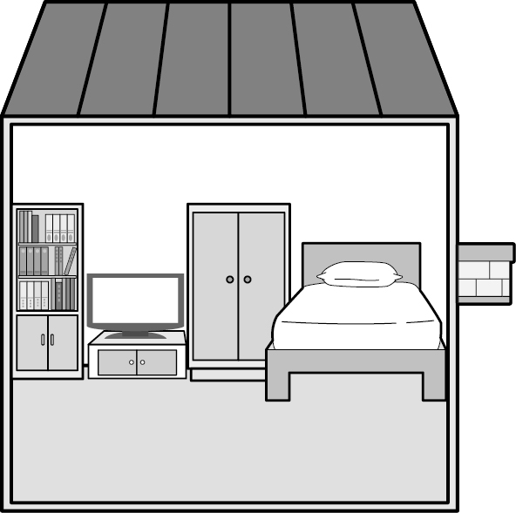 (B) 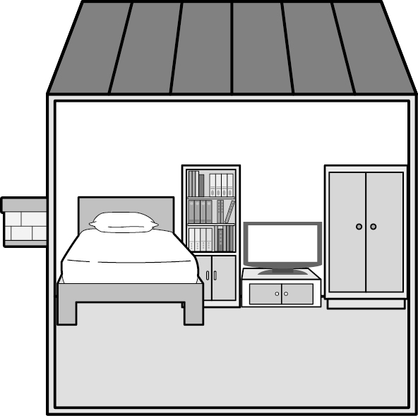 (C) 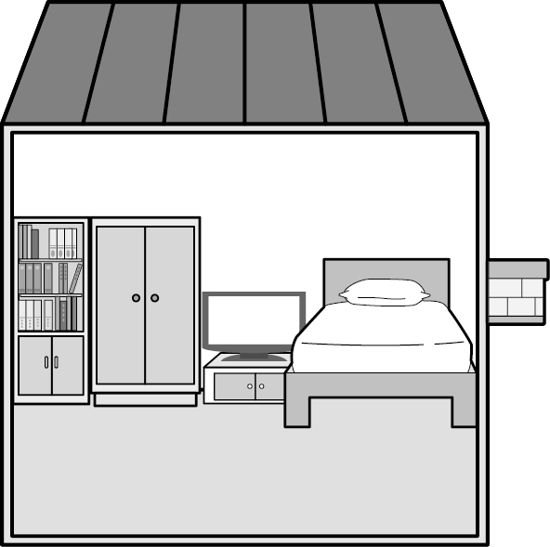 (D) 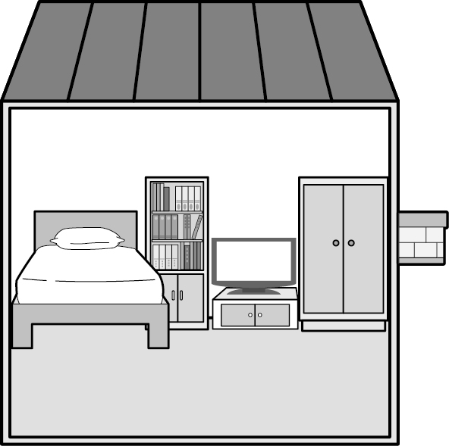
( ) (44) What may them be?
(A) The TV and the closet. (B) The closet and the old shelf. (C) The old and the new
bookshelves. (D) The TV and the old bookshelf.
( ) (45) Which is true about the new bookshelf?
(A) It is so noisy that it cannot be put it in the living room. (B) It will be put into the study
room of the apartment. (C) It may be brought back to where it was this morning.
(D) It is too crowded to put it into the dining room.
- During the summer, many people come to this river. It is a popular place for people to have picnics. They can relax and see many beautiful things around the river. An old wooden bridge crosses over the river and gives you a chance to dangle（晃）your feet over the edge（邊緣）as you watch the water running under you. Many people take some time to wade（涉水）along the river where they hope to see one of the rare local fish that can only be found in the river. The water is so clear and inviting that people want to go for a swim. If you do, you must be very careful, the water move faster than it looks and sadly, many people need rescuing（救援）every year.
( ) (46) What is the favorite season for people to visit this river?
(A) Summer. (B) Spring. (C) Fall. (D) Winter.
( ) (47) What might the word rare refer to（意指）?
(A) A lot. (B) Many. (C) Few. (D) Little.
( ) (48) What CAN’T people see along the river?
(A) An old bridge. (B) Tall buildings. (C) Clean water. (D) Rare fish.
( ) (49) Why do people lose their lives here in this river?
(A) The water flows too quickly. (B) The water is too clean. (C) There is an old bridge
here. (D) Many people might visit it in the summer.
( ) (50) Which is WRONG?
(A) Most people lose their lives in this river during summertime. (B) People seldom notice
the change of water flow. (C) There are many rare fish here in the river. (D) The writer asks us not to visit this river.

試題結束

