桃園市立觀音國民中學107學年度第1學期 第三次定期考 七年級英語科題目卷
班級：________座號：________姓名：________
第一部分：聽力測驗
一、辨識句意：每題均有三張圖片，請依據所聽到的句子，選出符合描述的圖片。（每題2分，共10分）
1. （ ）(A)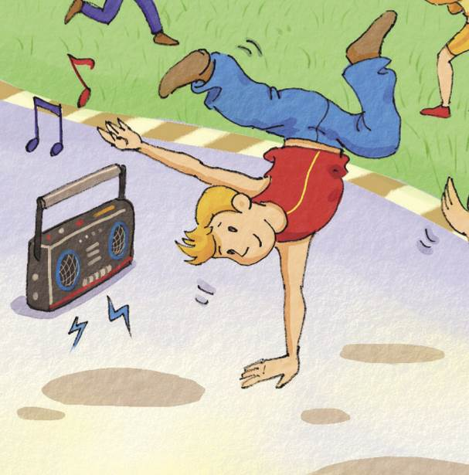 (B) (C)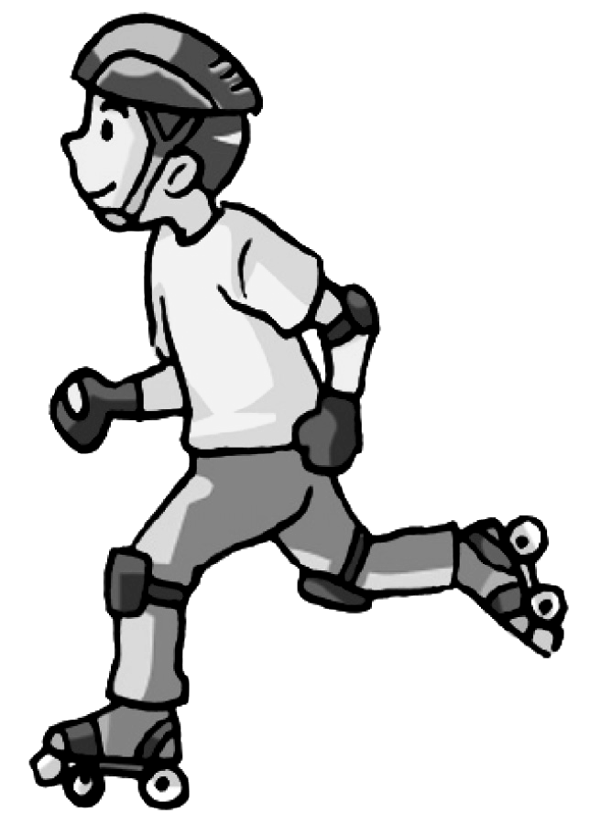
2. （ ）(A)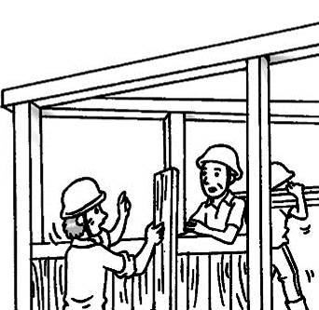 (B)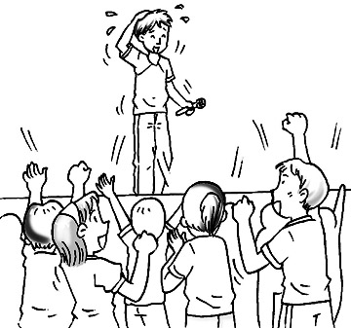 (C)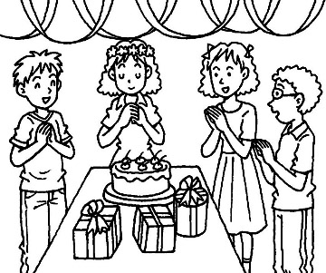
3. （ ）(A) (B) (C)
4. （ ）(A)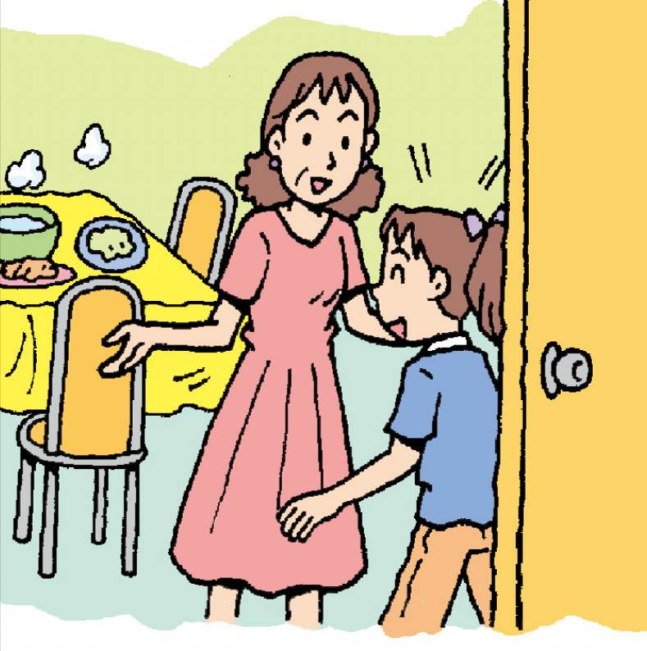 (B)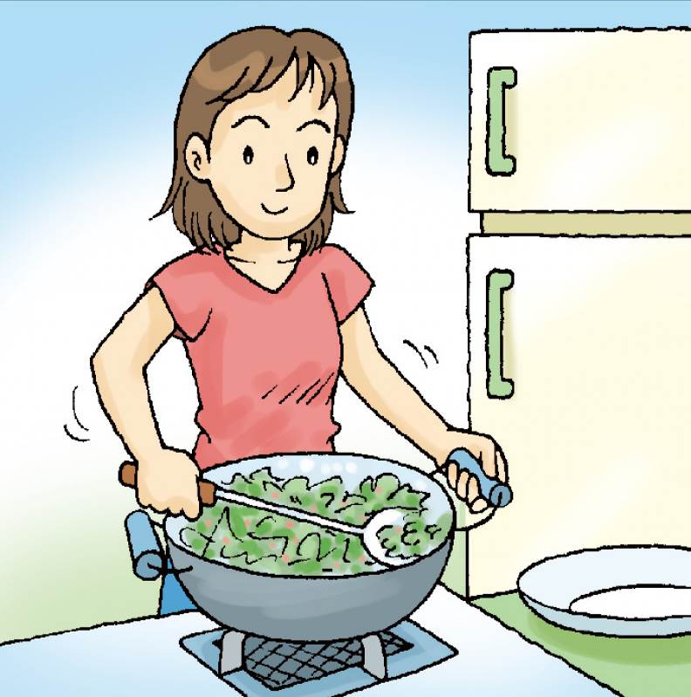 (C)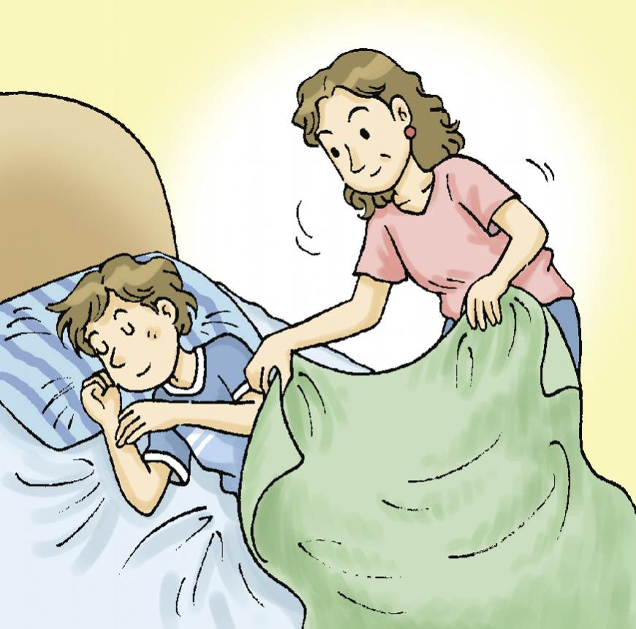
5. （ ）(A)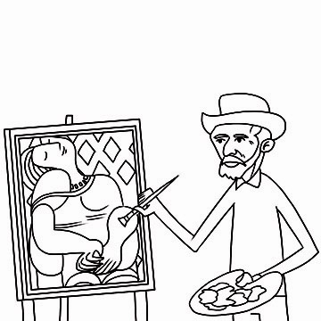 (B)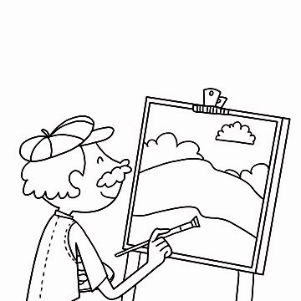 (C)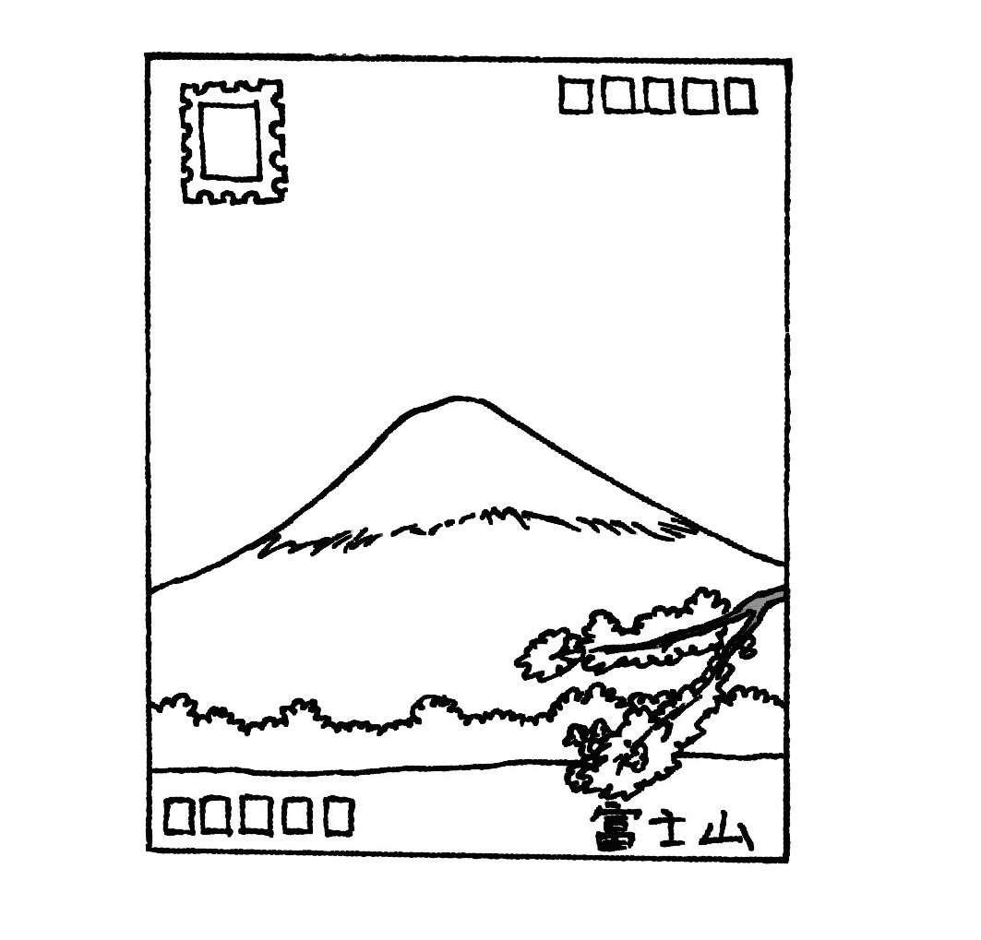

二、基本問答：每題均有三個選項，請依據所聽到的內容，選出一個最適合的回應。（每題2分，共10分）
6. （ ）(A) Oh! Your dog is cute. (B) It is jumping around. (C) Its name is Cody.
7. （ ）(A) Let’s not make noise. (B) No. She is crying. (C) Yes, she is swimming.
8. （ ）(A) He’s fine. Thank you. (B) His name is Michael Chang. (C) He’s in his room.
9. （ ）(A) Yes, a lot of people come here every year.
(B) No, there is not a lake here.
(C) No, it’s a special place.
10.（ ）(A) OK. Let’s buy a gift for Mom.
(B) You’re right. This is a nice place.
(C) Don’t worry. I have some money.

三、言談理解：每題均有三個選項，請依據所聽到的對話與問題，選出一個最適當的答案。
（每題2分，共10分）
11.（ ）(A) She’s running over to her friends.
(B) She’s singing with her friends.
(C) She’s dancing with her friends.
12.（ ）(A) Yes, she is.(B) No, she isn’t.(C) Yes, it’s seven o’clock now.
13.（ ）(A) A puppy is in the cage now.
(B) The cage is for the girl’s new pet.
(C) The girl’s mom is taking a cage with her.
14.（ ）(A) They are worrying about the picnic.
(B) They are having a picnic.
(C) They are watching cherry blossoms.
15. （ ）(A) The man is buying fruit in a shop.
(B) They are opening a fruit shop on the farm.
(C) There are some fruit trees on the woman’s farm.

第二部分：讀寫測驗
- 單題（每題2分，共40分）
16.（ ）Hazel: My dog can play frisbee with me. Linda: Really? Show ______.
- I (B) me (C)my (D) we
17.（ ）Remember to water the flowers in the ______ every day.
- cage (B) pocket (C) honey (D) garden
18.（ ）Taipei 101 is the tallest ______ in Taiwan.
- building (B) train (C)gift (D) station
19.（ ）Una: Oops! I am short of money. Catie: ______. There is a bank around here.
- Don’t worry (B) Hurry up (C) No wonder (D) See you
20.（ ） What a sunny day! Let’s have a ______.
- river (B) pond (C) picnic (D) place
21.（ ）Look! My father ______ bananas over there.
- buy (B) buying (C) is buying (D) are buying
22.（ ）The watch is ______ the computer ______ the TV.
- between; on (B) between; and (C)beside; in (D) beside; on
23.（ ）There aren’t ______ books in the drawer.
- a (B) some (C) one (D) any
24.（ ）Daniel is singing and ______ in his bedroom.
- dance (B) dances (C) danceing (D) dancing
25.（ ）Please don’t ______ in the classroom, Jason.
- shout (B) shouts (C) shouting (D) is shouting
26.（ ）The Yang family ______ having dinner in the night market.
- am (B) is (C)are (D) X
27.（ ）Ken and I are playing baseball in the park. We are ______.
- finding out (B) having lunch (C) looking for (D) having fun
28.（ ）Elsa is ______ a birthday cake for her brother.
- picnicking (B) practicing (C) painting (D) preparing
29.（ ）Andy: ______ is Eric? Jack: He is under the desk.
- What (B) Who (C)Where (D) When
30.（ ）It’s ______. Hurry up! We have to go out before(在…之前) twelve o’clock.
- ten after twelve (B) ten to twelve (C) a quarter after twelve (D) half past twelve
31.（ ）There is ______ near Guanyin Junior High School.
- bus station (B) a bus station (C) bus stations (D) the bus stations
32.（ ）Sean: Are there three hamburgers on the table? Peter: Yes, ______.
- there are (B) there aren’t (C) they are (D) they aren’t
33.（ ）Apps makes life more _______.
(A) convenient (B) comfortable (C) comment (D) cellphone
34.（ ）Trumpets are a type of _______.
(A) language (B) instrument (C) direction (D) restarant
35.（ ）Many people like to _______ their pictures and videos on Instagram.
(A) sell (B) cost (C) create (D) share

- 題組（每題2分，共30分）
I.
Ethan: It’s the _______ of the day. Are you _______ for lunch?
Russell: Yes, I’m _______. The office was very busy this morning.
Ethan: Want to go out for lunch?
Russell: Sure! Do you like pasta or pizza?
Ethan: I like pasta and I like pizza, too.
Russell: Great! A new place just opened next to the office. It sells _______.

36.( ) (A) meal (B) middle (C) metal (D) money
37.( ) (A) improve (B) review (C) interest (D) ready
38.( ) (A) hungry (B) crazy (C) funny (D) lovely
39.( ) (A) all (B) both (C) it (D) they

II.

Dear Luna,
I’m in Canada with Mona and Judy now. We see many beautiful maple trees on the road. The maple leaves all turn red now. You must come and see them yourself. We are in front of a great church now. Many people are taking photos around here. We are jumping, and we are having fun here. How are you in Taiwan?
Kelly

40.( ) What are the three girls doing now?
(A) They are singing songs. (B) They are playing frisbee.
(C) They are taking photos. (D) They are jumping.
41.( ) Who is NOT having fun in Canada?
(A) Mona (B) Judy (C) Luna (D) Kelly
42.( ) Where are the three girls?
(A) On the road. (B) In the church. (C) In front of the church. (D) In back of the church.

III.
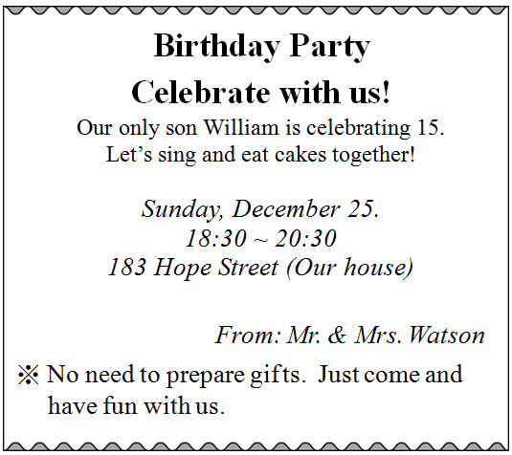
- celebrate慶祝 December十二月 street街
43.( ) How old is William?
(A) fifteen (B) twenty-five (C) eighteen (D) thirty
44.( ) Which is true（正確的）?
(A) People need to prepare gifts to the party. (B) People can sing and eat cakes together.
(C) The birthday party is on Saturday. (D) The birthday party will be last(持續) for three hours(小時).

IV.
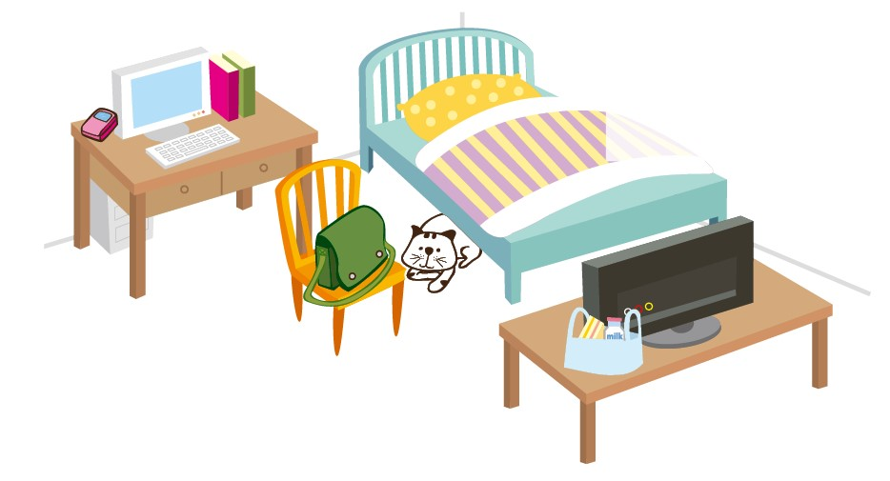
45.( )Where is the cat?
(A) On the desk. (B) Beside the TV. (C) In front of the computer. (D) Under the bed.
46.( )Is the cellphone on the chair?
(A) Yes, it is on the chair. (B) Yes, it is in back of the table.
(C) No, it is in the drawer. (D) No, it is beside the computer.
47.( )Which is true（正確的）?
(A) The schoolbag is under the chair. (B) There are five books on the desk.
(C) There is a dog in the bedroom. (D) The breakfast is on the table.

VI.
Nina lives in a downtown apartment with her family. There are six rooms in the apartment. But there are only two bedrooms. The large one is her father and mother’s bedroom. Nina and her sister, Cindy, share the small bedroom. There is also a small living room, too. The family eats together there. Nancy’s parents also work at the dining room sometimes. There is also a small kitchen and a small bathroom. Nina likes the apartment, but there aren’t enough rooms for her family. She hopes they can move to a bigger apartment some day.
- downtown市中心的 apartment公寓 large大的 parents雙親 enough足夠的

48.( ) How many people are there in Nina’s family?
(A) Two. (B) Four. (C) Six. (D) Eight.
49.( ) What do Nina and her family do in the living room?
(A) They read books. (B) They watch TV. (C) They eat meals. (D) They work together.
50.( ) Why do Nina want to move some day?
(A) Because both her parents are old.
(B) Because her home is far from school.
(C) Because the apartment is not big enough.
(D) Because Nina doesn’t want to share the bedroom with Cindy.

