桃園市立 觀音國民中學 107 學年度 第1學期 第三次定期考八年級英語科題目卷
班級：________ 座號：________ 姓名：________

- 聽力測驗: (每題2分,共15題,30分)
- 辨識句意：
根據聽到的內容，選出符合描述的圖片或符合圖片的描述。
- （ ）
(Ａ) | (Ｂ) | (Ｃ)
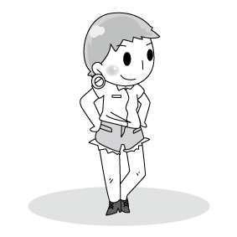 |  | 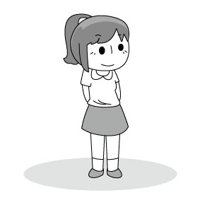
- （ ）
(Ａ) | (Ｂ) | (Ｃ)
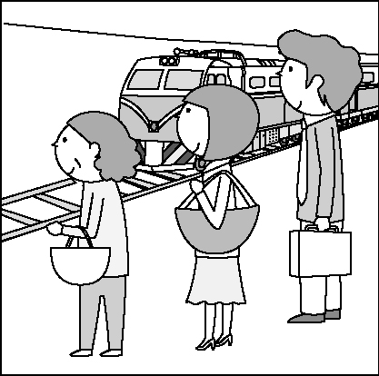 | 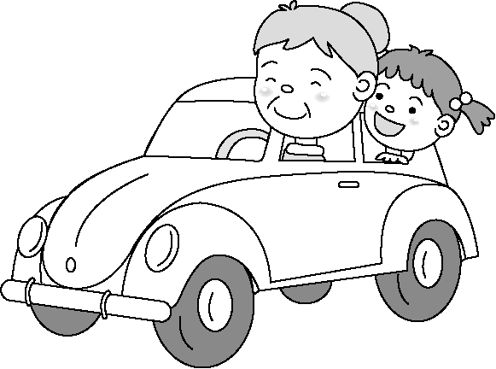 | 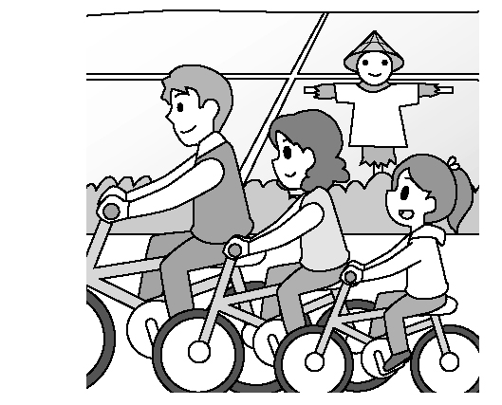
- （ ）
(Ａ) | (Ｂ) | (Ｃ)
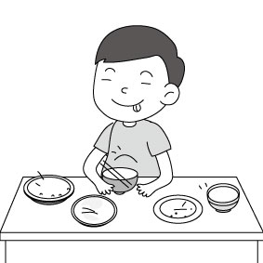 | 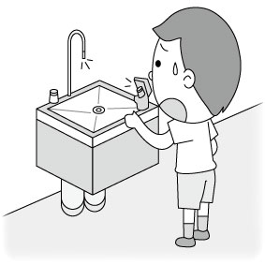 | 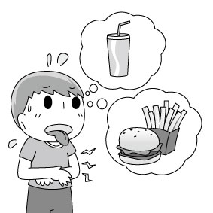
- （ ）
(Ａ) | (Ｂ) | (Ｃ)
 |  | 
- （ ）
(Ａ) | (Ｂ) | (Ｃ)
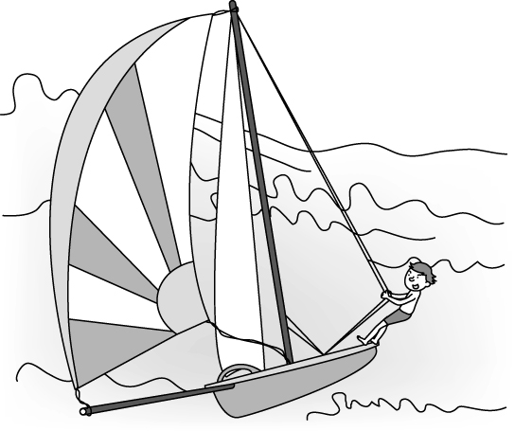 | 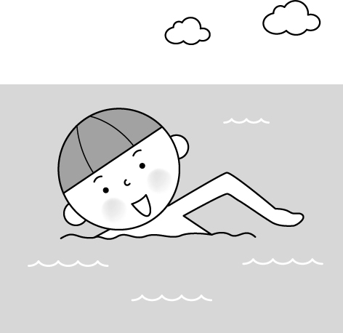 | 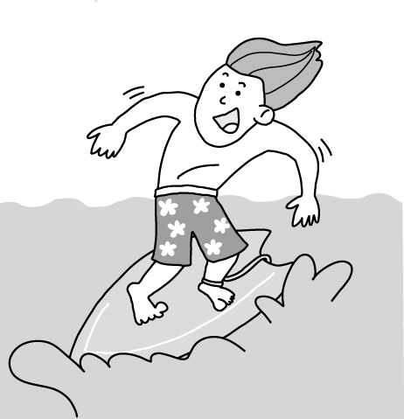
- （ ）
(Ａ) | (Ｂ) | (Ｃ)
INCLUDEPICTURE "http://hlart.hanlin.com.tw/artscript/art/artpreview.ashx?mode=show&fileID=464664&typeNo=false" \* MERGEFORMATINET 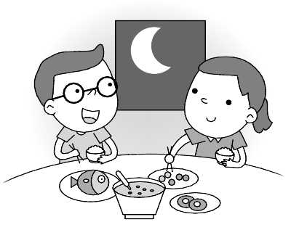 | 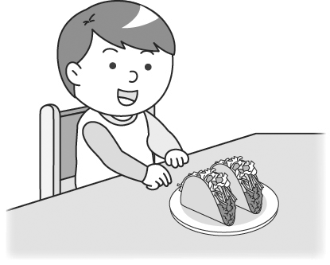 | 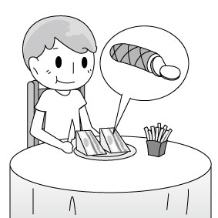
- （ ）
INCLUDEPICTURE "http://hlart.hanlin.com.tw/artscript/art/artpreview.ashx?mode=show&fileID=544963&typeNo=false" \* MERGEFORMATINET 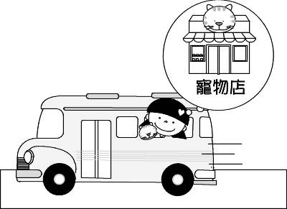
- （ ）
(Ａ) | (Ｂ) | (Ｃ)
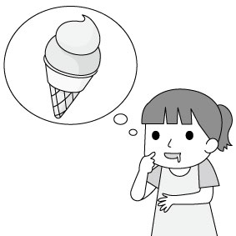 | 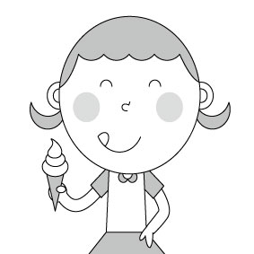 | 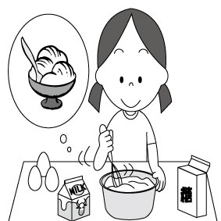
- （ ）
(Ａ) | (Ｂ) | (Ｃ)
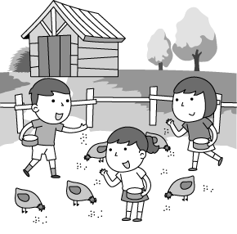 | 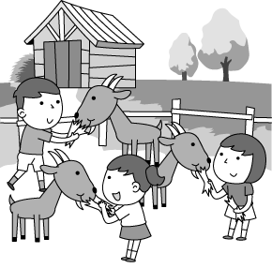 | 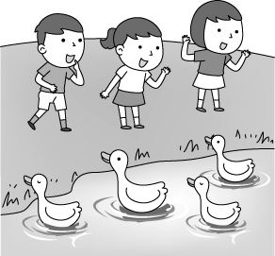
- （ ）
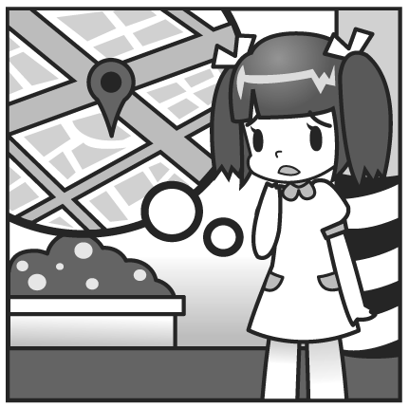

- 基本問答：根據聽到的內容，選出一
個最適合的回應或最適合的問句。
- （ ）
(Ａ) How much do I need to spend on the meal?
(Ｂ) I’m very full.
You really made yummy noodles.
(Ｃ) Thank you. It’s kind of you to be generous to
me all the time.
- （ ）
(Ａ) It costs NT$120.
(Ｂ) I want a cup, please.
(Ｃ) Thanks. I’m very thirsty.
- （ ）
(Ａ) I can make some delicious tacos for you.
(Ｂ) I enjoy going bird watching.
(Ｃ) I saw many insects on the way home.
- （ ）
(Ａ) You can sell fruit on the farm.
(Ｂ) They keep cows, sheep and turkeys.
(Ｃ) Go down this road for three blocks.
- （ ）
(Ａ) He enjoys the country life very much.
(Ｂ) He went jogging in the morning and went
biking in the evening.
(Ｃ) He doesn’t have much money, so he
can’t buy the expensive farmhouse.

聽力測驗結束，請繼續作答
二、語法測驗：(每題2分,共17題,34分)
( )16. ________ Alex and I going to do homework together?
(A)Are (B)Do (C)Will (D)Did
( )17. They’ll go to a coffee shop later, but I ________.
(A)won’t (B)didn’t
(C)don’t (D)am not
( )18. I ________ going to send e-mail to John later.
(A)is (B)was (C)am (D)are
( )19. A: What’s your plan for tomorrow?
B: I’ll go with my friends.
(A)camp (B)camped
(C)camping (D)camps
( )20. A: What time will Uncle Peter _____ in
Taipei?
B: At about five.
(A)borrow (B)arrive
(C)wear (D)take
( )21. Tim will go ________ on the beach this
weekend.
(A)hiking (B)shopping
(C)mountain climbing (D)surfing
( )22. We watched a(n) basketball game this morning. Jeremy Lin won the game again.
(Ａ) famous (Ｂ) exciting
(Ｃ) regular (Ｄ) easy
( )23. Ann: Did your husband fly to Japan yesterday?
Liz: Yes, he went there by .
(Ａ) MRT (Ｂ) train
(Ｃ) ship (Ｄ) plane
( )24. to the basketball game are expensive and hard to get.
(Ａ) Deserts (Ｂ) Tickets
(Ｃ) Sounds (Ｄ) Plants
( )25. Where are we? Let’s look at the .
(Ａ) road (Ｂ) street
(Ｃ) map (Ｄ) block
( )26. There are two girls riding on the on the playground.
(Ａ) swing (Ｂ) seesaw
(Ｃ) hotel (Ｄ) pool
( )27. There is no parking this street.
(Ａ) through (Ｂ) along
(Ｃ) behind (Ｄ) across
( )28. Which hotel did they at last Saturday?
(Ａ) live (Ｂ) living
(Ｃ) stay (Ｄ) staying
( )29. Turn right, and it’s left.
(Ａ) to; on the (Ｂ) ×; on the
(Ｃ) to the; on (Ｄ) the; on
( )30. Go , and you’ll find it on the right.
(Ａ) down (Ｂ) along
(Ｃ) straight (Ｄ) left
( )31. Alex: Does your dad you to school?
Mary: Yes, I always go to school car.
(Ａ) take; drive a (Ｂ) drive; by
(Ｃ) ride; in a (Ｄ) fly; on a
( )32. Josh: The house across from the street is on fire.
Brad:
(Ａ) How nice!
(Ｂ) Let’s go stop it.
(Ｃ) Doesn’t it look beautiful?
(Ｄ) Let’s call the fire station.

三、閱讀測驗：(每題2分,共18題,36分)
1.
( ) (33) What does humorous mean（意指）?
(A) Let people talk.
(B) Let people laugh.
(C) Let people dance.
(D) Let people sing.
( ) (34) Who DOESN’T like the book?
(A) Tim. (B) Cathy.
(C) Betty. (D) Harry.
( ) (35) What can we learn from the book?
(A) A new way of looking at the world.
(B) How to become a happy writer.
(C) A smart way to face family problem.
(D) How to buy a book online.
( ) (36) Who knows how to choose her good
friends now?
(A) Tim. (B) Cathy.
(C) Betty. (D) Harry.
( ) (37) Which is NOT true about the book
My Beach Life?
(A) It’s below NT$200.
(B) It is a real story.
(C) It is fun to read for Harry.
(D) Its second part is not fun to Betty.

2.
Peter: Where will you go traveling this
summer vacation, Sam?
Sam: I’ll go to Canada with my mother.
How about you, Peter?
Peter: I’ll join a summer camp（夏令營） in
Kenting with my good friend, Bill.
Hey, here comes Mia and Jill.
Sam: Hi, Mia and Jill. We’re talking about
the plans for this summer vacation.
Do you have any plans?
Mia: Well, I’ll go to Hong Kong to visit my
aunt myself. Jill is going to Japan.
Peter: That’s nice.
( ) (38) Who will join a summer camp in
Kenting?
(A) Sam. (B) Mia.
(C) Jill. (D) Peter and Bill.
( ) (39) Where will Sam go this summer
vacation?
(A) Canada. (B) Kenting.
(C) Hong Kong. (D) Japan.
( ) (40) Who will go to Hong Kong
himself/herself?
(A) Peter. (B) Mia.
(C) Jill. (D) Peter and Bill.
( ) (41) Where is Jill going?
(A) Canada. (B) Kenting.
(C) Hong Kong. (D) Japan.
( ) (42) Bill is ________ friend.
(A) Mia’s (B) Sam’s
(C) Peter’s (D) Jill’s
3.
Winter vacation is coming, and Nora is making plans. In the first week, she is going to practice riding a bicycle. Then she will go biking around Taipei with her friends, Lisa and Eric. In the second week, she will visit her grandparents in Cijin and celebrate Chinese New Year. In the third week, she will do her science report with Amber. She will also prepare for a test. How about you? Do you have any plans?
( ) (43) What will Nora do in the first week of this
winter vacation?
(A) Prepare for the coming test.
(B) Celebrate Chinese New Year.
(C) Go biking with her friends.
(D) Go shopping with her friends.
( ) (44) Where will Nora be in the second week of
this winter vacation?
(A) In Cijin. (B) In Taipei.
(C) At home. (D) At the bus stop.
( ) (45) When will Nora prepare for the test?
- In the first week of this winter vacation.
- In the third week of this winter vacation.
- In the second week of this winter vacation.
- In the third week of this summer vacation.

4.
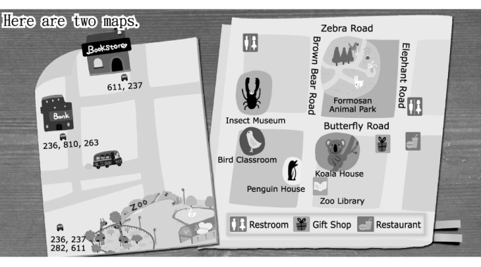
（ ）(46) Look at the street map. Jerry is waiting in front of the bank for the bus to the zoo. Which bus is he going to take?
(Ａ) Bus 236. (Ｂ) Bus 282.
(Ｃ) Bus 611. (Ｄ) Bus 237.
（ ）(47) Look at the zoo map. What is across from the Bird Classroom?
(Ａ) The Koala House.
(Ｂ) The Zoo Library.
(Ｃ) The Insect Museum.
(Ｄ) The Penguin House.
（ ）(48) Jerry is in front of the Zoo Library now, and he wants to use the restroom. How can he get there?
(Ａ) He can go down Butterfly Road.
It’s on the right.
(Ｂ) He can go down Brown Bear Road.
It’s on the left.
(Ｃ) He can go down Brown Bear Road,
and turn right on Zebra Road.
It’s on the left.
(Ｄ) He can go down Brown Bear Road,
turn right on Butterfly Road,
and walk for one block.
It’s on the left.
5.
Ted: Excuse me. How do I get to the railway
station?
Man: Go straight, and you’ll see the bus stop on
your right. Take Bus 2 or 16 and get off at
the train station.
Ted: By the way, is there a bookstore near here?
Man: No. But there are some near the train
station.
Ted: Thank you so much.
Man: You’re welcome.
（ ）(49) What does some mean?
(Ａ) Trains.
(Ｂ) Buses.
(Ｃ) Bookstores.
(Ｄ) Bus stops.
（ ）(50) How can Ted get to the railway station?
(Ａ) By train. (Ｂ) By bus.
(Ｃ) By bike. (Ｄ) By MRT.

測驗結束，細心檢查，祝考試順利!

HAPPY


