桃園市立觀音國民中學107學年度第2學期 第一次定期考 七年級英語科題目卷
班級：________座號：________姓名：________
第一部分：聽力測驗
一、辨識句意：每題均有三張圖片，請依據所聽到的句子，選出符合描述的圖片。（每題2分，共10分）
1.（ ）(A)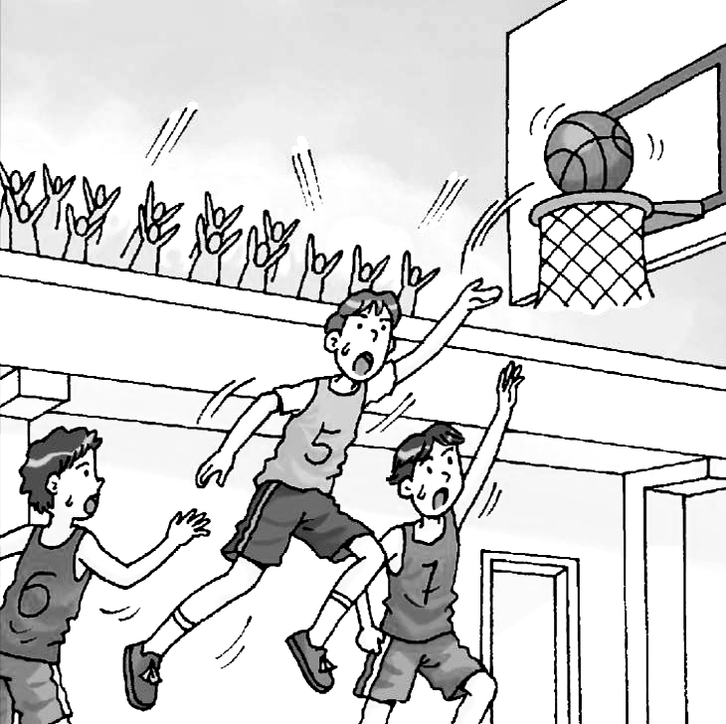 (B)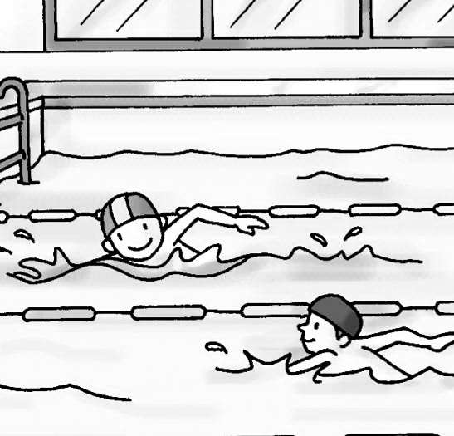 (C)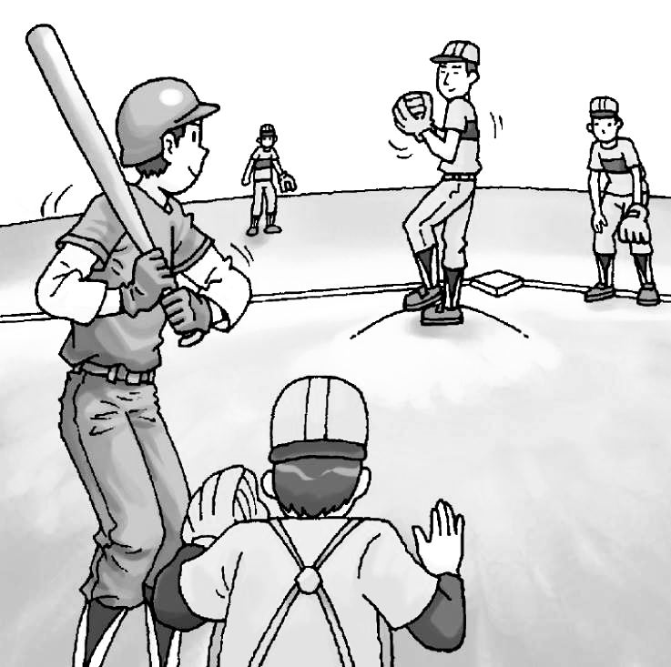
2.（ ）(A)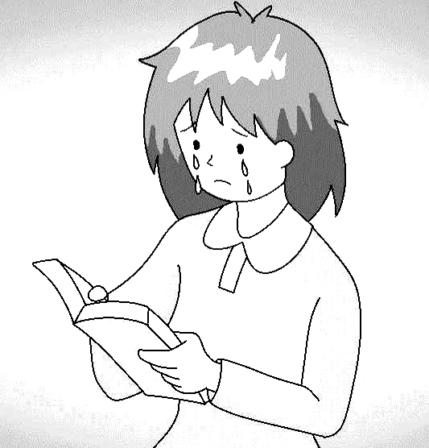 (B)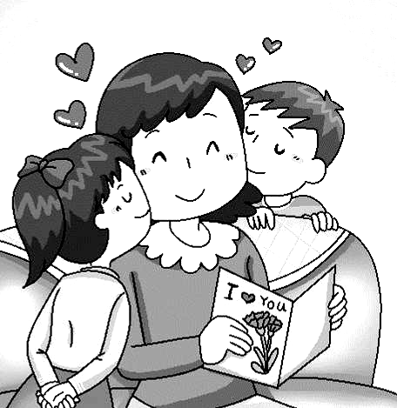 (C)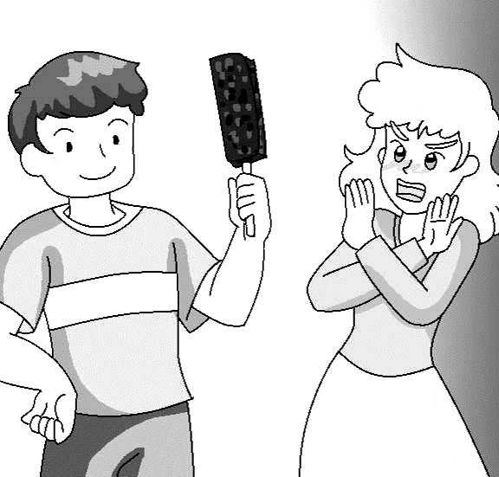
3.（ ）(A)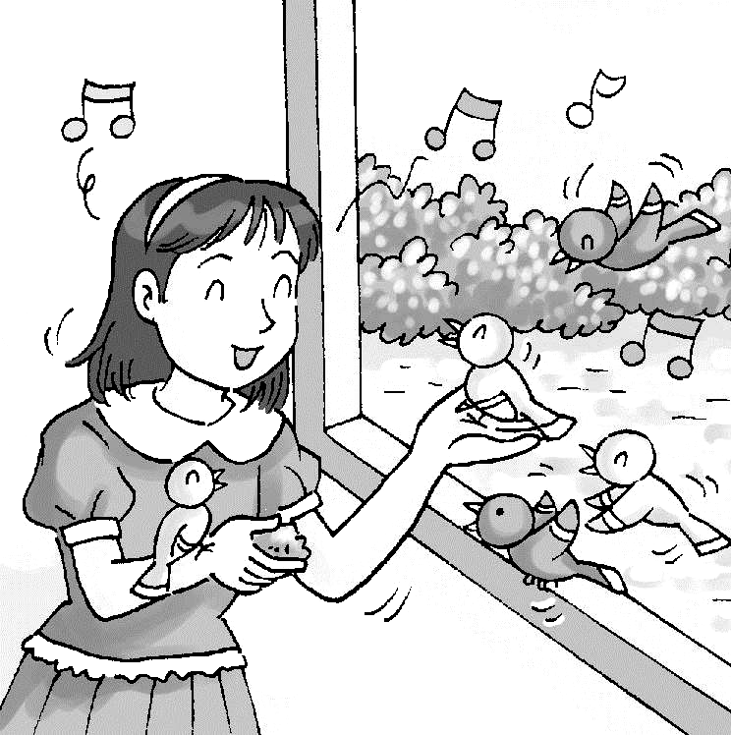 (B)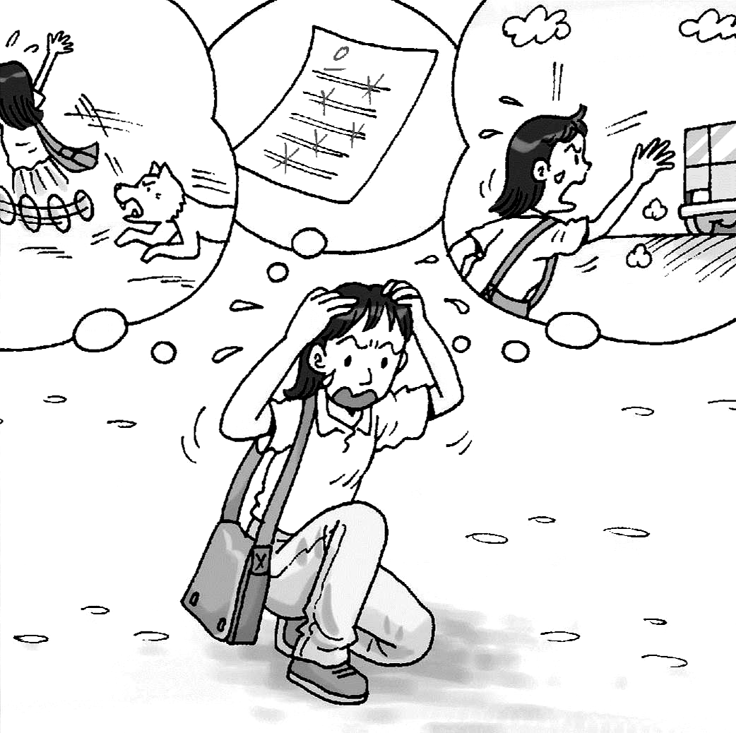 (C)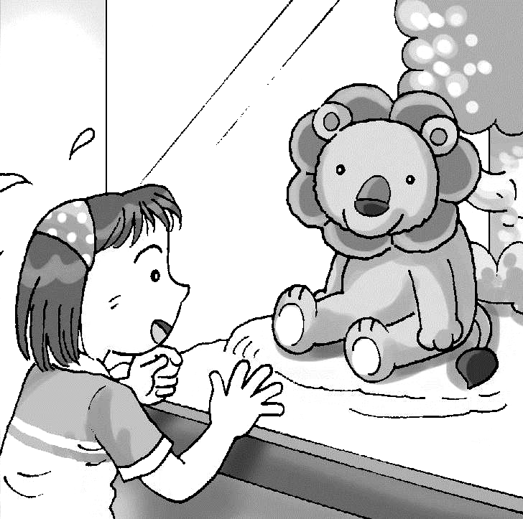
4.（ ）(A) (B)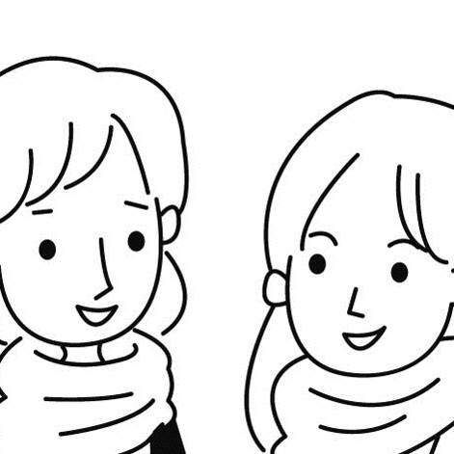 (C)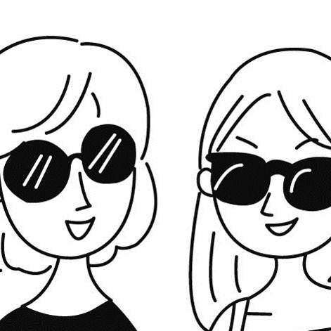
5.（ ）(A)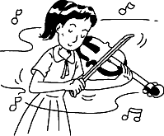 (B)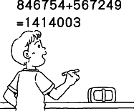 (C)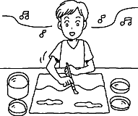
二、聽CD，配合圖片選出最適當的答案。（每題2分，共10分）
6.（ ）(A) It is so smart. (B) It can swim, too. (C) It’s jumping rope.
7.（ ）(A) Wow. It’s a small world! (B) My cousin is a school teacher. (C) I’m a junior high school student.
8.（ ）(A) Yes, I can meet you at the gym.
(B) Yes, I play it only on weekends.
(C) Yes, I do. Soccer is my favorite.
9.（ ）(A) Yes, I have a rabbit. (B) Yes, I have a music class. (C) Yes, I have homework today.
10.（ ）(A) You bet. (B) I don’t get it, either. (C) No one can help me.

三、基本問答：每題均有三個選項，請依據所聽到的內容，選出一個最適合的回應。（每題2分，共10分）
11.（ ）(A) He can’t jump rope. (B) He can’t train a dog. (C) He can’t catch a ball.
12.（ ） (A) He is the girl’s friend. (B) He is the girl’s favorite actor. (C) He is the teacher of the movie club.
13.（ ）(A) They jump rope every day.
(B) They don’t do sports every day.
(C) They eat a lot of food every day.
14.（ ）(A) The boy’s brother. (B) The girl’s brother. (C) The girl’s sister.
15.（ ）(A) The man is asking about today’s lunch.
(B) The woman is helping Amanda in the kitchen.
(C) Amanda and Kevin are washing the apples together.

第二部分：讀寫測驗
- 單題（每題2分，共30分）
16.（ ）It’s raining. Let’s go to the _______ to play tennis.
(A)gym (B) park (C) shop (D) museum
17.（ ）This cellphone is _______ different from the others.
(A)look at (B) too bad (C) a little (D) come on
18.（ ）The woman over there is my father’s sister, _______ Stella.
(A)Mother (B) Grandma (C) Uncle (D) Aunt
19.（ ）Michael Jordan is a/an _______ basketball player. He plays basketball very well.
(A)terrible (B) excellent (C) careful (D) beautiful
20.（ ）Elsa: It’s cold. I don’t want to go swimming. Anna: Me, _______.
(A)too (B) either (C) not (D) don’t
21.（ ）My favorite season is _______. The weather is cool and the air is fresh.
(A)spring (B) summer (C) autumn (D) winter
22.（ ）Let’s pick some _______ with grandpa and grandma tomorrow!
(A) sports (B) rabbits (C) pumpkins (D) drawers
23.（ ）Math is _______ for many students. They get bad grades on math tests.
(A)difficult (B) different (C) delicious (D) dangerous
24.（ ）Harry: I want a hamburger with apple juice. Waiter: OK! _______ do you want?
(A)Who else (B) What else (C) Where else (D) When else
25.（ ）Kelly can roller-skate but she _______ jump rope.
(A)is (B)can (C) isn’t (D)can’t
26.（ ）Mom: Can you fix the TV in the living room? Dad: _______.
(A)Yes, he can. (B) Yes, I can. (C) No, he can’t. (D) No, she can’t.
27.（ ）Tina: Do Mr. and Mrs. Potter have a computer? Shelly: _______.
(A)Yes, they do. (B)Yes, they have. (C)Yes, he does. (D)Yes, he has.
28.（ ）Zack _______ a kite with his girlfriend on Fridays, but we _______.
(A) fly; doesn’t (B) fly; don’t (C) flies; doesn’t (D) flies; don’t
29.（ ）Beca: What does Sharon _______? Charlie: She _______ lions.
(A) like; like (B) like; likes (C) likes; like (D) likes; likes
30.（ ）Taylor: Do you and your brother roller-skate? Oliver: Yes, I _______ but my brother _______.
(A)do; don’t (B)do; doesn’t (C)does; doesn’t (D)does; don’t
- 題組（每題2分，共18分）
I.
Jerry: If you could go anywhere, where would you go?
Mike: I would like to go to London! It’s a ____31_____ city.
Jerry: London must get a lot of visitors. It’s a popular city in _____32____.
Mike: By the way, I would like to visit the British Museum to see the collections of _____33____ art.
Jerry: Sounds interesting!

31.（ ）(A)yellow (B)easily (C)discover (D)marvelous
32.（ ）(A)Asia (B)Europe (C)Africa (D)America
33.（ ）(A)public (B)harvest (C)favorite (D)ancient

II.
O = can  X =can’t | Micky | Minnie | Daisy
Play the guitar | O | O | O
Play basketball | O | X | X
Jump rope | O | X | O
Swim | X | O | O
Fly a kite | X | O | O
34.（ ）Who can swim?
(A)Micky and Minnie. (B)Minnie and Daisy. (C)Micky and Daisy. (D)All of them.
35.（ ）X can play the guitar and jump rope but can’t fly a kite. Who is X?
(A)Micky. (B)Minnie. (C) Daisy. (D)All of them.

III.

My name is Frank. I am from Taiwan. I am studying in the USA. Paul is my classmate. He likes Chines very much. I teach him Chinese on weekends. He can speak some Chinese now. Paul is good at science. He helps me with my science homework.
Paul and I are on the same school basketball team. We practice basketball at the gym every day. Mr. Garnet is our coach, and he is very excellent. He gives a lot of training, but everyone likes him.

36.（ ）Does Paul help Frank with her science homework?
(A)Yes, he is. (B)No, he isn’t. (C)Yes, he does. (D)No, he doesn’t.
37.（ ）Which is true?
(A) Paul is a basketball coach. (B)Mr. Garnet speak good Chinese.
(C)Frank and Paul are from the USA. (D)Frank and Paul like Mr. Garnet.

IV.
Blood Types（血型）
People of Blood Type A  - like to be alone（單獨的）  - are afraid to tell what they really think about | People of Blood Type B  - love to be noticed（注意）  - are ready to help people
People of Blood Type AB  - do things in their own way  - are interested in learning something new | People of Blood Type O  - enjoy making friends  - are confident（有信心的） of solving their problems
38.（ ）Mandy is a person with blood type B. What kind of job（工作） may be best for her?
(A)A businessman. (B)A painter. (C)A singer. (D)A police officer.
39.（ ）Tim likes to get along with（相處） many people at school. What is Tim’s blood type?
(A) Blood Type A. (B) Blood Type B. (C) Blood Type AB. (D) Blood Type O.

第三部分：寫作測驗
六、引導式翻譯（每題2分，共16分）
1. Eric和Andy同班。Eric and Andy are in the same _________.
2. 我每個週末都跟我的表妹一起打籃球。I play basketball with my _________ every weekend.
3. Helen剛剛跟我說了一個鬼故事。Helen just told me a ghost _________.
4. 這場足球比賽真的很刺激！This soccer game is really _________!
5. Jason正在那裡打羽毛球。Jason is playing _________ over there.
6. 你想參加棒球社嗎？Do you want to _________ the baseball club?
7. Cindy和Judy常常一起上學。Cindy and Judy often go to school _________.
8. 動物園裡有很多動物。There are many _________ in the zoo.

七、依提示作答（每題3分，共6分）
1. What can your dog do?（用「握手」回答）
＿＿＿＿＿＿＿＿＿＿＿＿＿＿＿＿＿＿＿＿＿＿＿＿＿＿＿＿＿＿＿＿＿＿＿
2. Does Mr. Chen have a cat?（先簡答再肯定詳答）
＿＿＿＿＿＿＿＿＿＿＿＿＿＿＿＿＿＿＿＿＿＿＿＿＿＿＿＿＿＿＿＿＿＿＿

＃＃＃第一部分和第二部分請用2B鉛筆畫卡，第三部分請用藍筆或黑筆書寫於答案卷上＃＃＃

