桃園市立觀音國民中學 107 學年度 第2學期 第一次定期考 九年級 英語科 題目卷
班級：________ 座號：________ 姓名：________

- 聽力測驗:每題2分，共30分
- 辨識句意：根據聽到的內容，選出符合描述的圖片或符合圖片的描述。
- （ ）
(Ａ) | (Ｂ) | (Ｃ)
INCLUDEPICTURE "http://hlart.hanlin.com.tw/artscript/art/artpreview.ashx?mode=show&fileID=703763&typeNo=false" \* MERGEFORMATINET 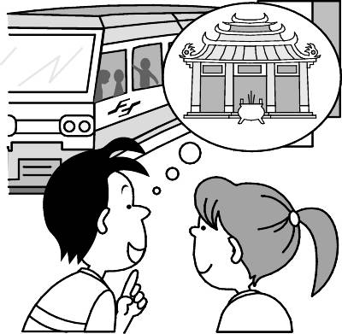 | INCLUDEPICTURE "http://hlart.hanlin.com.tw/artscript/art/artpreview.ashx?mode=show&fileID=629338&typeNo=false" \* MERGEFORMATINET 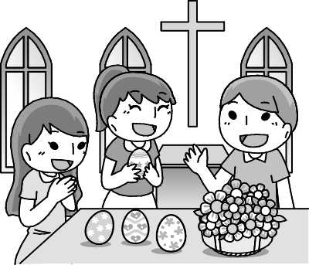 | INCLUDEPICTURE "http://hlart.hanlin.com.tw/artscript/art/artpreview.ashx?mode=show&fileID=567751&typeNo=false" \* MERGEFORMATINET 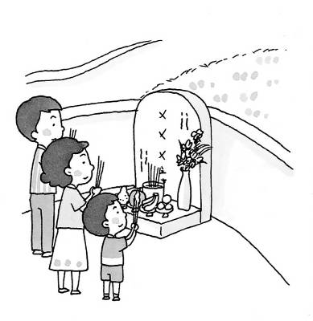
- （ ）
(Ａ) | (Ｂ) | (Ｃ)
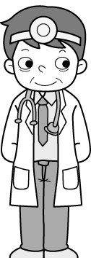 | 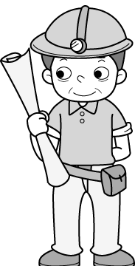 | 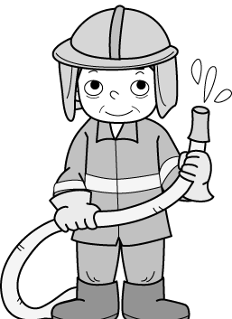
- （ ）
(Ａ) | (Ｂ) | (Ｃ)
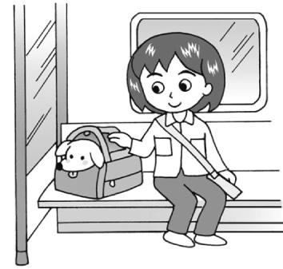 | 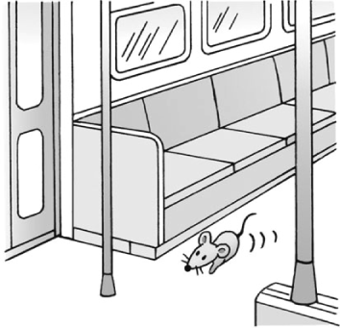 | INCLUDEPICTURE "http://hlart.hanlin.com.tw/artscript/art/artpreview.ashx?mode=show&fileID=628441&typeNo=false" \* MERGEFORMATINET 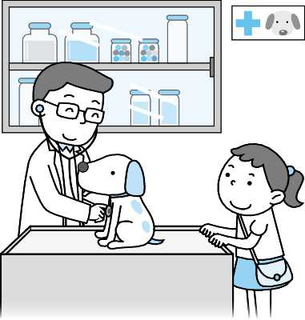

(二)基本問答：根據聽到的內容，選出一個最適合的回應或最適合的問句。
- （ ）
(Ａ) No, I haven’t had a chance.
(Ｂ) Yes, I’ve been to the USA twice.
(Ｃ) No, I wasn’t at home at that time.
- （ ）
(Ａ) No worries. I’m fine.
(Ｂ) Sorry, I was caught in the traffic.
(Ｃ) I’ll bring some drinks for the party.
- （ ）
(Ａ) Neither crying nor shouting can solve the problem.
(Ｂ) Can you lend me an ear?
(Ｃ) You can talk to your parents about your worries.
- （ ）
(Ａ) Yes, please.
(Ｂ) Yes, it was a great meal.
(Ｃ) Yes, I can lend you some.
- （ ）
(Ａ) No way!
(Ｂ) I can’t help it.
(Ｃ) Sure. See you then!
- （ ）
(Ａ) Think before you do.
(Ｂ) I don’t, either.
(Ｃ) I will be able to take care of it.
- （ ）
(Ａ) We can take it onto the train.
(Ｂ) Ten miles or so.
(Ｃ) About two years.

(三)言談理解：根據聽到的內容，選出一個最適合的答案。
- （ ）
(Ａ) Twenty.
(Ｂ) Thirty-two.
(Ｃ) Sixty-eight.
- （ ）
(Ａ) Lydia is the man’s daughter.
(Ｂ) Lydia is the woman’s relative.
(Ｃ) Lydia will go shopping with the man.
- （ ）
(Ａ) Rita is helpful to Mr. Wu.
(Ｂ) Rita wants to find a secretary.
(Ｃ) Rita is going to quit, and so is Mr. Wu.
- （ ）
(Ａ) Neither the man nor the woman likes cats.
(Ｂ) The woman likes not only cats but also
dogs.
(Ｃ) To the man, either cats or dogs are
friendly animals.
- （ ）
(Ａ) Teresa told him.
(Ｂ) He found it out himself.
(Ｃ) He heard from others.
_________聽力測驗結束，繼續作答__________

- 語法測驗:每題2分，共30分
16.( )Families get together and eat a big dinner on .
(Ａ) Chinese New Year’s Eve (Ｂ) Easter
(Ｃ) Grandparents’ Day (Ｄ) New Year’s Day
17.( )The are not able to see anything, are they?
(Ａ) blind (Ｂ) young (Ｃ) old (Ｄ) poor
18.( )Dad is checking the water under the tub.
(Ａ) pipe (Ｂ) puppy (Ｃ) pet (Ｄ) dot
19.( )Pasting is one of the activities for Chinese New Year.
(Ａ) riddle parties(Ｂ) a big family dinner
(Ｃ) spring couplets(Ｄ) animal signs
20.( )When her son came back home safely, she gave him a big and told him to be more careful next time.
(Ａ) lid (Ｂ) cage (Ｃ) hug (Ｄ) pin
21.( )I didn’t want to visit the zoo because I ________ there several times.
(A)am (B)will be (C)had been (D)was
  - ( )When my father got home last night, all of us ________ to bed already.
(A)have gone (B)had gone (C)were going (D)went
23. ( ) Jack told me that he ________ the movie twice.
(A)saw (B)had seen (C)has seen (D)was seeing
24.( )William would like ________ some pictures to send to his friends.
(A)take (B)takes (C)taking (D)to take
25. ( )The book is so interesting that over 100 million copies ________ around the world.
(A)have been sold (B)will sell (C)has sold (D)are selling
26. ( )We ________ that car for ten years before it broke down（故障）.
(A)have had (B)had (C)had had (D)had have
27. ( )Jack didn’t catch the train because it ________ when he ________.
(A)has left; arrived (B)had left; arrived (C)will leave; arrive (D)left; had arrived
28. ( )I will never forget ________ my teacher taught me.
(A)who (B)what (C)that (D)which
29. ( )My grandma is a vegetarian(素食者). She eats ________ meat ________ fish.
(A)both; and (B)neither; nor
(C)not only; but also (D)either; or
30. ( )Cathy isn’t free this evening, and Dora isn’t, either. So ________ Cathy ________ Dora will come to the party tonight.
(A)both; and (B)either; or
(C)not only; but also (D)neither; nor

二、克漏字測驗：每題2分，共20分
(一)
It’s never comfortable to take the MRT during rush hour（尖峰時間）on a hot summer day. All my friends hate it, and I (31) it, too.
The story happened one month ago. I was on the MRT that was crowded（擁擠的）. I (32) my friend, Mary, to see a movie. And then she called and said she had to take care of her little sister. ”This is not what I expected（期望）for Friday.” I thought. The air on the MRT made me feel sick; the boy next to me smelled like dead fish. While I was feeling sad, a girl called my name. I didn’t recognize her at first. Then I was (33) to find that she was Mei-ling, my old classmate. I (34) Mei-ling in years. We used to do homework together at school. We were happy to see each other, so we decided to have dinner together. And that was the start of many dinners after.
With Mei-ling, the MRT ride (35) something I like. The MRT is still full of people, but I enjoy the ride every day.
( ) (31) (A) hate (B) have hated
(C) used to hate (D) had hated
( ) (32) (A) used to meet
(B) was going to meet
(C) will meet
(D) have met
( ) (33) (A) interested (B) surprised (C) bored (D) tired
( ) (34) (A) won’t see
(B) wouldn’t see
(C) haven’t seen
(D) hadn’t seen
( ) (35) (A) will become
(B) would become
(C) has become
(D) had become
(二)
(Tony’s motorcycle has (36) . He calls his friend, Ben.)
Tony: Hi, Ben. I have a big problem.
Ben: What’s wrong?
Tony: My motorcycle won’t start. And I have no way to (37) .
Ben: Is there any bus you can (38) ?
Tony: I don’t think so. And I have no time to (39) . Can you please give me a ride?
Ben: No problem. I can (40) in fifteen minutes.
Tony: Thank you so much.
Ben: Not at all. What are friends for?
( ) (36) (A) been born (B) taken out (C) broken down (D) picked up
( ) (37) (A) get to work (B) get lost (C) get sick (D) get hurt
( ) (38) (A) fly (B) drive (C) ride (D) take
( ) (39) (A) have my motorcycle fixed
(B) buy a new bicycle
(C) take a bus to work
(D) call the police
( ) (40) (A) drive you home
(B) take you to school
(C) be at your place
(D) be at the motorcycle shop

三、閱讀測驗：每題2分，共20分
- During the past one hundred years, there have been many inventions（發明）that make our life much easier and more interesting. TV is one of them. Many people enjoy watching TV for fun. Some even believe that TV has made their children smarter because there are all kinds of information on it－news, science, sports, and language. Children can learn a lot from TV in a short time without going out. Many parents are happy about this because they themselves are too busy to spend time with their children.
But we have found that more and more children today have problems with reading and thinking even though they have watched a lot of TV. In fact, getting information from TV doesn’t mean real learning. Children who watch too much TV do not have enough time to think or to talk with people. Besides, it takes time and love for children to grow up. What children need most is their parents. We should teach our children what real life is without TV. After all, machines should not be more important than people.
( ) (41) What do many people enjoy
watching TV for?
(A) For being smarter.
(B) For fun.
(C) For more news.
(D) For problems.
( ) (42) What CAN’T you get from TV?
(A) Information about science.
(B) Information about sports.
(C) Fun.
(D) Parents’ love.
( ) (43) Why do many parents make their children sit in front of the TV?
(A) They don’t have much time to spend with their children.
(B) TV is more important than themselves.
(C) They spend money buying the TV.
(D) Their children don’t need them.
( ) (44) Which is true?
(A) Children who watch a lot of TV don’t have any problems with
reading and thinking
(B) TV can teach children what the real life is.
(C) Children who watch too much TV do not have enough time
to think or to talk with people.
(D) Children who watch a lot of TV are smarter than those who
don’t watch TV.
( ) (45) What children who are growing up need most is ________.
(A) a good TV
(B) their parents
(C) a lot of information from TV
(D) good inventions which make life easier and more interesting
- Robert often traveled to very small towns because he sold things to farmers. Robert enjoyed the job because he was fond of farming. He usually went to visit the farmers by car. But he found it easy to travel by train especially when the weather was bad. When he went to a hotel, he wanted to be warm, to have some hot water and good food.
One evening in the winter, after an uninteresting train trip, he asked a local man how many hotels there were nearby. The man answered that there were two. Robert wanted his opinion（意見）on which to go to, but the man was not very helpful because he thought that both hotels were equally（同樣地）bad.
( ) (46) What was Robert most likely（最可能）?
(A) A businessman. (B) A farmer. (C) A train driver. (D) A miner.
( ) (47) Where did Robert stay at night when he went to see the farmers?
(A) In the train. (B) At a hotel. (C) In his car. (D) At his home.
( ) (48) To Robert, traveling by train was ________ than traveling by car on rainy or snowy days.
(A) slower (B) worse (C) easier (D) cheaper
( ) (49) What did Robert expect when he got to a hotel after a tiring trip?
(A) Hot water. (B) Good food. (C) A warm room. (D) All of the above.
( ) (50) What did Robert ask the local man that evening?
(A) “How many children do you have?”
(B) “Which is the better of the two hotels?”
(C) “How is the weather here in winter?”
(D) “What kind of job do you like best?”
_____________________________________試題結束_____________________________________

