桃園市立觀音國民中學107學年度第2學期 第二次定期考 七年級英語科題目卷
班級：________座號：________姓名：________
第一部分：聽力測驗
一、辨識句意：每題均有三張圖片，請依據所聽到的句子，選出符合描述的圖片。（每題2分，共10分）
1.（ ） (A)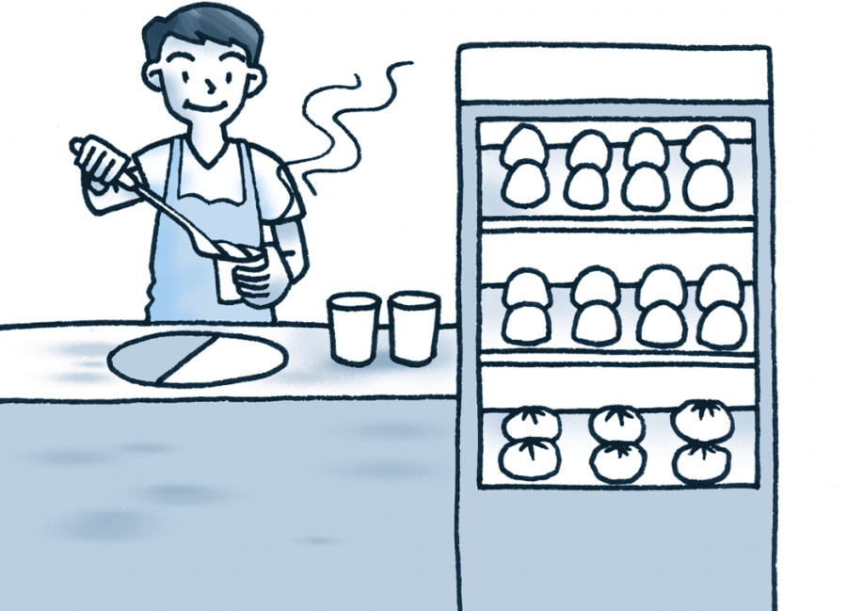 (B)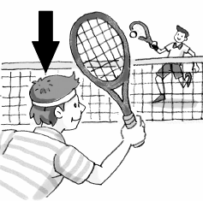 (C)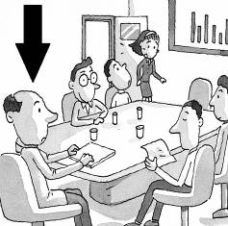
2.（ ）(A)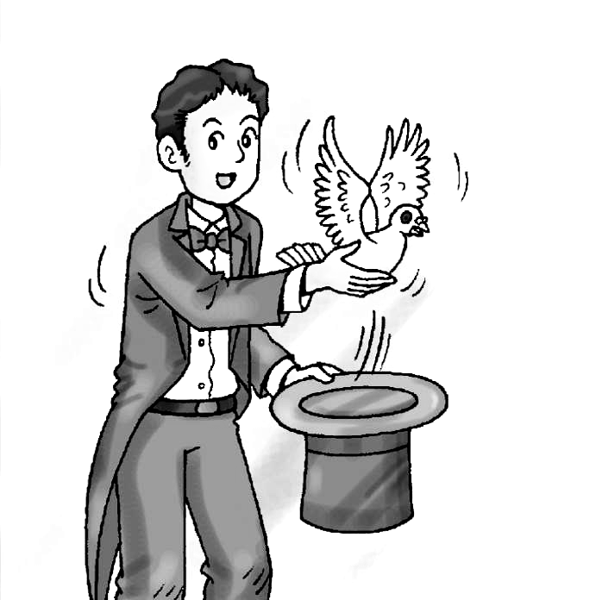 (B)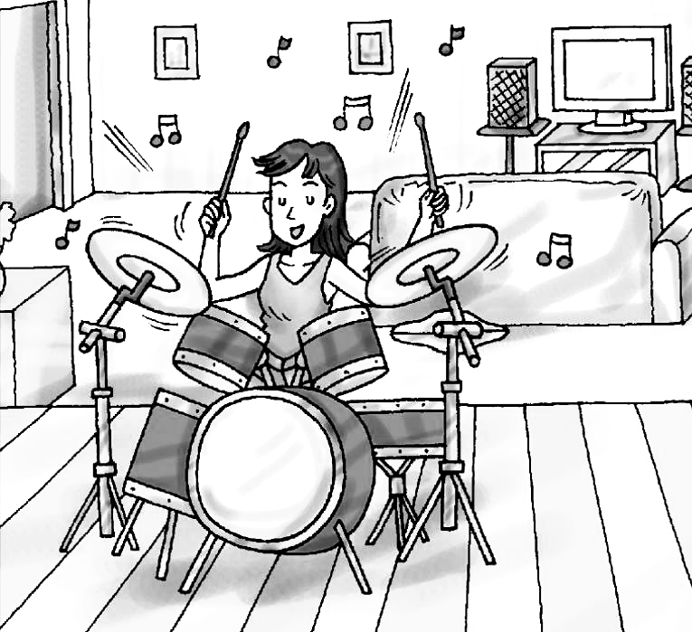 (C)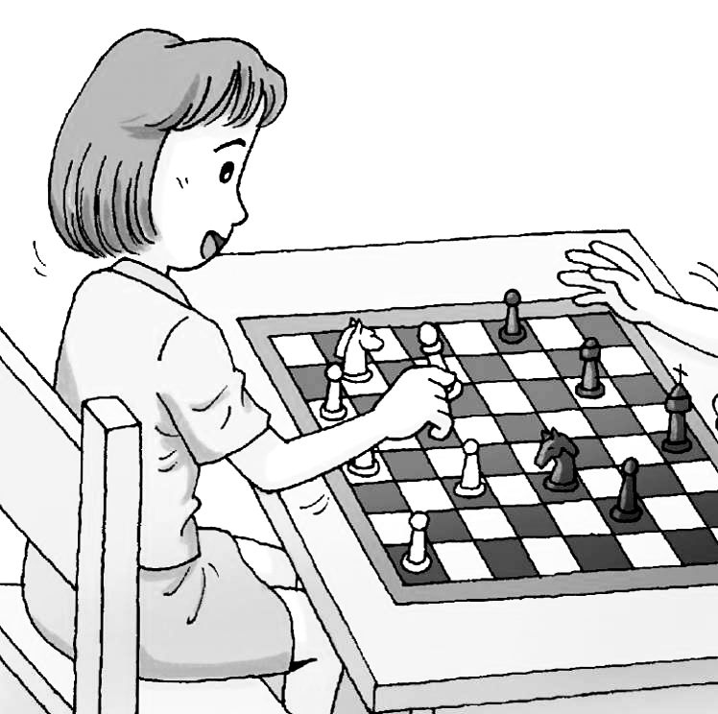
3.（ ）(A)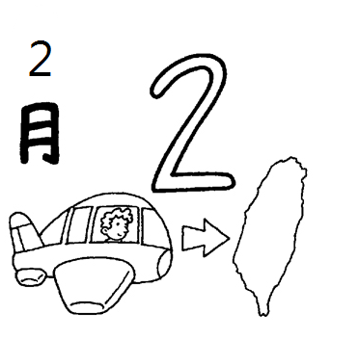 (B)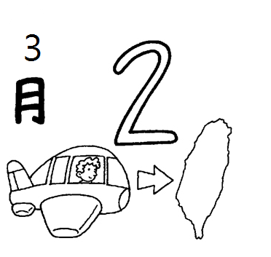 (C)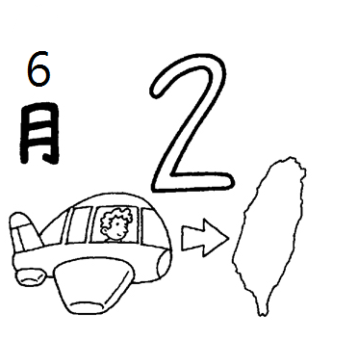
4.（ ）(A)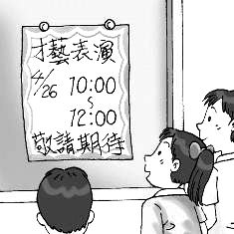 (B)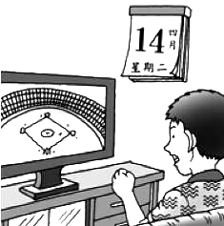 (C)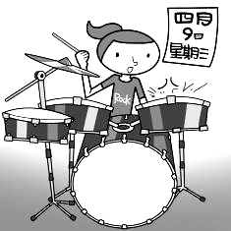
5.（ ）(A)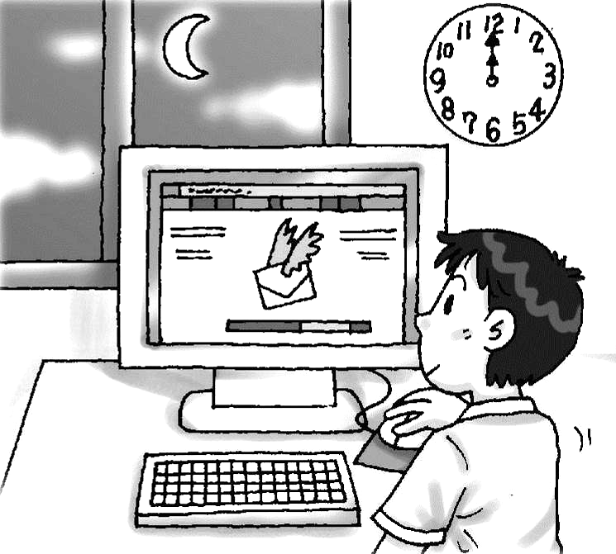 (B)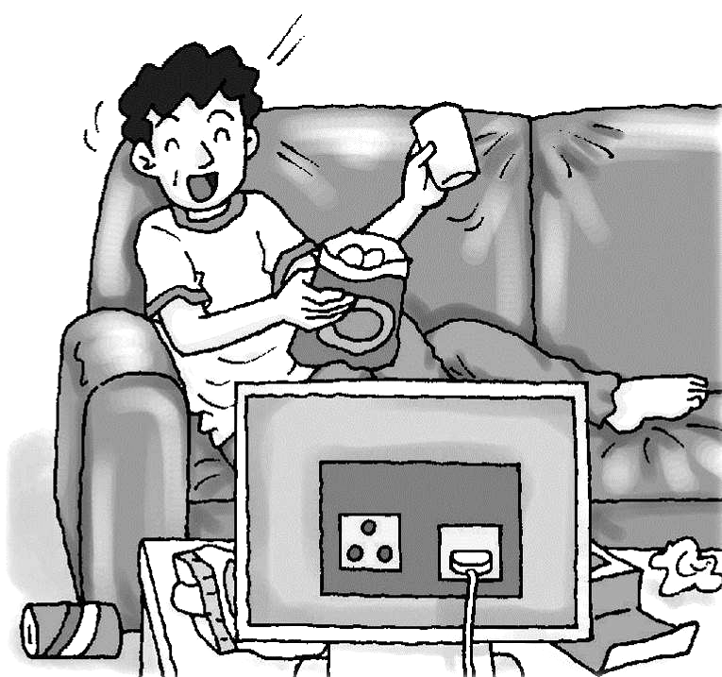 (C)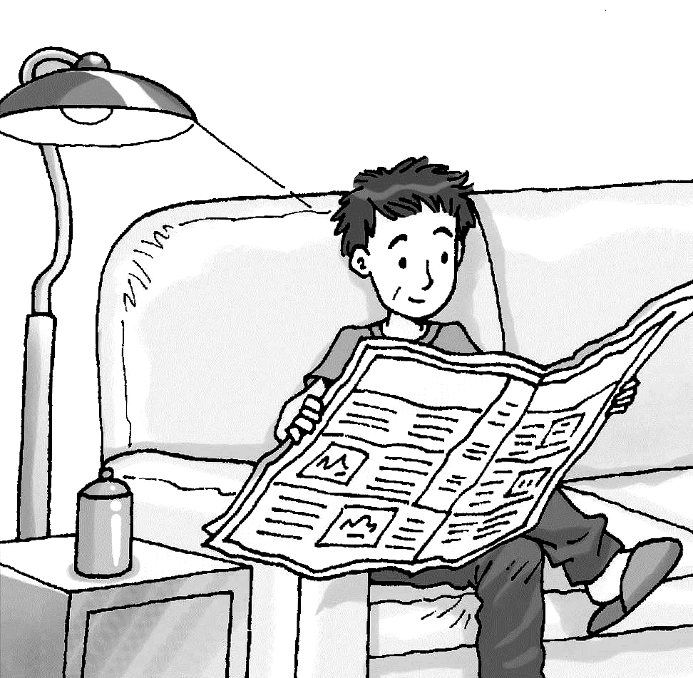

二、基本問答：每題均有三個選項，請依據所聽到的內容，選出一個最適合的回應。（每題2分，共10分）
6.（ ）(A) She practices English on Thursdays.
(B) She isn’t good at English.
(C) She practices baseball every day.
7.（ ）(A) Sure. I’m still very busy now.
(B) Yes. I practice with the school band.
(C) No. I have a violin lesson this evening.
8.（ ）(A) It’s on the same date this year.
(B) It’s on the third Sunday of June.
(C) They don’t celebrate it with a party.
9.（ ）(A) Great! Let’s eat out. (B) Great! I have it, too. (C) All right. It’s good for our health.
10.（ ）(A) He doesn’t care about his bad grades.
(B) He plays badminton once a month.
(C) He plays badminton with his friends.

三、言談理解：每題均有三個選項，請依據所聽到的對話與問題，選出一個最適當的答案。
（每題2分，共10分）
11.（ ）(A) He practices tennis on Wednesdays.
(B) He plays tennis after school every day.
(C) He goes to the tennis club every evening.
12.（ ）(A) It’s on February ninth. (B) It’s on February twenty-ninth. (C) It’s in March.
13.（ ）(A) It’s Monday. (B) It’s March third. (C) It’s March fourth.
14.（ ）(A) At 6 a.m. (B) At 11 p.m. (C) At 9 p.m.
15.（ ）(A) Ms. Brown doesn’t care about money.
(B) Ms. Brown doesn’t really enjoy her life.
(C) Ms. Brown always has fun with her friends.

第二部分：讀寫測驗
- 單題（每題2分，共30分）
16.（ ）Sally: _______ you a happy New Year! Elsa: Thanks!
(A)Wish (B)Care (C)Stay (D)See
17.（ ）Rick: Oh…I have a toothache now. Nina: Go to a _______ first.
(A)doctor (B)dentist (C)nurse (D)vet
18.（ ）The Potter family will _______ Mr. Potter’s birthday this weekend.
(A)fix (B)say (C)understand (D)celebrate
19.（ ）Beca really misses her grandma up there, and her sister_______ does.
(A)also (B)too (C)either (D)every
20.（ ）Jay _______ playing the guitar with his friends after school.
(A)speaks (B)gives (C)enjoys (D)counts
21.（ ）A: Who has big eyes? B: Frank and Sean _______.
(A)have (B)has (C)do (D)does
22.（ ）Everything _______ great here. Don’t worry about me.
(A)am (B)is (C)are (D)be
23.（ ）A: Do you always clean your bedroom? B: No, _______.
(A)I always do (B)I do always (C)I never do (D)I do never
24.（ ）Judy _______ to bed at 11:30 at night.
(A)usually go (B)go usually (C)usually goes (D)goes usually
25.（ ）A: What days do you go swimming? B: _______ Fridays and Saturdays.
(A)At (B)On (C)In (D)Every
26.（ ）A: _______ can help me with my English homework? B: I think Sharon can help you.
(A)How (B)Who (C)What (D)Where
27.（ ）A: What time is it now? B: It is _______. The movie starts at 8 p.m. We still have an hour.
(A)7 a.m. (B)7 p.m. (C)9 a.m. (D)9 p.m.
28.（ ）Ruby: When is Christmas? Hazel: It’s on December _______. It is my favorite holiday.
(A)twenty-five (B)twenty-fifth (C)twentieth-five (D)twentieth-fifth
29.（ ）_______ comes after June. Many students love this month because of summer vacation(暑假).
(A)April (B)July (C)March (D)August
30.（ ）Lisa is nearsighted because she uses the computer and watches TV _______ 10 hours a day.
(A)make friends (B)at least (C)care about (D)in fact

- 題組（每題2分，共18分）
I.
Cindy: Is your uncle a foreigner(外國人)?
Linda: Yes, he is from France.
Cindy: Cool! Can you ___31.___ him?
Linda: He is tall and thin. And he usually wears square glasses.
Cindy: Talk about his ___32.___.
Linda: He is friendly and kind. We like him so much.
Cindy: What a great man!
Linda: No one is ___33.___. In fact, he is sometimes selfish.

31.（ ）(A)dislike (B)deserve (C)discover (D)describe
32.（ ）(A)neck (B) weight (C)percent (D) personality
33.（ ）(A)tall (B)heavy (C)handsome (D)perfect
II.

Monkey Tarzan lives in Banana Island(島嶼). He is very happy there. He loves sports, so he plays badminton with Doggy Sue every Monday. On Tuesdays, he swims with Turtle Slow. On Wednesdays, he learns street dance(街舞) at the park. After Wednesdays, he does different things. He goes to the movies with his cousins on Thursdays and Fridays. He goes to Banana Mountain and pick(摘取) bananas for his family on weekends.

34.（ ）What does Monkey Tarzan do on Wednesdays?
(A)Play chess. (B)Play badminton. (C)Swim. (D)Dance.
35.（ ）Which is true about Monkey Tarzan?
(A)He doesn’t play sports. (B)He is a big music lover.
(C)He plays badminton every day. (D)He picks food for his family two days a week.
III.
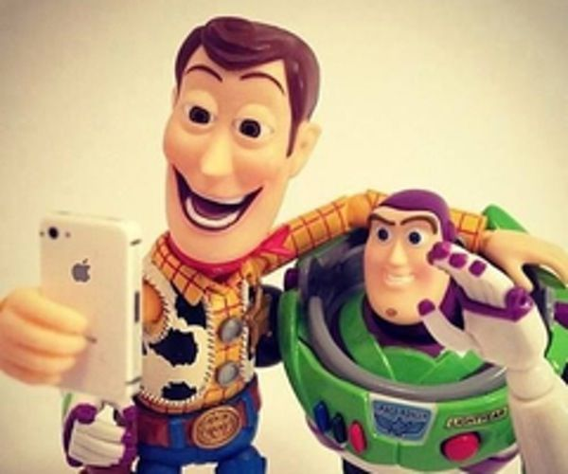
Many people like to take selfies(自拍). They use the camera on their smartphone. How do you take a good selfie? First find good light(光線). Use natural(自然的) light outside. Or use light from a window. And don’t hold the camera too close to your face. You can use a selfie stick(自拍棒). Then look at the camera and smile! Take many pictures and keep your favorite ones.

36.（ ）What do people usually use to take a selfie?
(A)A TV. (B)A watch. (C)A cellphone. (D)A computer.
37.（ ）Where can you find “good light”?
(A)Underthe bed. (B)In the drawer. (C)On the desk. (D)Next to the window.
IV.
5 Tips to Stay Healthy
1. Be happy. Always look on the bright(光明的) side and have a big smile.
2. Sleep 8 hours. Getting a good sleep can improve(改善) your memory(記憶力).
3. Drink lots of water. Drink about 3 liters(公升) of water a day can keep you healthy.
4. Brush your teeth. Remember to brush your teeth after meals every day.
5. Cut back on sugar(糖). Eat less(少的) food with much sugar in it, such as candies and coke(可樂).

38.（ ）Wendy has to get up at 7 o’clock in the morning, what time should she go to bed?
(A)11 p.m. (B)12 a.m. (C)1 a.m. (D)2 a.m.
39.（ ）If Bill wants to stay healthy, what can he do?
(A)Use the computer all night. (B)Be angry all the time.
(C)Drink 3 cups of coke every day. (D)Brush his teeth three times a day.

第三部分：寫作測驗
六、引導式翻譯（每題2分，共16分）
1. Ethan和Eric每週五練習彈鋼琴。Steven and James ___________ playing the piano on Fridays.
2. 讓我們來選個聖誕禮物給阿公吧！Let’s ___________ a Christmas gift for Grandpa!
3. 也許你可以打給Luna請她幫忙。___________ you can call Luna for help.
4. 你這個週末有空嗎？Are you ___________ this weekend?
5. 加拿大的父親節在六月的第三個週日。Father’s Day in Canada is on the ___________ Sunday of June.
6. 教師節在九月二十八日。Teacher’s Day is on ___________ twenty-eighth.
7. Daniel沒有足夠的錢買新車。Daniel doesn’t have ___________ money to buy a new car.
8. Andy很少上學遲到。Andy is ___________ late for school.

七、依提示作答（每題3分，共6分）
1. 今天幾月幾日？（翻譯）
＿＿＿＿＿＿＿＿＿＿＿＿＿＿＿＿＿＿＿＿＿＿＿＿＿＿＿＿＿＿＿＿＿＿＿
2. How often do your brothers go swimming? （用「一個月四次」回答）
＿＿＿＿＿＿＿＿＿＿＿＿＿＿＿＿＿＿＿＿＿＿＿＿＿＿＿＿＿＿＿＿＿＿＿

＃＃＃第一部分和第二部分請用2B鉛筆畫卡，第三部分請用藍筆或黑筆書寫於答案卷上＃＃＃

