桃園市立 107學年第二學期 觀音國中八年級第二次段考英語科卷
八年____班 座號：_____ 姓名：__________

此份考卷無劃卡，請將所有答案填入作答卷中，考試完畢請交出作答卷。

- 聽力測驗：每題2分，共10題20分
- 辨識句意：根據聽到的內容，選出符合描述的圖片或符合圖片的描述。
- （ ）
(Ａ) | (Ｂ) | (Ｃ)
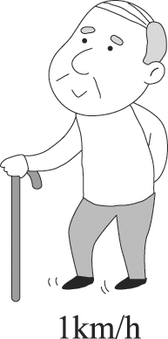 | 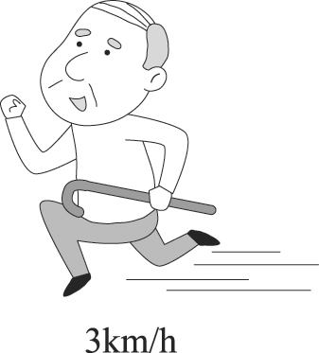 | 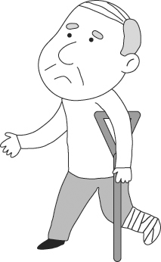
- （ ）
(Ａ) 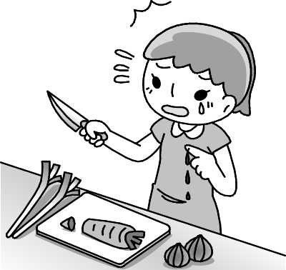 | (Ｂ) 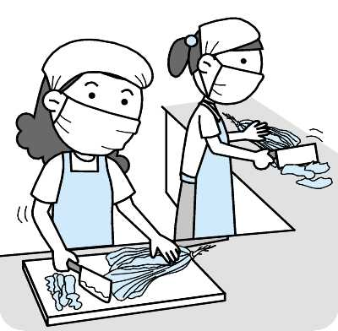 | (Ｃ) 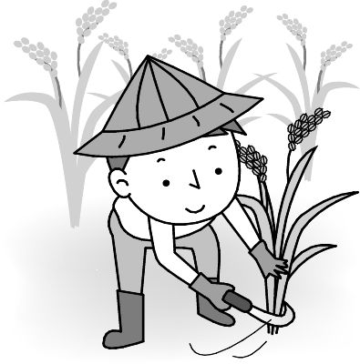
- （ ）
(Ａ) 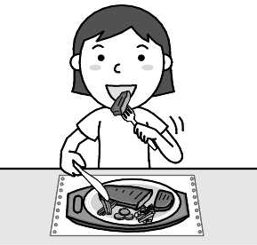 | (Ｂ) 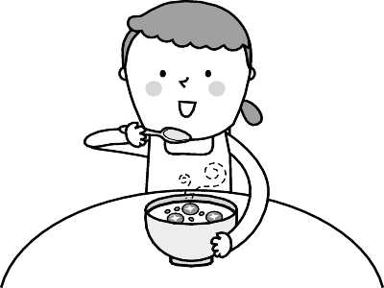 | (Ｃ) 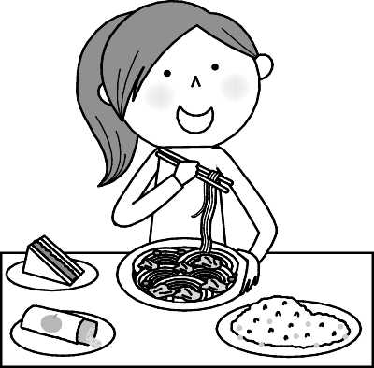
- （ ）
(Ａ) 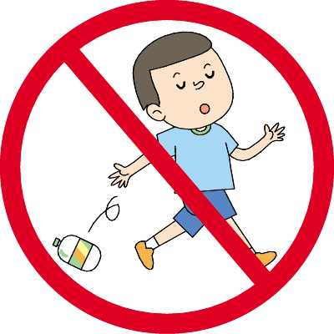 | (Ｂ) 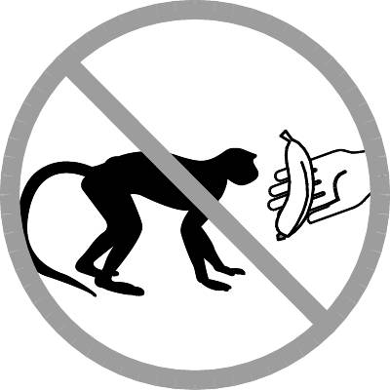 | (Ｃ) 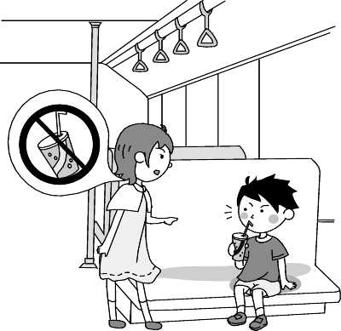
- （ ）
(Ａ) 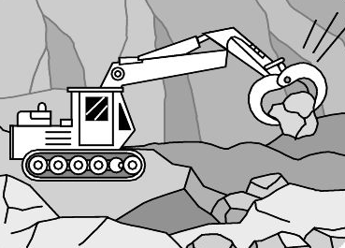 | (Ｂ) 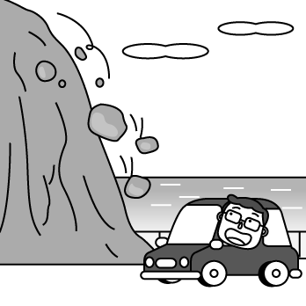 | (Ｃ) 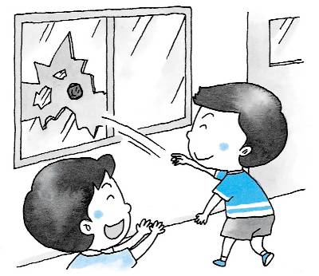

(二)言談理解：根據聽到的內容，選出一個最適合的答案。
- （ ）
(Ａ) He couldn’t play baseball well.
(Ｂ) He couldn’t find a good doctor.
(Ｃ) He hurt his shoulder.

- （ ）
(Ａ) She has to take care of her grandpa.
(Ｂ) Her parents can’t come on sports day.
(Ｃ) She can’t join the relay race.
- （ ）
(Ａ) Loving her pet.
(Ｂ) Saving the world.
(Ｃ) Helping street animals.
- （ ）
(Ａ) They can hear waves hitting rocks.
(Ｂ) They can watch the sun going down.
(Ｃ) They can feel the rocks rolling down.
- （ ）
(Ａ) Yes, she does.
(Ｂ) No, she doesn’t.
(Ｃ) We are not sure.

-聽力結束，請繼續作答-
____________________________________________________________________________________________

二、語法測驗：每題2分，共15題30分
( )1. Cindy woke up ________ this morning.
(A)fastly (B)early (C)hardly (D)lately
( )2. All cars ________ ________ left there.
(A)must;turns (B) should;turns (C)should;turn (D) must;turned
( )3. Tom was so excited（興奮的）and jumped ________ on the bed.
(A)high (B)highly (C)happy (D)higher
( )4. My mother had me ________ the trash.
(A)to sort (B) sorted (C)sort (D) sorting
( )5. Emily sings ________. She is a great singer.
(A)better (B)well (C)best (D)good
( )6. The kangaroo moves ________ than the lion.
(A)slow (B)slower (C)slowly (D)more slowly
( )7. Jamie won the game ________.
(A)luckily (B)much lucky (C)more luckily (D)lucky
( )8. The girl from Class 603 ran ________ in the races.
(A)quick (B)quicker (C)fastly (D)fast
( )9. Every morning I can hear birds ________.
(A)singing (B)sung (C)sang (D)to sing
( )10. A: ______ can we get to the theater?
B: Let’s ask the taxi driver.
(A)How (B)Who (C)What (D)Where
( )11. Your friends went to Ocean Park by ________ yesterday.
(A)themselves (B)youself (C)ourselves (D)himself
( )12. On summer nights, we can see a lot of ________ in the sky.
(A)chances (B)oceans (C)stars (D)boats
( )13. Being close to ________ is good for children.
(A)sight (B)nature (C)island (D)mountain
( )14. Jason ran too ________, so he lost the important race.
(A)early (B)slowly (C)deeply (D)quickly
( )15. The boys changed their clothes ________ and ran to the sports field（體育場）.
(A)deeply (B)slowly (C)quickly (D)suddenly

三、填入英語單字/片語測驗：每題2分，共12題24分

1.綠島 | 2.行動 | 3.地球 | 4.減少 | 5.跑者 | 6.小心的
7.承諾 | 8.溫泉 | 9.玩得愉快 | 10.能夠 | 11.運動會 | 12.也不
 |  | e o | ____ ____ ____

四、依提示作答：每題3分，共2題6分
- Emma finished her homework first.（加入quickly改寫句子）
__________________________________________________________________________________
- They talked in the living room last night.
They were noisy.（合併句子）
__________________________________________________________________________________

五、閱讀測驗：每題2分，共10題20分
- Here is a map of Taipei City. Look at the map and answer the questions.
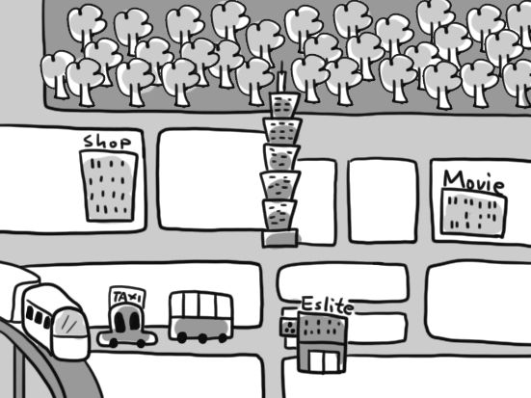
( ) (１) Which CAN’T Joe take to Taipei 101?
(A) An airplane.
(B) A bus.
(C) A taxi.
(D) The MRT.
( ) (２) If Bill wants to see the movie, where can he see it?
(A) At C.
(B) At B.
(C) At A.
(D) At D.
( ) (３) How far（遠）is the department store from Taipei 101?
(A) It is one block.
(B) It is two blocks.
(C) It is three blocks.
(D) It is four blocks.
( ) (４) What CAN’T we find in this map?
(A) Eslite Bookstore.
(B) A post office.
(C) A shop.
(D) A movie theater.
( ) (５) Which of the following is NOT true?
(A) We can go shopping at D.
(B) We have to go south for three blocks to find a bookstore.
(C) We can exercise near Taipei 101.
(D) Taking an airplane is the best way to get to Taipei 101.
- Long time ago, there lived a girl, Little Red Riding Hood, in the forest . One day, Little Red Riding Hood’s mom asked her to visit her sick grandma.
However, a big bad wolf came to her grandma’s house earlier than her. He ate her grandma and lied in bed comfortably. When Little Red Riding Hood arrived, she noticed that her grandmother looked very strange. She said, “What a deep voice you have!” “The better to greet you happily”, answered the wolf. “Goodness , what big eyes you have!” “The better to see you clearly”, said the wolf. He moved closer to her gently without making her aware of it. And “what big hands you have!” “The better to hug you tightly”, answered the wolf. And finally, “What a big mouth you have!” “The better to eat you quickly!”, answered the wolf. Suddenly , he jumped high, ate her hungrily, and then fell asleep deeply.
A hunter just came across. He cut open the sleeping wolf quickly and found Little Red Riding Hood and her grandmother were still inside. Then they filled the wolf’s body with heavy stones. The wolf woke up and tried to run away hard, but he fell into the water and died.
Forest/森林deep/深沉的voice/聲音Goodness/天啊greet/問候aware of/察覺
Hug/擁抱tightly/緊地Suddenly/突然地fell asleep/睡著hunter/獵人body/軀體died/死亡
( ) (１) Which is right about the reading?
(A) 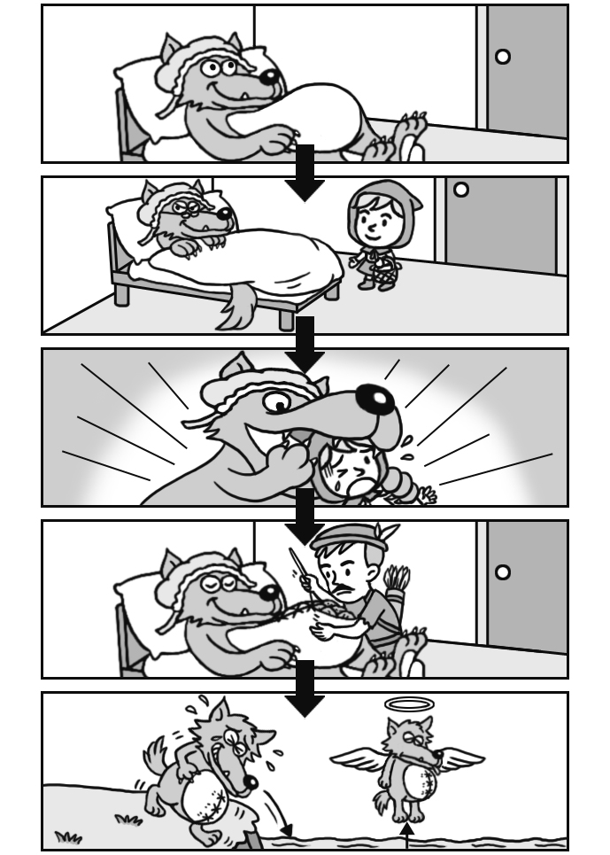 (B) 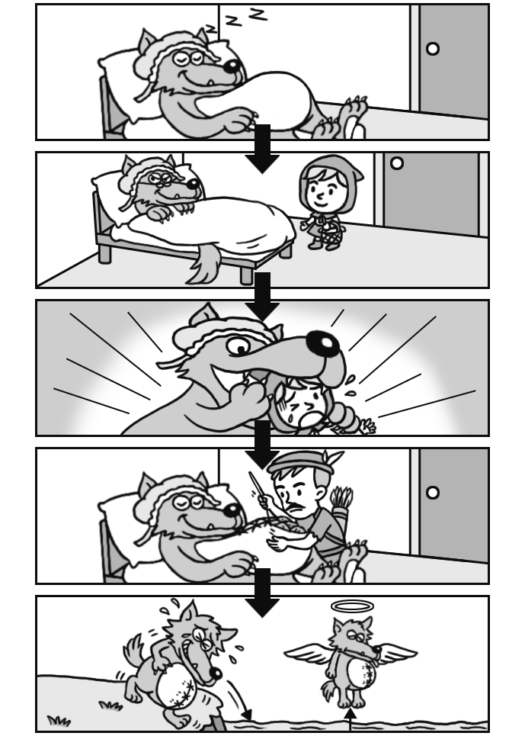
(C) 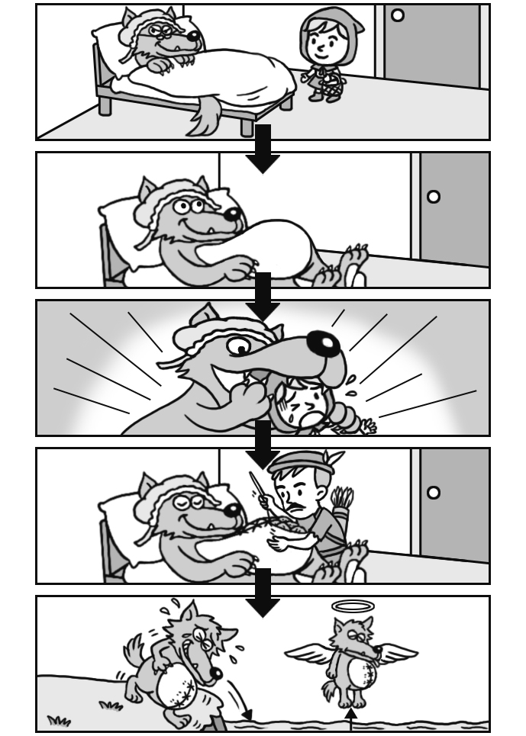 (D) 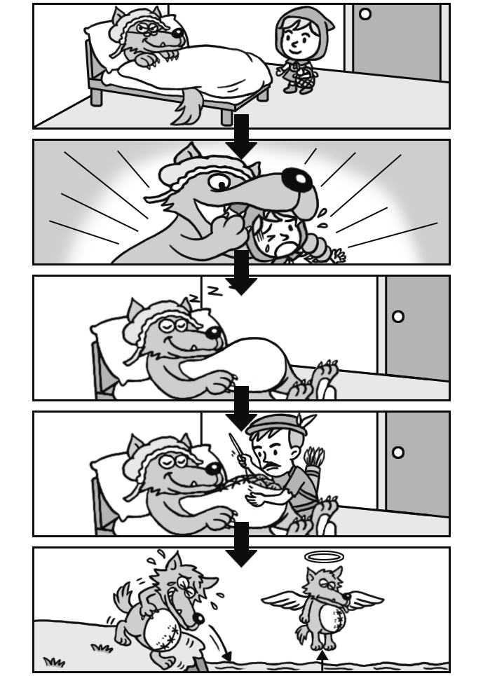
( ) (２) Which word may gently close to?
(A) Loudly.
(B) Hungrily.
(C) Hard.
(D) Lightly.
( ) (３) What is the main idea of the reading?
(A) We should eat slowly.
(B) We should trust（信任）people.
(C) We should stay alert（警覺的）.
(D) We should sleep shortly.
- A good breakfast is important. Before breakfast, we didn’t eat anything for about ten to twelve hours. Our bodies need food for a day’s work. A healthy breakfast should be rice or bread, an egg, milk, and fruit. A hot drink is necessary. To enjoy the first and most important meal, you had better get up early. A good breakfast can help you work better, study well, and even play more happily. Every day will be a good day after you have a relaxing and healthy breakfast.
( ) (１) Why does the writer suggest（建議）us to get up early?
(A) We can make breakfast by ourselves.
(B) We can take our time enjoying our breakfast.
(C) It’s better to eat breakfast earlier.
(D) It’s better to have breakfast long after we get up.
( ) (２) According to（根據）the reading, what ISN’T the good thing of having a good breakfast?
(A) We can study well.
(B) We can work better.
(C) We can sleep well.
(D) We can have more fun. (-試題結束，請仔細檢查-)

