桃園市立觀音國民中學107學年度第2學期 第三次定期考 七年級英語科題目卷
班級：________座號：________姓名：________
第一部分：聽力測驗
一、辨識句意：每題均有三張圖片，請依據所聽到的句子，選出符合描述的圖片。（每題2分，共10分）
1.（ ）(A) (B) (C)
2.（ ）(A)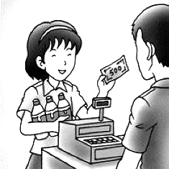 (B)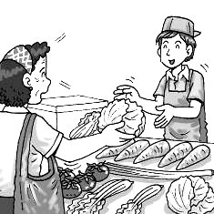 (C)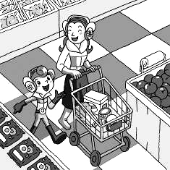
3.（ ）(A)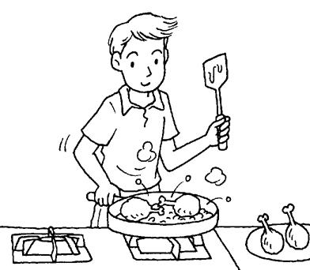 (B)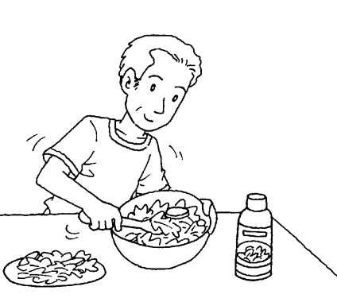 (C)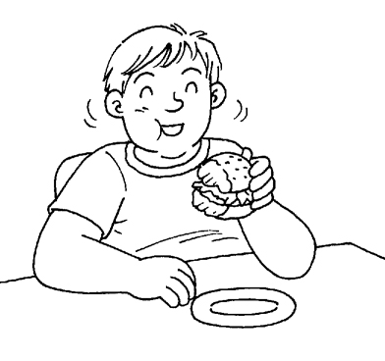
4.（ ）(A)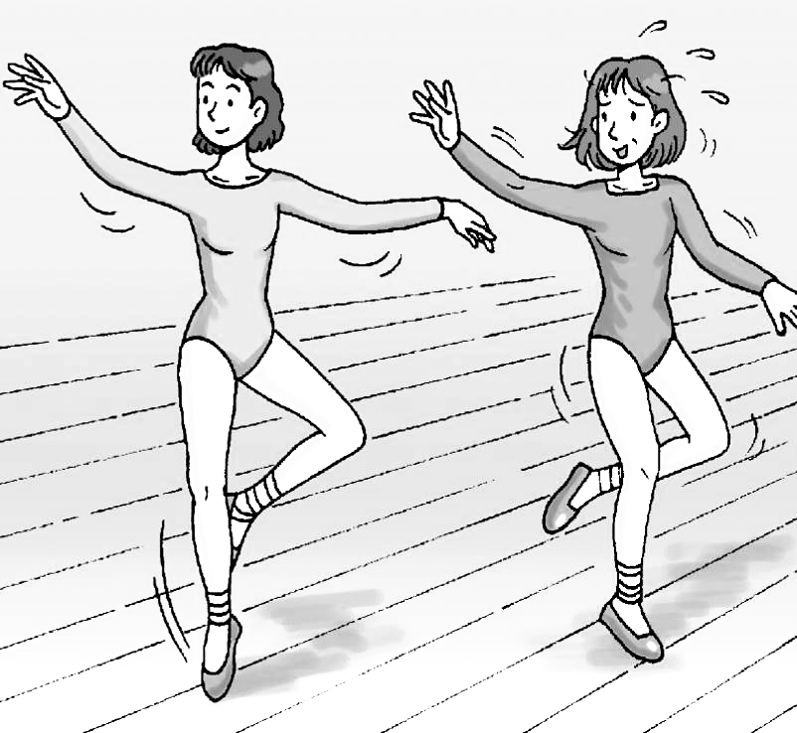 (B)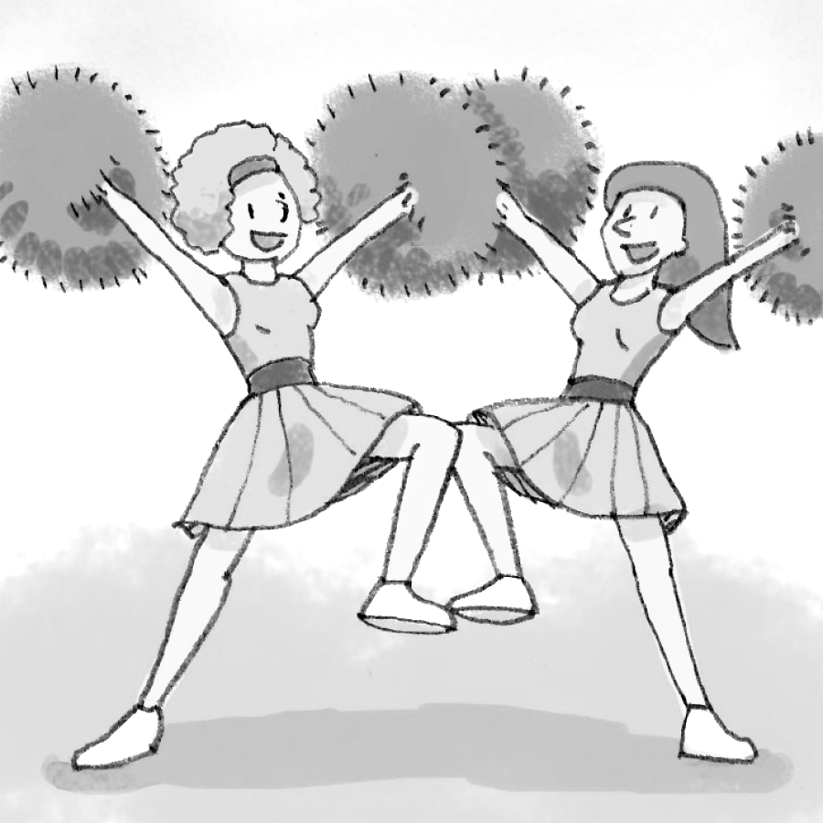 (C)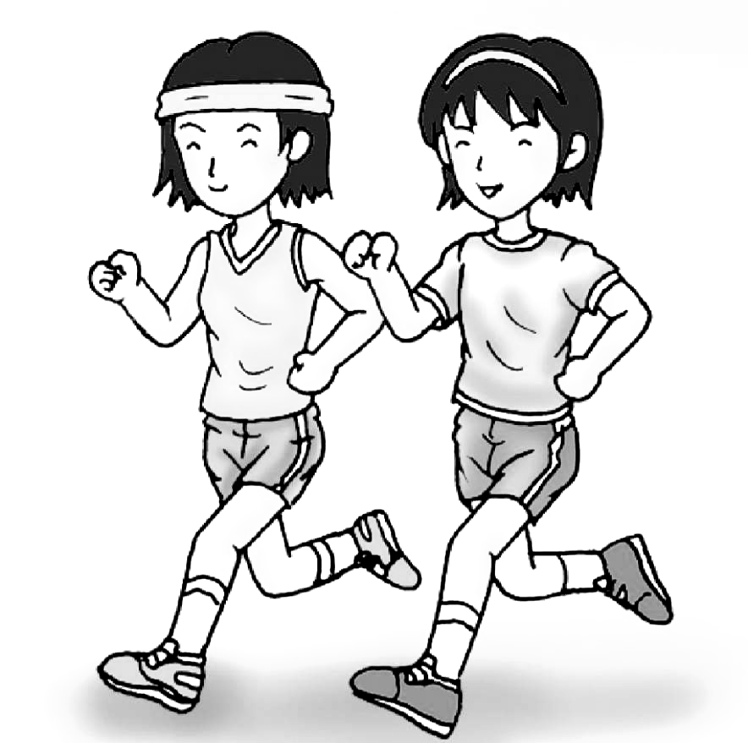
5.（ ）(A) (B) (C)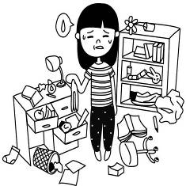
二、基本問答：每題均有三個選項，請依據所聽到的內容，選出一個最適合的回應。（每題2分，共10分）
6.（ ）(A) Only 49 dollars. (B) It’s not a large bag. (C) One is enough. Thanks.
7.（ ）(A) Yes, I need two boxes of peaches. (B) No, thanks. I’m on a diet. (C) No, chocolate cakes are yummy.
8.（ ）(A) OK. I have some peaches.(B) Yes. Let’s add a spoon of salt.(C) All right. We can cut the lettuce then.
9.（ ）(A) He was at the school library. (B) No, he was on the sports field. (C) He wasn’t in the game.
10.（ ）(A) Well, I still don’t remember him.
(B) You bet. He was short and chubby before.
(C) No wonder. He can always be a sweet person.
三、言談理解：每題均有三個選項，請依據所聽到的對話與問題，選出一個最適當的答案。
（每題2分，共10分）
11.（ ）(A) The people in Tainan are nice. (B) The food in Tainan is delicious. (C) The life in Tainan is fun.
12.（ ）(A) She doesn’t want any food. (B) She wants beef noodles. (C) She wants beef rice.
13.（ ）(A) Five. (B) Three. (C) Eight.
14.（ ）(A) A bowl. (B) Two pounds. (C) Three kilograms.
15.（ ）(A) It is wide and clean. (B) She lives there on the weekend. (C) There are many different stores there.
第二部分：讀寫測驗
- 單題（每題2分，共40分）
16.（ ）Please be quiet in the _______.
(A)playground (B)sports field (C)restroom (D)library
17.（ ）Jenny is the captain of the school team _______.
(A)X (B)last week (C)at that time (D) ten years ago
18.（ ）A lot of people come to Tainan _______ the delicious food.
(A)at (B)on (C)for (D)with
19.（ ）Let’s follow the _______ on the recipe(食譜) and make our own cheese cake.
(A)sports (B)steps (C)streets (D)spoons
20.（ ）Don’t eat too much junk food. It is not _______ for you.
(A)yummy (B)dirty (C)chubby (D)healthy
21.（ ）My coffee is not sweet enough. Could you please add some _______ to it?
(A)spoon (B)plate (C)salt (D)sugar
22.（ ）Jerry: _______ subject do you like, Chinese or English? Sean: I like Chinese.
(A)When (B)Where (C)What (D)Which
23.（ ）The cellphone was really new two years _______, but is is old now.
(A)ago (B)before (C)after (D)then
24.（ ）Cindy: _______ is the fried chicken? Lind: 50 NT dollars.
(A)How often (B)How much (C)How long (D)How many
25.（ ）The _______ is heavy on Fridays and Saturdays because there is a night market here.
(A)body (B)team (C)store (D)traffic
26.（ ）Frank: Do we still have milk at home? Dora: No, there isn’t _______ milk at home.
(A)no (B)any (C)some (D)many
27.（ ）Love River is not clean _______. There is a lot of trash in the river.
(A)anyone (B)anybody (C)anything (D)anymore
28.（ ）Andy: Do you want some ice cream? Eric: No, I am _______. I can’t eat anymore now.
(A)full (B)fine (C)fresh (D)fair
29.（ ）Ruby: How many _______ are there in the kitchen? Jason: There are three.
(A)coffee (B)meat (C)salt (D)peaches
30.（ ）Sharon was very beautiful, and she _______ very beautiful now.
(A)am (B)is (C)are (D)were
31.（ ）Most people in India(印度) don’t eat _______ because cows are sacred(神聖的) there.
(A)fish (B)pork (C)beef (D)chicken
32.（ ）Alice is a popular dancer in Canada. _______, she doesn’t dance very well.
(A)However (B)Of course (C) Why not (D)For example
33.（ ）Katy: What do you need, Mom? Gina: I need _______. Thanks!
(A)two water (B)two bottles water (C) two bottle of water (D) two bottles of water
34.（ ）Hazel: I would like to have two cups of papaya milk and a cup of tomato juice. Waiter: _______
(A)What’s up? (B)Too bad. (C)Anything else? (D)How much?
35.（ ）James: Were you a salesman five years ago? Luna: _______
(A)Yes, you were. (B)No, she wasn’t. (C)Yes, I was. (D)No, you weren’t.
- 題組（每題2分，共30分）
I.
Bunny goes on a picnic with Kitty and Puppy on Sunday afternoon. In the park, they sit under a big tree and enjoy their afternoon tea. Bunny brings three hot dogs. Kitty shares fresh fruit with everyone. They have apples, oranges and tomatoes. Puppy brings some chocolate and three bottles of green tea, They have a great time together.

36.（ ）How many hot dogs does Bunny bring?
(A)One. (B)Two. (C)Three. (D)Four.
37.（ ）Which is true?
(A)Kitty brings some green tea. (B)Puppy bakes a big chocolate pie.
(C)Bunny shares some fresh friut. (D)They have a picnic in the park.
II.
Some people like bad weather. They enjoy watching storms. They like to see the lightning and hear the ___38___. Typhoons are powerful storms. They often bring much rain and strong winds when they hit. There may be floods, too. Where do typhoons come from? Typhoons form over the ocean. Super typhoons are so powerful that they can be seen from ___39___! Also, typhoon season is usually from June to October in Taiwan. People should ___40___ extra food and water.

38.（ ）(A)thunder (B)soccer (C)pasta (D)disease
39.（ ）(A)trouble (B)square (C)speed (D)space
40.（ ）(A)discover (B)catch (C)reach (D)prepare
III.
Mina: Dear, can you help me buy some food for lunch on your way home?
Willy: Sure, what do you need?
Mina: I need one lettuce, two tomatoes, one pound of beef, two bottles of milk, two bags of dumplings
and ten eggs.
Willy: OK! How about some friut?
Mina: Great! Let’s have some apples and guavas.
Willy: Oops! My wallet is on the table at home.
Mina: Fine! I will go to Steven’s by myself later.

41.（ ）What is “Steven’s”?
(A)A library. (B)An ice cream stand. (C)A supermarket. (D)A flower shop.
42.（ ）What time may Willy buy the food?
(A)At 4:00 a.m. (B)At 11:00 a.m. (C)At 5:00 p.m. (D)At 9:00 p.m.
IV. Here are four breakfast shops.
Big Brother’s | Chicken pizza | NT$100 | Chicken sandwich | NT$65
Big Brother’s | Milk tea | NT$30 | Hot coffee | NT$55
Granny’s | Rice ball | NT$35 | Fried dumpling | NT$50
Granny’s | Soy milk | NT$20 | Orange juice | NT$30
Momo’s | Fruit pie | NT$90 | Pumpkin pie | NT$60
Momo’s | Fruit pizza | NT$100 | Salad | NT$30
Yummy’s | Cola | NT$20 | Milk shake | NT$70
Yummy’s | Green tea | NT$25 | Chocolate milk | NT$50

43.（Ｃ）How much are two rice balls at Granny’s?
(A)NT$35. (B)NT$60. (C)NT$70. (D)NT$105.
44.（Ｃ）Mia has eighty dollars. She wants pie or pizza for lunch. What can she get from the four breakfast shops?
(A)Fruit pie. (B)Fruit pizza. (C)Pumpkin pie. (D)Chicken pizza.
45.（Ｄ）Belle has one hundred and twenty dollars. How much drink can she get from the shops?
(A)Five glasses of cola and a cup of green tea. (B)A glass of milk shake and a cup of chocolate milk.
(C)Four cups of soy milk and two glasses of juice. (D)Two cups of milk tea and two cups of hot coffee.
V.
Eighty years ago, Mr. Wang was young and poor then. However, he was an excellent businessman. A lot of people shopped at his store. He was busy every day in the store.
Now Mr. Wang is successful. He has a lot of money and stores. However, he still understands poor people. He is nice to them and gives them money and food. Mr. Wang is not young anymore, but he is a popular person in town.

46.（ ）What is a good title for the reading?
(A)Poor Mr. Wang (B)The Poor Businessman
(C)The Magic of Money (D)The Popular Businessman in Town
47.（ ）Which is right?
(A)Mr. Wang is old and poor. (B)Mr. Wang is never popular in town.
(C)Mr. Wang wasn’t nice to poor people. (D)Mr. Wang is a friend of poor people.
48.（ ）Why is Mr. Wang “successful”?
(A)He is young and poor. (B)He is poor but handsome.
(C)He is popular with poor people. (D)He has a lot of money and stores.
VI.

Making goulash
we don’t talk much,
Daddy and me.

“The talking’s in the making, son.”
He smiles.
I see what he means.

It’s in the knife
meeting the beef,

in the dancing of potatoes
as they turn in the water,
in the singing
of boiling soup in the pot.

There are enough words
in the way
Daddy teaches me his famous dish
and the way he hugs me
when we finish.

Making goulash
we don’t talk much,
Daddy and me,

but everything is said.

(Ideas from Candace Pearson’s poem)

49.（ ）What are “Daddy and me” doing in the poem?
(A)Eating. (B)Singing.
(C)Dancing. (D)Cooking.
50.（ ）What can we most likely know about the
speaker?
(A)He seldom understands his father. (B)He enjoys his time with his father.
(C)He often makes goulash for his father. (D)He wants to be as famous as his father.

