**★請將答案畫記於答案卡上**

辨識句意：根據聽到的內容，選出符合描述的圖片或符合圖片的描述(4題，一題3分，共12分)

1. ( )

|  |  |  |
| --- | --- | --- |
| (Ａ) | (Ｂ) | (Ｃ) |
| 4-17時鐘，時鐘顯示11點15 | 4-18時鐘，時鐘顯示10點15 | 4-19時鐘，時鐘顯示10點45 |

1. ( )

|  |
| --- |
| 4-10(吃掉半個蛋糕) |

1. ( )

|  |  |  |
| --- | --- | --- |
| (Ａ) | (Ｂ) | (Ｃ) |
| 5-27在工廠當作業員 | 5-28在郵局裡整理信件 | artpreview |

1. ( )

|  |
| --- |
| 6-11 |

基本問答：根據聽到的內容，選出一個最適合的回應或最適合的問句(3題，一題3分，共9分)

1. ( )  
   (Ａ)　It’s ten after nine in the morning.  
   (Ｂ)　I woke up last night.  
   (Ｃ)　I was cleaning the mat this morning.
2. ( )  
   (Ａ)　I study in Taipei.  
   (Ｂ)　I want to be a youtuber.

(Ｃ)　I love to dance.

1. ( )  
   (Ａ)　It’s ok. I will do it later.  
   (Ｂ)　No, I feel so bad. I have a cough and a headache.  
   (Ｃ)　No. Don’t worry about me. I have a high fever.

言談理解：根據聽到的內容，選出一個最適合的答案

**(3題，一題3分，共9分)**

1. ( )  
   (Ａ)　It’s 6:10.  
   (Ｂ)　It’s 7:50.  
   (Ｃ)　It’s 10:06.

1

1. ( )  
   (Ａ)　He wants to be a cook.  
   (Ｂ)　He likes cooking very much.  
   (Ｃ)　He can’t cook because it’s hard.
2. ( )  
    (Ａ)　She has a toothache.  
    (Ｂ)　She has a sore throat.  
    (Ｃ)　She has a stomachache.

**四、文意選擇(10題，一題2分，共20分)**

( )11. Let’s watch the _____ from security camera to find

out who broke into(闖入) our house.

1. dream
2. picture
3. video
4. window

( )12. Bees make _____, and it is sweet and yummy.

1. clothes
2. friends
3. honey
4. sound

( )13. A: Is it _____ to ten?

B: Yes, it’s 9:45 now.

1. half
2. fifty
3. a day
4. a quarter

( )14. Our school baseball _____ won the game. All the

students were happy for them.

1. caps
2. team
3. shape
4. company

( )15. The _____ stopped Cindy because she was driving

too fast(快).

1. actress
2. mailman
3. fisherman
4. police officer

( )16. A: I have _____ tomorrow.

B: Good luck!(祝你好運)

You will(將會) get the job.

1. a picnic
2. a question
3. an e-mail
4. an interview

( )17. Eddie has a _____, so the doctor told him to wear

a mask.

1. fever
2. cough
3. headache
4. stomachache

( )18. A: I go exercising four times a week.

B: Wow! That’s a healthy _____.

1. body
2. habit
3. pose
4. rest

( )19. Jessie is studying in her room because

she has a/an _____ test tomorrow.

1. sick
2. cheap
3. popular
4. important

( )20. Nick: I have a karaoke contest tomorrow.

I’m so nervous(緊張).

Mia: __________. Just try your best(盡力而為)!

1. Take it easy
2. Take out the trash
3. Take the medicine
4. Take me to the hospital

**五、語法選擇(10題，一題2分，共20分)**

( )21. Steve _____ the floor at 7:50 this morning.

1. mops
2. mopped
3. is mopping
4. was mopping

( )22. Nancy was doing the dishes _____.

1. then
2. yesterday
3. now
4. tomorrow

( )23. A: Is it 6:30?

B: Yes, it’s half _____ six.

1. at
2. to
3. after

2

1. before

( )24. Grandma is good at _____. She makes dinner for us

every day.

1. cook
2. cooked
3. to cook
4. cooking

( )25. Brian _____ playing basketball after school.

1. wants
2. needs
3. plans
4. enjoys

( )26. Wayne couldn’t find his key, so he kept _____ for it

the whole afternoon.

1. looks
2. looked
3. to look
4. looking

( )27. Cathy loves _____ in the library.

Her favorite writer is J.K. Rowling.

1. read
2. reads
3. to read
4. to reading

( )28. It is fun _____ volley ball with friends.

1. play
2. played
3. to play
4. playing

( )29. Playing sports at least three times a week _____ good

for your health.

★at least至少

1. is
2. are
3. has
4. have

( )30. Linda: Jenny, will you still be here this afternoon?

Jenny: Yes, I will stay _____ five o’clock.

★will將會

(A) at

(B) for

(C) from

(D) until

試題尚未結束，請繼續作答

**六、閱讀測驗(10題，一題3分，共30分)**

***Part1.***

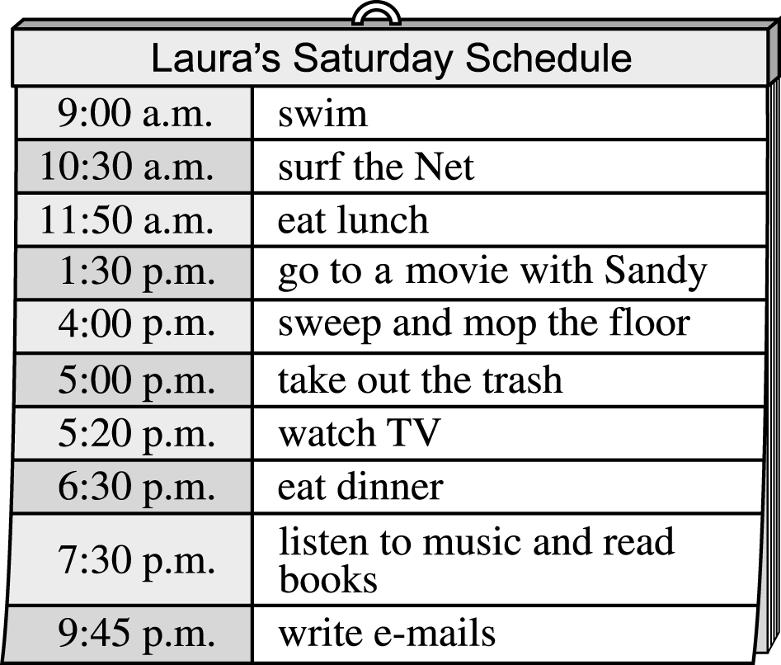



( )31. What was Laura doing when（當）she was listening to

music?

(Ａ)　She was reading books.

(Ｂ)　She was watching TV.

(Ｃ)　She was surfing the Net.

(Ｄ)　She was writing e-mails.

( )32.　What was Laura doing at ten past six?

(Ａ)　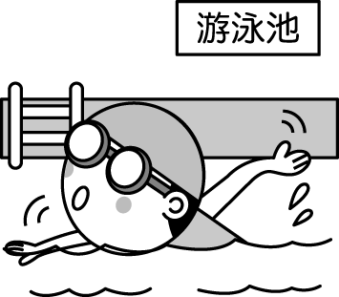　(Ｂ)　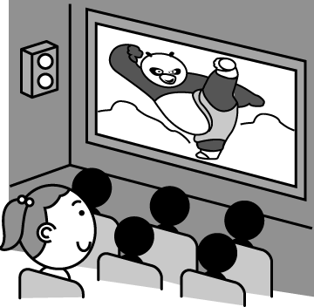

(Ｃ)　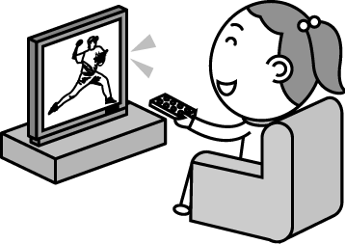　(Ｄ)　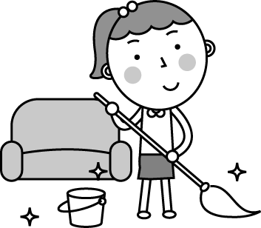

( )33. How long did Laura sweep and mop the floor?

(Ａ)　For two hours.

(Ｂ)　For one hour.

(Ｃ)　For half an hour.

(Ｄ)　For one and half an hour.

3

***Part2.***

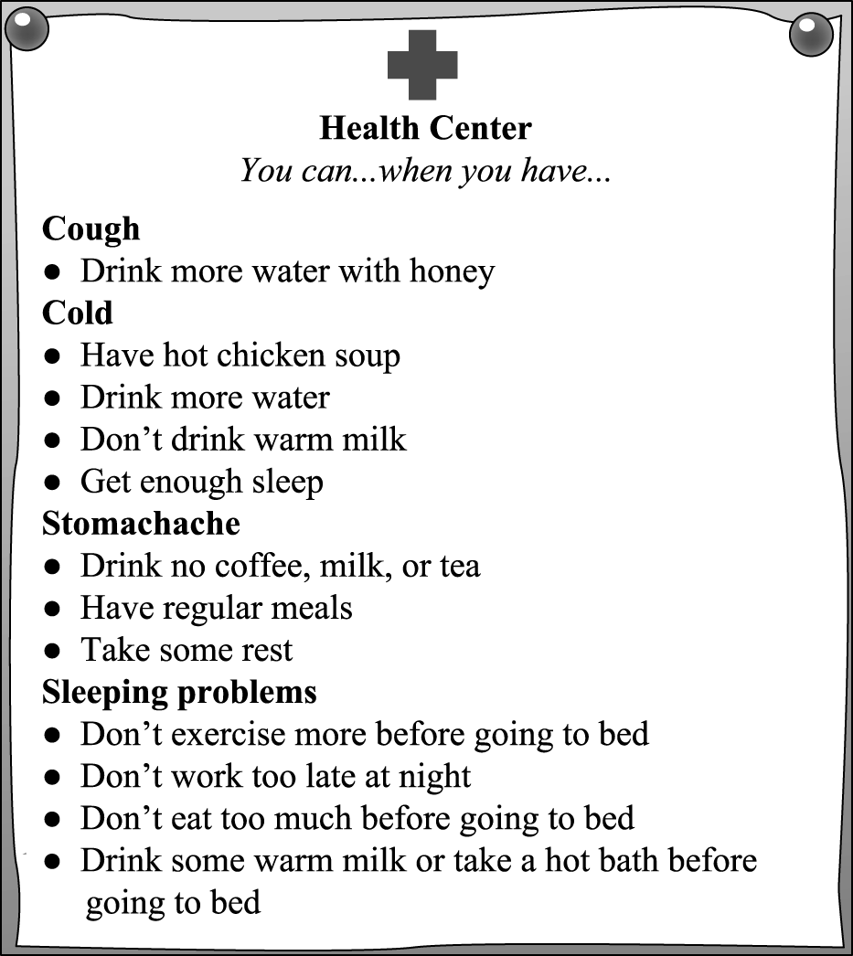

( )34. What can you do if you have sleeping problems?

★if如果

　 (Ａ)　Exercise more before going to bed.

(Ｂ)　Work late at night.

(Ｃ)　Have a hamburger and cola before going to bed.　(Ｄ)　Take a hot bath before going to bed.

( )35. Who can drink some warm milk?

(Ａ)　Alice. She often has sleeping problems.

(Ｂ)　Eric. He has a bad cold.

(Ｃ)　Ian. He has a stomachache.

(Ｄ)　Bill. He has a cough.

( )36. What can you do if you have a cough?

(Ａ)　Have hot chicken soup.

(Ｂ)　Have some water with honey.

(Ｃ)　Have some coffee.

(Ｄ)　Have some black tea.

試題尚未結束，請繼續作答

***Part3.***

The following are the notes from David’s notebooks during the trip to Kiwa World. David is reading them with his classmate, Jessica in the classroom.

|  |  |
| --- | --- |
| ***Day1***  Today is April 4, Children’s Day, the first day of our trip. It’s four thirty. I’m riding a bike with my parents and my little brother Mike by the Blue River. We are singing, listening to the water and birds, and having a lot of fun. | ***Day2***  It is the second day of our trip. We plan to have a night picnic at Jingle Park, the second pick in the city. There are too many people having fun at King Park. My parents want to share their working experiences with us and talk about my future job. What do I want to be? Ha! Maybe a reporter, a teacher, or a singer. I am not sure. |
| ***Day3***  My parents are visiting their old friend, Aunt Polly, a famous writer, at her place. I am having lunch with Mike and watching a **tedious** show at Wiki Kitchen. The food is not so yummy and the show…, well, I don’t like it. I hate the third day of the trip. | ***Day4***  We’re going back home at 1:00 p.m. It’s 10:00 a.m. and we are visiting the famous Toy Museum and making toys by ourselves. We are really having a great time here! Sweet Kiwa! I love this place! |

🕮 following以下的 experience經驗 ourselves我們自己

( )37. What may “**tedious**” mean?  
(A) Wonderful. (B) Bad.  
(C) Yummy. (D) Easy.

( )38. Which is true about David’s trip to Kiwa World?  
(A) They were riding a bike in the afternoon   
 on the first day.  
(B) He was visiting a toy museum on the   
 third morning of the trip.  
(C) His parents were talking about his future   
 school during the picnic.  
(D) His brother Mike was visiting his friend   
 on the noon of the second day.

( )39. What do we learn from David’s notes?  
(A) David was very happy during the trip   
 every day.  
(B) David and Mike made toys for their   
 classmates.  
(C) They came back home on April 7.  
(D) He took a lot of pictures.

( )40. Which is the best pick for people to have a picnic at

Kiwa World?

★best最好的  
 (A) Wiki Kitchen. (B) Toy Museum.  
 (C) Jingle Park. (D) King Park.

試題結束

4