**★請將答案畫記於答案卡上**

辨識句意：根據聽到的內容，選出符合描述的圖片或符合圖片的描述。(3題，一題3分，共9分)

1. （　）

|  |  |  |
| --- | --- | --- |
| (Ａ) | (Ｂ) | (Ｃ) |
| 566951 -a | 566951 -b | 566951 -c |

1. （　）

|  |  |  |
| --- | --- | --- |
| (Ａ) | (Ｂ) | (Ｃ)  565937-C |
| 565937-A | 565937-B |  |

1. （　）

|  |  |  |
| --- | --- | --- |
| (Ａ) | (Ｂ) | (Ｃ) |
| 7-1 | 7-2 | 7-3 |

基本問答：根據聽到的內容，選出一個最適合的回應或最適合的問句。(4題，一題3分，共12分)

1. （　）  
   (Ａ)　Great. And you?  
   (Ｂ)　I was at the museum.  
   (Ｃ)　I’ve been there twice.
2. （　）  
   (Ａ)　From now on.  
   (Ｂ)　Three years later.  
   (Ｃ)　Since 1998.
3. （　）  
   (Ａ)　I need a belt because the dress is too big.  
   (Ｂ)　Oh, thank you. This dress is my size.  
   (Ｃ)　I’m not sure. Maybe size M or L.
4. （　）  
   (Ａ)　I’m crazy.  
   (Ｂ)　Yes, I do. I feel very excited.  
   (Ｃ)　I can’t help it.

言談理解：根據聽到的內容，選出一個最適合的答案。

**(3題，一題3分，共9分)**

1. （　）  
   (Ａ)　The sound of “clock” is unlucky in Chinese.  
   (Ｂ)　It’s too expensive.  
   (Ｃ)　We don’t know.
2. （　）  
   (Ａ)　The man didn’t want to hear anything from the cat.  
   (Ｂ)　The woman is sad because of the man.  
   (Ｃ)　The man’s cat died yesterday.

1

1. （　）  
    (Ａ)　The boy showed some tricks to Ms. Taylor.  
    (Ｂ)　Ms. Taylor dressed up as a ghost.  
    (Ｃ)　 Today is Halloween, not Christmas.

**四、文意選擇(10題，一題2分，共20分)**

( )11. A: Can you give me a piece of _____ to write down

the address(地址) and phone number?

B: Sure.

(A) bread

(B) cake

(C) meat

(D) paper

( )12. Tina: Honey, what did Amy give us _____ the

wedding gift?

Ted: It was a pair of paper umbrellas. How cool!

1. as
2. at
3. of
4. to

( )13. Ms. Smith is _____ at telling stories, so all of her

students enjoy story time in her class very much.

1. convenient
2. excellent
3. lucky
4. ready

( )14. In Taiwan, people _____ eighteen years old can’t ride

a motorcycle or drive a car.

1. below
2. between
3. over
4. through

( )15. A: Dad, may I surf the Net?

B: What for?

A: To find some _____ for my science report.

1. body
2. brain
3. information
4. measurement

( )16. Look at the picture.

The girl drew two _____ on the wall.

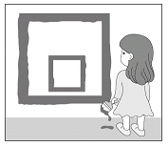

1. circles
2. lines
3. points
4. squares

( )17. _____ is on the night of October 31. It’s popular with

kids.

1. Christmas
2. Halloween
3. Moon Festival
4. New Year’s Eve

( )18. Taiwanese people celebrate(慶祝) _____

in the seventh lunar month.

1. Mother’s Day
2. Teacher’s Day
3. Ghost Festival
4. Dragon Boat Festival

( )19. Children go _____ on the night of October 31.

They ask for candies from door to door.

1. camping
2. shopping
3. swimming
4. trick-or-treating

( )20. Never _____ how much money you bring with you,

or(否則) you’ll be in danger(危險).

1. fill up
2. hear of
3. show off
4. make sense of

**五、語法選擇(10題，一題2分，共20分)**

( )21. A: _____ has Tim watched TV?

B: He has glued his eyes to the TV for two hours.

1. How old
2. How long
3. How often
4. How much

( )22. My family have lived in Taoyuan _____ ten years.

1. for
2. in
3. of
4. since

( )23. Have you got anything for Joe _____? He’d be happy

to get your gift on his birthday.

1. almost
2. either
3. soon
4. yet

( )24. Getting up early on a cold morning is not easy, ____?

1. are you
2. do you
3. does it
4. is it

( )25. Alice really likes having noodles for breakfast, ____?

1. doesn’t she
2. is she
3. hasn’t she
4. did she

2

( )26. A: Charles wanted to borrow $500 from me yesterday.

B: You didn’t lend(借出) him the money, _____?

1. will you
2. won’t you
3. did you
4. didn’t you

( )27. A: How was the party last night?

B: It was _____. I had a whale of a time.

1. bored
2. boring
3. interested
4. interesting

( )28. My father is _____ about the vacation. He has made a

plan for it.

1. excite
2. excites
3. excited
4. exciting

( )29. Lily is _____ at the news. She can’t believe that it’s

true.

1. afraid
2. bored
3. interested
4. surprised

( )30. A: Let’s go trick-or-treating!

B: No, thanks. I think _____ trick-or-treating is not

funny.

1. about
2. of
3. over
4. that

**六、閱讀測驗(10題，一題3分，共30分)**

***Part1. Look at the letter, and answer the questions below.***

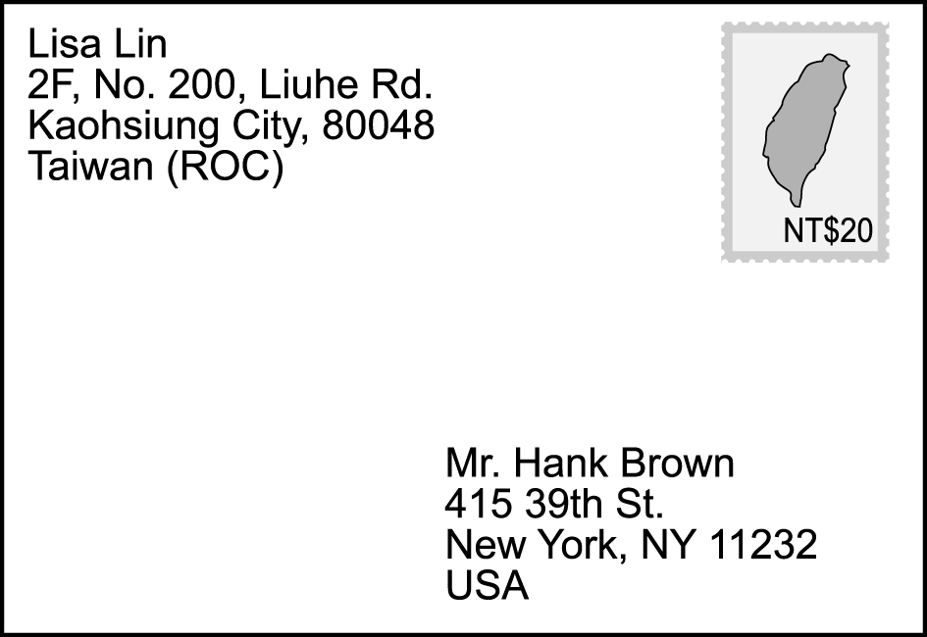

( )31. Who will receive(收到) the letter?

1. ROC
2. USA
3. Lisa Lin
4. Hank Brown

( )32. Which is **NOT** true?

1. Lisa is Hank’s sister.
2. Hank lives in New York, USA.
3. Lisa lives in Kaohsiung, Taiwan.
4. It cost twenty NT dollars to send the letter.

***Part2.***

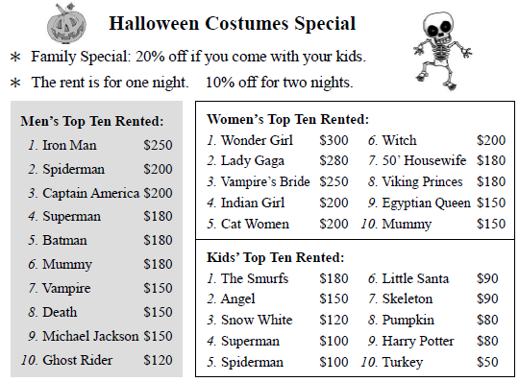

★rent租金、租借 Top Ten Rented租借戲服前十名

( )33. Mr. and Mrs. Chen and their twins(雙胞胎) come to

rent costumes. Mr. Chen wants to be Captain America.

Mrs. Chen wants to be Vampire’s Bride. The twins

want to be the Smurfs. They rent costumes for one

night. How much money do they need to pay?

(A)$810

(B)$648

(C)$630

(D)$504

( )34. Jack and Rose will have two Halloween parties this

Saturday and Sunday. Jack plans to be Superman.

Rose plans to be Wonder Girl.

How much money do they need to pay?

(A)$432

(B)$480

(C)$864

(D)$960

____________________________________________________

***Part3.***

　What do you think about Lego bricks? For most of us, they are just toys to play with. However, for some businessmen, they have helped them to make money. They will buy special Lego sets for around NT$5,000 and sell them later at high prices.  
　　The most popular Lego sets have been about movies like *Star Wars*. For example, Lego fans paid almost NT$16,000 for a *Star Wars* Millennium Falcon in 2007, but if they want it now, they will have to spend more than NT$120,000.  
　　Lego sets about daily scenes are also popular in the market. For example, when Lego started selling Café Corner in 2007, it cost more than NT$4,000. However, when the Lego factory(工廠) stopped making it several years later(數年後), its price **soared**. If you want one now, you’ll need to pay almost(幾乎) NT$100,000 in the second-hand market.  
🕮 Lego bricks樂高積木however然而set 組合

3

Millennium Falcon 千年鷹號daily scene日常場景  
（ ）35. What does the word “**soared**” mean?  
　　　　(A) Something fell slowly.  
　　　　(B) Something never grew.  
　　　　(C) Something went up quickly.  
　　　　(D) Something kept changing up and down.

（ ）36. Which is **NOT** true about Lego bricks?  
　　　　(A) They are more than toys to play with.  
　　　　(B) *Star Wars* is a popular theme(主題) for Lego sets.   
　　　　(C) The prices of special sets grow year by year.  
　　　　(D) The Lego factory stopped making *Star Wars* sets

several years ago.

（ ）37. Which chart(圖表) shows the prices of the

Millennium Falcon and Café Corner?  
　　　　(A)  
　　　　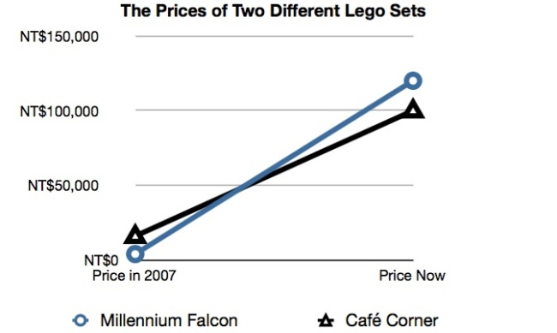  
　　　　(B)  
　　　　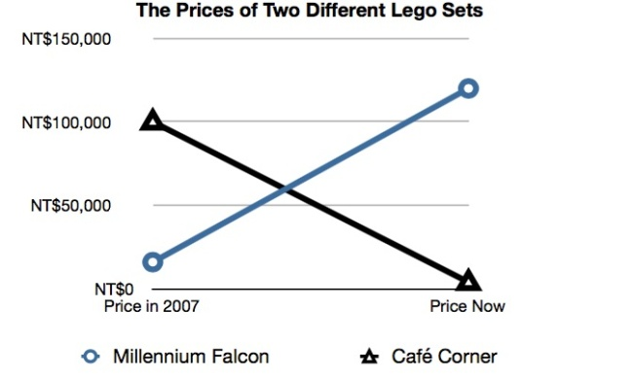  
　　　　(C)  
　　　　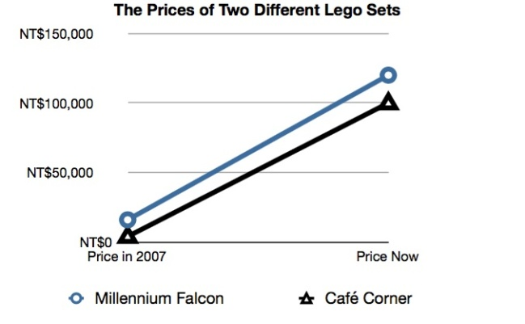  
　　　　(D)  
　　　　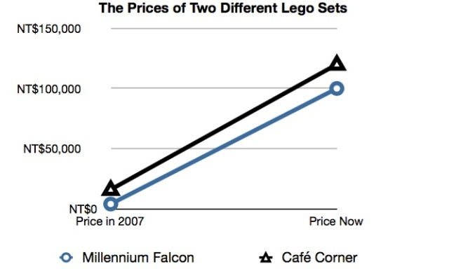

***Part4.***

Since the first case of human infection by the Zika virus in the USA, more and more Americans have become **aware** of the contagious disease. It is possible to catch Zika fever(茲卡熱病) if a sick mosquito bites you. After that happens, you may feel nothing then. However, after three to seven days, you will have a headache. If you don’t take it seriously(認真看待), you may die from the disease several days later.  
　　Zika fever has become a serious(嚴重的) problem since its outbreak in Brazil(巴西) in 2015. There, almost 1.5 million people have caught Zika fever. That means Brazil is going through a hard time now, and countries near Brazil are also facing(面對) the same problem. In Venezuela (委內瑞拉), about 4,700 people have caught Zika fever. In Honduras(宏都拉斯), fewer people have caught it than in the other two countries.

Everyone around the world should be careful when it comes to Zika fever.  
🕮 human infection人體感染Zika virus茲卡病毒

contagious disease傳染病catch得到mosquito蚊子

outbreak爆發  
（ ）38. What does “**aware**” mean?  
　　　　(A) Filling up something.   
　　　　(B) Feeling bored with something.  
　　　　(C) Having a whale of a time doing something.  
　　　　(D) Knowing or having knowledge(知識) of something.  
（ ）39. Which is **NOT** true about Zika fever?  
　　　　(A) Mosquitoes transmit(傳播) it.   
　　　　(B) It’s the most serious problem in Brazil now.  
　　　　(C) There have been no cases of it in the USA since its

outbreak in 2015.  
　　　　(D) You may not feel sick first if an inflected mosquito

bites you.

（ ）40. Which chart shows the number of Zika fever cases

in each country?  
　　　　(A)  (B)　 

3649

4700

3649

4700

4

(C)



4700

(D)



4700

4700

—試題結束—