**★請將答案畫記於答案卡上**

辨識句意 (3題，一題3分，共9分)

1. ( )

|  |  |  |
| --- | --- | --- |
| (Ａ) | (Ｂ) | (Ｃ) |
| 12A三顆球，一顆白的，兩顆黑的 | 12B三顆球，兩顆白的，一顆黑的 | 12C三顆球都是白的 |

1. ( )

|  |  |  |
| --- | --- | --- |
| (Ａ) | (Ｂ) | (Ｃ) |
| U8-3-A-看電視寫功課 | U8-3-B-看電視寫功課 | U8-3-C-看電視打掃 |

1. ( )

|  |  |  |
| --- | --- | --- |
| (Ａ) | (Ｂ) | (Ｃ) |
| U9-5-A-雍容華貴 | U9-5-B-衣衫襤褸不開心 | U9-5-C-衣衫襤褸很開心 |

基本問答 (4題，一題3分，共12分)

1. ( )  
   (Ａ) Medium, please.   
   (Ｂ) This way, please.   
   (Ｃ) Yes, I’d like the spaghetti.
2. ( )   
   (Ａ)　Medium, please.   
   (Ｂ)　At the steak house.  
   (Ｃ)　Both of them smell good.
3. ( )   
   (Ａ)　The play touched my heart.  
   (Ｂ)　I’m a giant dragon in the play.  
   (Ｃ)　Everyone stood up and clapped loudly.
4. ( )   
   (Ａ)　We went hiking last weekend.   
   (Ｂ)　We go hiking every Sunday.   
   (Ｃ)　We will go hiking together.

言談理解 (3題，一題3分，共9分)

1. ( )   
   (Ａ)　The boy is a lovely prince in the play.  
   (Ｂ)　The boy will join the club play.  
   (Ｃ)　The club play is on Sunday evening.
2. ( )   
   (Ａ)　What to do this Saturday.  
   (Ｂ)　How to surf.   
   (Ｃ)　How to climb rocks.

1

1. ( )

(Ａ)　A story.  
(Ｂ)　An animal.  
(Ｃ)　A dictionary.

**四、文意選擇 (10題，一題2分，共20分)**

( )11. When you use a _____, be careful. Don’t cut yourself.

1. fork
2. knife
3. straw
4. menu

( )12. A: Jason is good at basketball.

B: _____. His team won many games.

1. No way
2. No wonder
3. No big deal
4. No problem

( )13. A: Do you have this T-shirt in a small size?

B: No. It only comes in _____.

1. blue
2. circles
3. dozens
4. medium

( )14. For Taiwanese people, _____ bring good luck.

1. snakes
2. whales
3. dragons
4. zombies

( )15. _____ Elizabeth is popular with British people.

They respect her very much.

★British people英國人

1. Prince
2. Queen
3. Soldier
4. Waitress

( )16. A: Did you see *Train to Busan*? It is amazing!

B: Sorry, I’m not a _____ of zombie movies.

★*Train to Busan* 屍速列車(韓國電影)

1. fan
2. part
3. group
4. member

( )17. Before you hand in the test paper, _____ the answers

again.

1. fail
2. check
3. forget
4. understand

( )18. Sandy sounds happy when we talk on the phone.

I can feel joy in her _____.

1. eyes
2. mail
3. smile
4. voice

( )19. The party _____ the end of summer vacation.

Tomorrow we will go home and get ready for school.

1. saves
2. marks
3. passes
4. changes

( )20. You can get the main idea by _____ the article.

1. giving up
2. going over
3. letting out
4. working out

**五、語法選擇 (10題，一題2分，共20分)**

( )21. Jeremy Lin, _____ of NBA basketball players, is 191

centimeters tall.

1. one
2. two
3. all
4. most

( )22. I have two brothers. _____ of them are soldiers.

1. One
2. Both
3. Some
4. Many

( )23. Let’s buy some bread at *Wu Pao Chun Bakery.*

All of his bread _____ delicious.

★bakery麵包店

1. be
2. is
3. am
4. are

( )24. A: It is 17:50. The movie will start at 18:00.

B: ____ the movie starts, let’s turn off the cellphones.

(A) If

(B) Though

(C) After

(D) Before

( )25. When Tom got home, his mother _____ on the phone.

(A) was talking

(B) talks

(C) is talking

(D) will talk

2

( )26. Ken: The cheese burger is so yummy.

Ann: You can say that again.

Mom: _____ you finish the fast food, remember to

sort the trash.

(A) Because

(B) Though

(C) After

(D) Before

( )27. _____ Joe looks strong, he gets sick easily.

(A) If

(B) Though

(C) When

(D) Because

( )28. _____ Mia knows fast food is not good for health,

she still eats it.

(A) If

(B) Though

(C) When

(D) Because

( )29. If Frank _____ to the office tonight, give the package

to him.

★package包裹

(A) came

(B) was coming

(C) comes

(D) will come

( )30. If it _____ tomorrow, we will not go to France.

(A) is rainy

(B) is sunny

(C) will rain

(D) will snow

1. **閱讀測驗 (10題，一題3分，共30分)**

***Part1.***

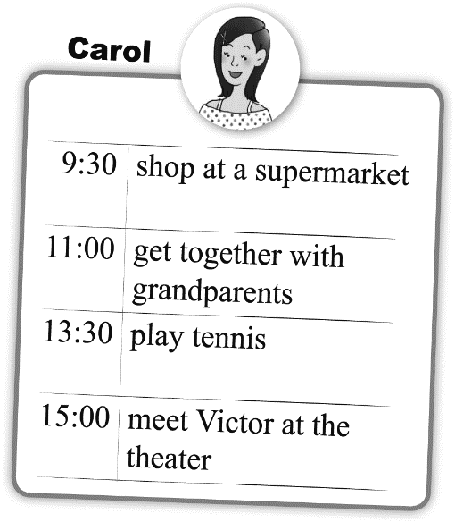Look at the two schedules and answer the questions.

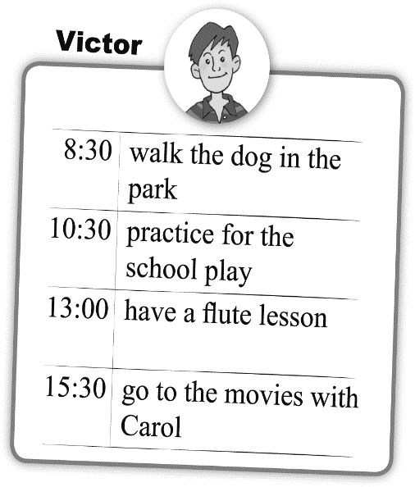

( )31. After Carol played tennis, where did she go?

(A) A supermarket

(B) Grandparents’ house

(C) A park.

另一張考卷尚有試題

(D) A movie theater.

( )32. Before Victor practiced for the play, what did he do?

(A) He walked his dog.

(B) He played tennis.

(C) He played the flute.

(D) He watched a movie.

( )33. When Carol played tennis, what was Victor doing?

(A) He was going shopping.

(B) He was walking his dog.

(C) He was playing the flute.

(D) He was watching a movie.

***Part2.***

There are 25 students in Class 901. On 6/12, they went to Granny’s Kitchen for graduation party(畢業餐會).

Everyone ordered one main dish. Here is the bill(帳單).

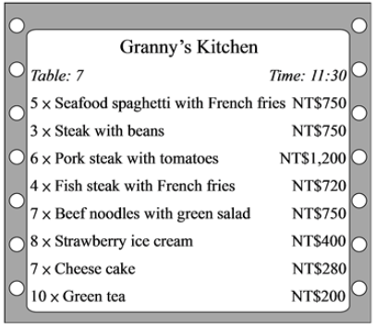

( )34. How many of the students ordered spaghetti?

(A) 4

(B) 5

(C) 6

(D) 7

( )35. Which is true?

(A) A cheese cake costs NT$40.

(B) A strawberry ice cream costs NT$40.

(C) Two of them ordered steak with beans.

(D) Five of them ordered pork steak with tomatoes.

3

***Part3.***

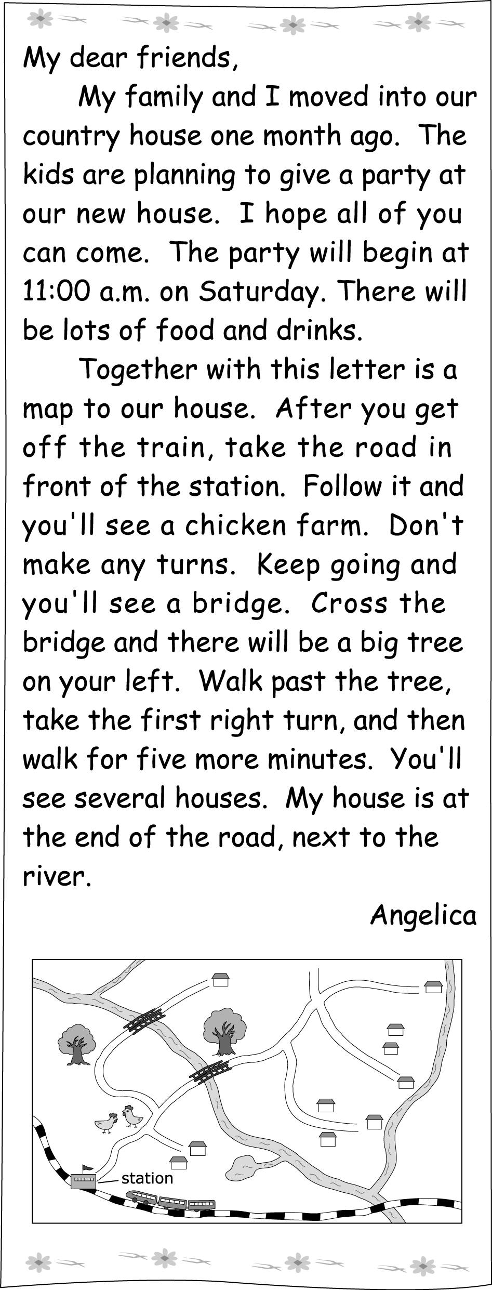

( )36. Why did Angelica invite(邀請) her friends?

(A) To see her new home.

(B) To visit the chicken farm.

(C) To take a train trip.

(D) To have a picnic.

( )37. Look at the map below. Where does Angelica live?

(A) At .

(B) At .

(C) At .

(D) At .

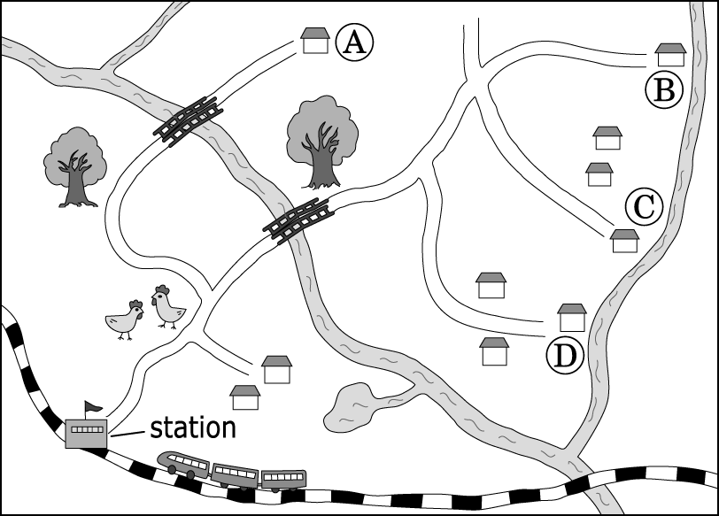

***Part4.***

Look at the post(貼文) and answer the questions.



★ if是否 manners禮儀 advice建議 receive收到

informal不拘禮的 topic聊天話題 avoid避免 private私人的salary薪水

( )38. Why did Jack post the question?

(A) Because he wanted to find a job.

(B) Because he wanted to buy a gift.

(C) Because he wanted to know correct manners.

(D) Because he wanted to know travel tips in USA.

( )39. What **can’t** you do when you visit American families?

(A) Ask someone’s age.

(B) Open the gift right away.

(C) Enter the house with shoes on.

(D) Bring a gift from your country.

4

( )40. What does the word **remove** mean in Sakura’s reply?

★ reply回覆

(A) Put on.

(B) Take off.

(C) Give up.

(D) Look up.

試題結束

祝暑假愉快