**★請將答案畫記於答案卡上**

辨識句意：根據聽到的內容，選出符合描述的圖片或符合圖片的描述。(3題，一題3分，共9分)

1. （ ）

|  |  |  |
| --- | --- | --- |
| (Ａ) | (Ｂ) | (Ｃ) |
|  |  |  |

1. （ ）

|  |  |  |
| --- | --- | --- |
| (Ａ) 9-A-玉山最高 | (Ｂ) 9-B-陽明山最高 | (Ｃ) 9-C-合歡山最高 |

1. （ ）

|  |  |  |
| --- | --- | --- |
| (Ａ) 11-A-男孩喜歡吃番茄 | (Ｂ) 11-B-男孩喜歡吃西瓜 | (Ｃ) 11-C-男孩喜歡吃草莓 |

基本問答：根據聽到的內容，選出一個最適合的回應或最適合的問句。(3題，一題3分，共9分)

1. （ ）  
   (Ａ)　Erica is very tall.  
   (Ｂ)　Erica has shorter hair.  
   (Ｃ)　Jessie is taller than Erica.
2. （ ）  
   (Ａ)　Food in Tainan is so delicious.  
   (Ｂ)　July is the hottest month in Tainan.  
   (Ｃ)　I don’t like the hot weather at all.
3. （ ）  
   (Ａ)　It feels good.  
   (Ｂ)　It’s papaya milk.  
   (Ｃ)　It’s too sweet.

言談理解：根據聽到的內容，選出一個最適合的答案。

**(4題，一題3分，共12分)**

1. （ ）  
   (Ａ)　The gray one.  
   (Ｂ)　The red one.  
   (Ｃ)　He doesn’t know.
2. （ ）  
   (Ａ)　Because he likes swimming very much.  
   (Ｂ)　Because he finished his science report last Wednesday.  
   (Ｃ)　Because the weather is getting hotter and hotter.
3. （ ）  
   (Ａ)　Orange juice.  
   (Ｂ)　Grape juice.  
   (Ｃ)　Lemon juice.

1

1. （ ）  
    (Ａ)　Keep the woman clean.  
    (Ｂ)　Take a bath for Lucky.  
    (Ｃ)　Be busy at work.

**四、文意選擇(10題，一題2分，共20分)**

( )11. The price of the car is not _____. It’s more than

NT$1000000.

1. low
2. high
3. crazy
4. excited

( )12. Today is 11/11(購物節), so everything is _____.

1. on TV
2. on sale
3. on foot
4. on time

( )13. My father always buys and uses MIT _____.

He loves using everything made(製造) in Taiwan.

1. peaches
2. papayas
3. presents
4. products

( )14. Remember to put the milk in the refrigerator to

keep it _____.

1. fast
2. free
3. fresh
4. famous

( )15. _____ is my favorite fruit in summer. It’s sweet

and juicy(多汁的).

1. Lemon
2. Lettuce
3. Strawberry
4. Watermelon

( )16. A: Oh, we don’t have any coffee _____ at home.

B: That’s okay. Let’s buy coffee at Starbucks(星巴克).

1. buns
2. beans
3. bands
4. baskets

( )17. Children paint eggs in beautiful colors on _____.

1. Easter
2. Christmas
3. Halloween
4. Chinese New Year

背面尚有試題

( )18. Look at picture 1. The cat is sleeping _____ the box.

1. under

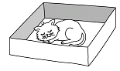

picture 1

1. inside
2. behind
3. in front of

( )19. _____! It’s 7:45 a.m. We’re late.

1. Hurry up
2. Watch out
3. No big deal
4. Take it easy

( )20. Before we drink water, it is better to _____ it.

1. edit
2. boil
3. grow
4. upload

**五、語法選擇(10題，一題2分，共20分)**

( )21. My mom seldom eats dinner with me. She is _____.

1. as busy as a bee
2. as slow as a turtle
3. as hungry as a bear
4. as cool as a cucumber

( )22. Allen is 15 years old. Amy is 10 years old.

Allen is five years _____ than Amy.

1. old
2. older
3. young
4. younger

( )23. Catelyn: It’s -3°C this morning. It is getting _____.

Ned: Winter is coming.

1. hotter and hotter
2. colder and colder
3. wetter and wetter
4. warmer and warmer

( )24. A: How was your vacation?

B: It can’t be _____. I don’t want to talk about it.

1. good
2. better
3. bad
4. worse

( )25. Patty is _____ girl at the party. Every boy would like

to dance with her.

1. uglier
2. the ugliest
3. prettier
4. the prettiest

2

( )26. Let’s go to Benny’s steak house for dinner.

His steak is _____ in the city.

1. more delicious
2. the most delicious
3. more terrible
4. the most terrible

( )27. The movie won many prizes. It is _____ of all.

1. better
2. the best
3. worse
4. the worst

( )28. A: Let’s go to the zoo. We can feed alpacas(草泥馬).

B: The idea _____ interesting.

1. looks
2. sounds
3. smells
4. tastes

( )29. Take out the trash, please. It _____ terrible.

1. smells
2. sounds
3. tastes
4. feels

( )30. The meat _____ beef, and it is yummy.

1. sounds
2. sounds like
3. tastes
4. tastes like

**六、閱讀測驗(10題，一題3分，共30分)**

***Part1.***

**Betty’s Fruit Stand**

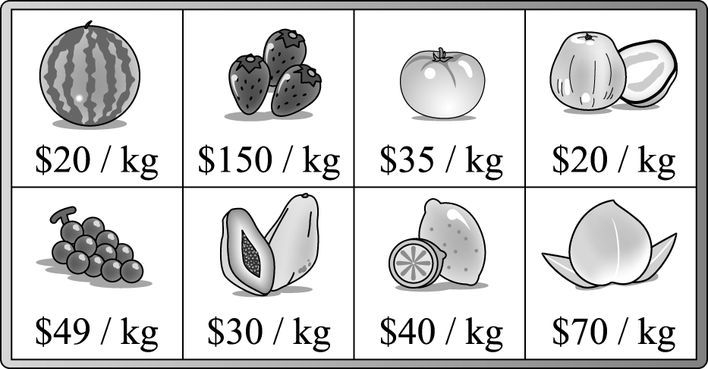

( )31. Which fruit is the most expensive at Betty’s stand?

(Ａ)　Lemons.

(Ｂ) Peaches.

(Ｃ)　Strawberries.

(Ｄ)　Watermelons.

( )32. Which fruit is cheaper than the tomato?

(Ａ)　The lemon.

(Ｂ)　The grapes.

(Ｃ)　The peach.

(Ｄ)　The papaya.

另一張考卷尚有試題

***Part2.***

　　There are four hundred students at Guan Yin Junior High School. The bar chart shows their hobbies. Please look at it and answer the questions.

Boys

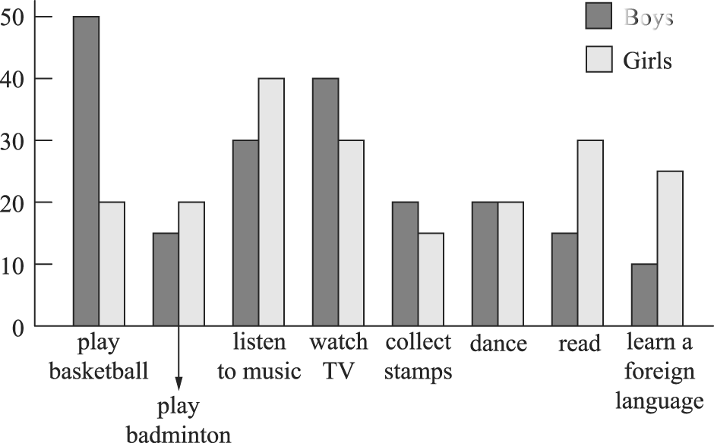

* bar chart長條圖 hobby嗜好

badminton羽球 collect stamps收集郵票

( )33. Which hobby do boys like **the most**?

(Ａ) Dancing.

(Ｂ)　Watching TV.

(Ｃ)　Playing basketball.

(Ｄ)　Playing badminton.

( ) 34. Which hobby do girls like **the least**?

(Ａ)　Reading.

(Ｂ)　Collecting stamps.

(Ｃ)　Listening to music.

(Ｄ)　Learning a foreign language.

( ) 35. Which is **NOT** true?

(Ａ)　Fewer boys like playing badminton than girls.

(Ｂ)　Only twenty boys like dancing.

(Ｃ) Students like watching TV better than

playing sports.

(Ｄ) More girls like learning a foreign language than boys.

***Part3.***

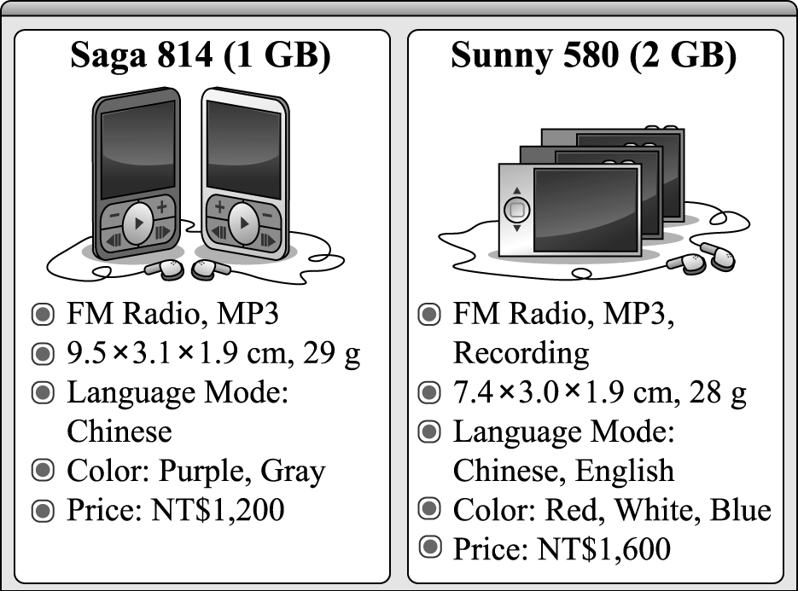



( ) 36. Who would like to buy Saga 814?

(Ａ) Ken; he speaks Chinese only.

(Ｂ)　Ted; he often needs to record things.

(Ｃ)　Ann; she wants a blue MP3 player.

3

(Ｄ) Max; he has less than one thousand dollars.

( ) 37.Which is true about the two MP3 players?

(Ａ) Sunny 580 is larger than Saga 814.

(Ｂ) Sunny 580 is heavier than Saga 814.

(Ｃ)　Saga 814 is more expensive than Sunny 580.

(Ｄ) We can put more songs in Sunny 580 than in Saga

814.

***Part4.***

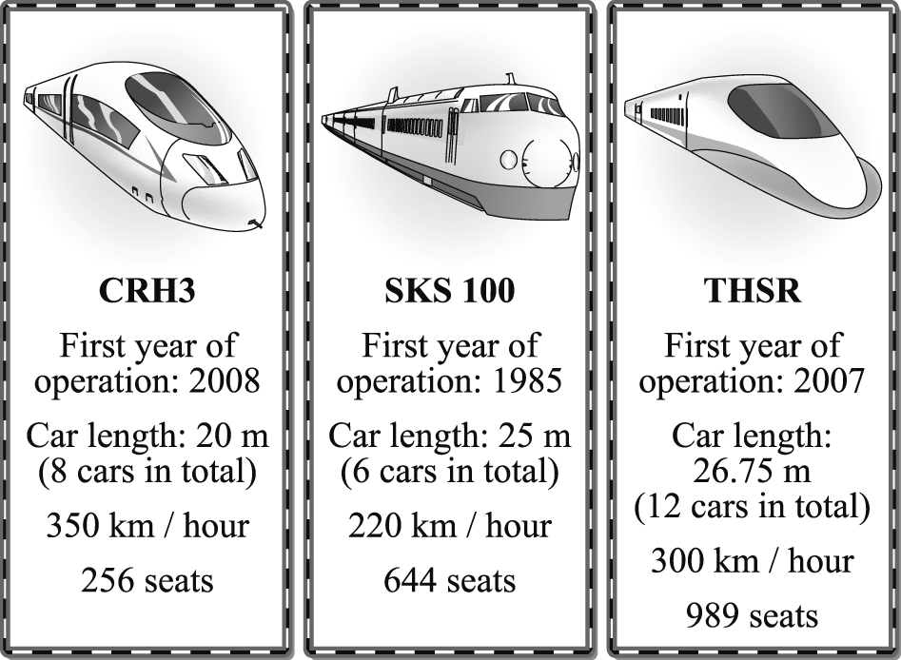



( ) 38. How long is the youngest train?

(Ａ)　150　m.

(Ｂ)　160　m.

(Ｃ)　220　m.

(Ｄ)　321　m.

( ) 39. Which is true about the THSR?

(Ａ) It has more than 900 seats.

(Ｂ) A THSR train has ten cars in total.

(Ｃ) Its total car length is less than 300　m.

(Ｄ)　It began to operate（營運）in 2008.

( ) 40. Which is **NOT** true about the three trains?

(Ａ)　CRH3 is the fastest.

(Ｂ) CRH3 is the shortest train of the three.

(Ｃ)　SKS 100 carries more people than CRH3.

(Ｄ)　THSR is older than CRH3 but younger than

SKS 100.

試題結束