**★請將答案畫記於答案卡上**

辨識句意：根據聽到的內容，選出符合描述的圖片或符合圖片的描述。(4題，一題3分，共12分)

1. （ ）

|  |  |  |
| --- | --- | --- |
| (Ａ) | (Ｂ) | (Ｃ) |
| 7-29 | 7-30 | 7-31 |

1. （ ）

|  |  |  |
| --- | --- | --- |
| (Ａ) | (Ｂ) | (Ｃ) |
| 4-1 | 4-2 | 4-3 |

1. （ ）

|  |  |  |
| --- | --- | --- |
| (Ａ) | (Ｂ) | (Ｃ) |
| 8-17 | 8-18 | 8-19 |

1. （ ）

|  |  |  |
| --- | --- | --- |
| (Ａ) | (Ｂ) | (Ｃ) |
| 9-37網路購物 | 9-38列購物清單 | 9-39寫電子郵件， |

基本問答：根據聽到的內容，選出一個最適合的回應或最適合的問句。(3題，一題3分，共9分)

1. （ ）  
   (Ａ)　So do I.  
   (Ｂ)　I didn’t do that.  
   (Ｃ)　You’re good at gardening.
2. （ ）  
   (Ａ)　She is young and cute.  
   (Ｂ)　She is good at English.  
   (Ｃ)　The woman that is talking to Jane.
3. （ ）  
   (Ａ)　In 2003.  
   (Ｂ)　I grew up here.  
   (Ｃ)　I lived in the south then.

言談理解：根據聽到的內容，選出一個最適合的答案。

**(3題，一題3分，共9分)**

1. （ ）  
   (Ａ)　Their parents.  
   (Ｂ)　Nobody.  
   (Ｃ)　Both of them.

1

1. （ ）  
   (Ａ)　It’s a famous baseball team.  
   (Ｂ)　It’s a store that sells food.  
   (Ｃ)　It’s a popular coffee shop.

10. （ ）   
(Ａ)　Do the dishes.  
(Ｂ)　Play basketball in the playground.  
(Ｃ)　Find friends that we haven’t heard from for years.

**四、文意選擇(10題，一題2分，共20分)**

( )11. Lily likes to _____. She spends her free time growing

flowers and plants.

1. build
2. garden
3. post
4. type

( )12. A: Can you buy _____ for me? I want to send

postcards.

B: My pleasure.

1. roses
2. stars
3. news
4. stamps

( )13. Jerry is interested in making bread, so owning

a _____ is his dream.

1. bakery
2. badminton
3. fire station
4. post office

( )14. Mom and Dad _____ to be tired today. Let’s help

them with the housework!

1. lead
2. seem
3. turn
4. volunteer

( )15. I couldn’t find a _____ when I got on the bus because

it was filled with people.

1. driver
2. seat
3. sidewalk
4. ticket

( )16. A: I need someone to carry books for our class.

Any _____?

B: I will, Ms. Lee.

A: Thank you so much, Allen.

1. boss
2. stranger
3. prisoner
4. volunteer

( )17. Jessie prepares one _____ of chalk for teachers

every week. She is sweet.

1. kilogram
2. pack
3. pound
4. square meter

( )18. Mr. Wu comes here on business. He will have a _____

tomorrow morning.

1. career
2. meeting
3. reward
4. seat

( )19. Sandy is unhappy, so please leave her _____.

She will feel better later.

1. alone
2. aside
3. above
4. abroad

( )20. Stop taking a rest! We still have _____ things to do.

1. much
2. a little
3. few
4. dozens of

**五、語法選擇(10題，一題2分，共20分)**

( )21. My brother is sick, and so _____ my parents.

1. is
2. am
3. are
4. do

( )22. Andy does not like dogs, and _____ Amy.

1. so do
2. so does
3. neither do
4. neither does

( )23. David likes the girl _____.

1. in a white dress
2. in short hair
3. with blue jeans
4. with a white T-shirt

( )24. The boy _____ glasses is playing with the girl _____

a blue jacket.

1. in ; in
2. with ; with
3. in ; with
4. with ; in

( )25. Do you know those foreingers _____ blue eyes?

1. in
2. with
3. who has

2

1. which has

( )26. The man _____ a blue shirt is my boyfriend.

1. is in
2. is with
3. who wears
4. which wears

( )27. I want to buy a house _____ 30 square meters of

living space.

1. provides
2. it provides
3. who provides
4. which provides

( )28. The man _____ at bakery is my teacher.

1. who saw
2. which saw
3. who you saw
4. which you saw

( )29. Alice loves her boss _____ name is Alex.

1. his
2. who
3. which
4. whose

( )30. Actor David Piper became tired of talking about the

movie _____ after he was interviewed about it many

times.

1. he is famous
2. that he is famous
3. that is famous for
4. he is famous for

尚有試題，請繼續作答

**六、閱讀測驗(10題，一題3分，共30分)**

***Part1.***

　　Four hundred students at Guan Yin Junior High School are asked what their hobby is. Please look at the bar chart and answer the questions.

Boys

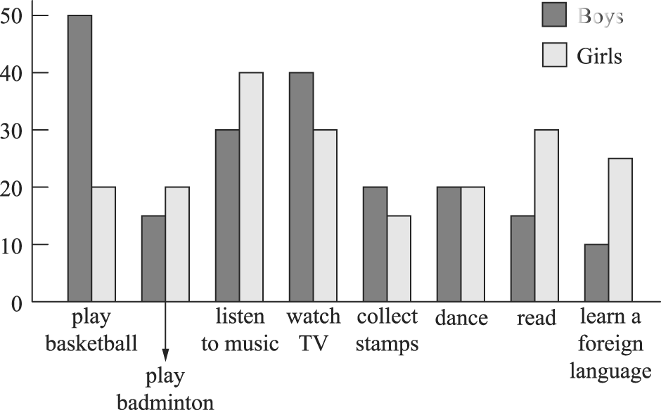



( )31. Which is boys’ favorite hobby?

(Ａ) Dancing.

(Ｂ)　Watching TV.

(Ｃ)　Playing basketball.

(Ｄ)　Playing badminton.

( ) 32. Which hobby do girls like the least?

(Ａ)　Reading.

(Ｂ)　Collecting stamps.

(Ｃ)　Listening to music.

(Ｄ)　Learning a foreign language.

( ) 33. Which **IS NOT** true?

(Ａ)　Fewer boys like playing badminton than girls.

(Ｂ)　Only 10% of the girls like dancing, and so do boys.　(Ｃ) Students like watching TV better than playing sports.　　(Ｄ) More girls like learning a foreign language than boys.

____________________________________________________

***Part2.***

　　Dr. Albert Schweitzer（史懷哲）was born in Germany in 1875 and died in West Africa in 1965. He was a doctor who went to Africa to help Africans. In the very beginning, Schweitzer didn’t plan to be a doctor until he read a story about the poor people in Africa. He then decided to study medicine, and seven years later, he became a doctor. At the age of 38, he and his wife, Helen, went to West Africa. He helped the sick people there for over 50 years. Also, because of his hard work, many people got to know how poor Africans were and donated money to help build a hospital there. Dr. Schweitzer is and will always be remembered for his devotion.



3

( ) 34. According to the article(根據文章),

what can we learn from Dr. Albert Schweitzer?

(Ａ)　The tips for studying.

(Ｂ)　The skill of nursing(照護).

(Ｃ)　The spirit（精神）of giving.

(Ｄ)　The different use of medicine.

( ) 35. Why do people respect（尊敬）Dr. Albert Schweitzer?

(Ａ)　He donated a lot of money to Africans.

(Ｂ)　He wrote stories about the poor in Africa.

(Ｃ)　He taught people in Africa how to read and write.

(Ｄ)　He helped the sick people in Africa for over 50 years.

____________________________________________________

***Part3.***

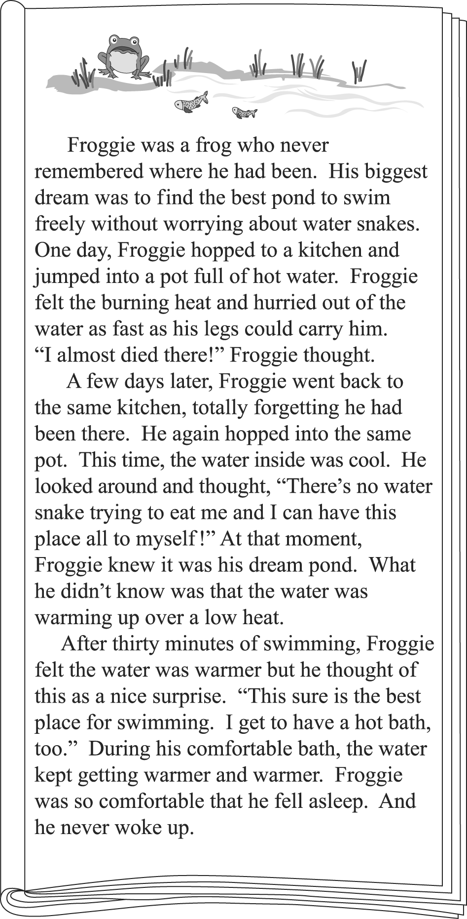

★had been之前在哪 hop跳躍 almost幾乎

fell asleep睡著

( ) 36.What lesson can we learn from Froggie’s story?

(Ａ)　Life is too short; one should live it to the fullest.

(Ｂ)　Those who use their time well will win in the end.

(Ｃ)　People are blind to problems that slowly get worse over time.

(Ｄ)　It is difficult to give up old habits, but easy to pick up new ones.

( ) 37.What do we know about Froggie?

(Ａ)　He thought his dream came true.

(Ｂ)　He learned to share what he liked with others.

(Ｃ)　He once almost lost a dear friend to a water snake.

(Ｄ)　He wanted to go back to the same pot for a hot bath.

____________________________________________________

***Part4.***

　　Below is what Josie wrote in her notebook.

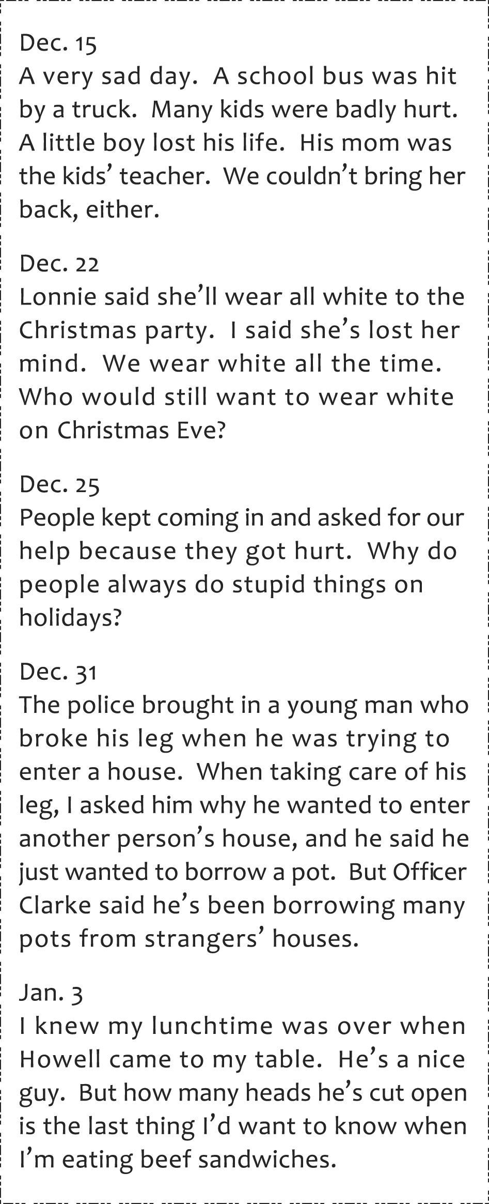

★badly嚴重地 lost her mind她瘋了

( ) 38.　Where does Josie work?

(Ａ)　In a school.

(Ｂ)　In a hospital.

(Ｃ)　In a restaurant.

(Ｄ)　In a police station.

4

( )39.　Which is true about Josie?

(Ａ)　She did not work on Christmas because she got hurt.

(Ｂ)　She does not like what Howell talks about at lunchtime.

(Ｃ)　She lost her little boy when the school bus was hit by a

truck.

(Ｄ)　She liked Lonnie’s idea about what to wear for the

Christmas party.

( )40.　What do we know from the reading?

(Ａ)　The truck driver who hit the school bus died.

(Ｂ)　Howell loves to have beef sandwiches for lunch.

(Ｃ)　Lonnie did not want to go to the Christmas party with

Josie.

(Ｄ)　Officer Clarke did not think we could trust the young man.

試題結束