**★請將答案畫記於答案卡上**

辨識句意：根據聽到的內容，選出符合描述的圖片或符合圖片的描述。(3題，一題3分，共9分)

1. （　 ）

|  |  |  |
| --- | --- | --- |
| (Ａ) | (Ｂ) | (Ｃ) |
| 35 | artpreview | U5-25-1 |

1. （　 ）

|  |  |  |
| --- | --- | --- |
| (Ａ) U5-14-A男人穿著背心短褲坐在沙發上滿身大汗 | (Ｂ) U5-14-B男人穿著背心短褲坐在沙發上，身體蜷縮在一起感覺很冷 | (Ｃ) U5-14-C男人穿著背心短褲坐在沙發上，滿身大汗 |

1. （　 ）

|  |  |  |
| --- | --- | --- |
| (Ａ) artpreview | (Ｂ) | (Ｃ) artpreview |

基本問答：根據聽到的內容，選出一個最適合的回應或最適合的問句。(4題，一題3分，共12分)

1. （　 ）  
   (Ａ)　Thank you.  
   (Ｂ)　Excuse me.  
   (Ｃ)　You’re welcome.
2. （　 ）  
   (Ａ)　I want to go to the zoo.  
   (Ｂ)　I want to have a barbecue.   
   (Ｃ)　I want to be a salesman in the future.
3. （　 ）  
   (Ａ)　Take care.  
   (Ｂ)　I am happy.  
   (Ｃ)　Have a good time.
4. （　 ）  
   (Ａ)　No way.  
   (Ｂ)　That’s right.  
   (Ｃ)　Yes. That’s boring.

言談理解：根據聽到的內容，選出一個最適合的答案。

**(3題，一題3分，共9分)**

1. （　 ）  
   (Ａ)　In a movie theater.  
   (Ｂ)　In a clothing store.  
   (Ｃ)　In a convenience store.
2. （　 ）

(Ａ)　She is a clerk.  
(Ｂ)　She is a teacher.  
(Ｃ)　She is a waitress.

1

1. （　 ）  
   (Ａ)　A teacher.  
   (Ｂ)　A reporter.  
   (Ｃ)　A policeman.

**四、單題 (20題，一題2分，共40分)**

( )11. When the baby cried, Mr. Wu _____ in the kitchen

and did not hear it.

1. cooked
2. was cooking
3. has cooked
4. is going to cook

( )12. You need not only good luck but also hard work to

become a _____ baseball player.

1. young
2. successful
3. happy
4. friendly

( )13. Anyone who reads Loren’s business plan will quickly

see some serious problem in it, or _____ feel

something is not right.

1. at least
2. even
3. in fact
4. still

( )14. Dad: Have you brushed your teeth yet?

Ann: No, but I _____ before I go to bed.

1. haven’t
2. have
3. won’t
4. will

( )15. Excuse me. I really need to go now. My kids _____

for me at school.

1. are waiting
2. were waiting
3. wait
4. waited

( )16. The little girl was _____ by a truck on her way home

and was badly hurt.

1. hit
2. led
3. lost
4. paid

( )17. Amy’s father is very sick. The doctors can do nothing

for him, so Amy went to the temple to _____ for him.

1. care
2. count
3. look
4. pray

( )18. _____ a map with you when you go to a place for

the first time.

1. Have taken
2. Take
3. Taking
4. To take

( )19. Mr. Jackson is a very _____ writer, people of all ages

enjoy his stories.

1. polite
2. popular
3. handsome
4. honest

( )20. Susan bought _____ bread in the supermarket, but

she did not buy anything to drink.

1. many
2. some
3. any
4. one

( )21. Playing sports at least three times a week _____ good

for your health.

1. is
2. are
3. has
4. have

( )22. My parents have different hobbies. One enjoys baking;

_____ enjoys taking pictures.

1. another
2. the next
3. the other
4. the second

( )23. This dress is pretty, _____ it doesn’t look good on me.

1. so
2. but
3. or
4. if

( )24. Charles _____ a day in the department store looking

for a hat for his wife.

1. cost
2. spent
3. saw
4. made

( )25. I don’t like any one of these three watches.

Can you show me _____ one?

1. the others
2. other
3. either
4. another

2

( )26. Getting up early on a cold morning is not easy, ____?

1. are you
2. do you
3. does it
4. is it

( )27. I have to catch the bus right now, _____ I’ll miss

my brother’s birthday party.

1. and
2. because
3. or
4. until

( )28. More and more cows on this farm are getting sick.

The problem is so _____ that the farm will be closed

from tomorrow on.

1. heavy
2. popular
3. serious
4. strong

( )29. Helen: Can you turn off the TV?

I can’t study with the _____.

Troy: You can just go back to your room,

so you won’t hear it.

1. noise
2. heat
3. power
4. light

( )30. Ken: Bye, girls. See you tomorrow, Amy.

Mia: _____ did Ken say he would see you tomorrow?

Amy: We’re going out for a picnic.

Do you want to come?

1. What
2. When
3. Where
4. Why

下一張尚有試題

**五、閱讀測驗 (10題，一題3分，共30分)**

***Part1.***

Kill the boy.

The time has come.

Kill the boy and be strong.

There is no way to turn back.

Kill the boy.

The world has changed.

Kill the boy and let the man **claim**.

There is no time to look back.

Changes let us grow.

Let the boy go,

And let the man be you.

There is no time to moan.

The sun will be high.

The wind will be strong.

You’ll find the strength to do things right.

Don’t be afraid when the time comes.

★moan悲嘆 strength力量

( )31. What does “**claim**” mean in the reading?

1. Kick.
2. Rule.
3. Attack.
4. Collect.

( )32. According to the reading, the words of “boy” and “man” can be changed to _____.

★according to 根據

(A) “moon” and ”sun”

(B) “son” and ”father”

(C) “seed” and ”flower”

(D) “girl” and ”woman”

( )33. What does the poem try to say?

★poem詩

1. Crying like a baby does not help.
2. Don’t be scared to change the world.
3. Remembering the past helps a man become strong.
4. It is time to grow up and to face the problems ahead of you.

3

***Part2.***

**34題請根據A部分漫畫作答**

**35題請根據B部分漫畫作答**

***A.***

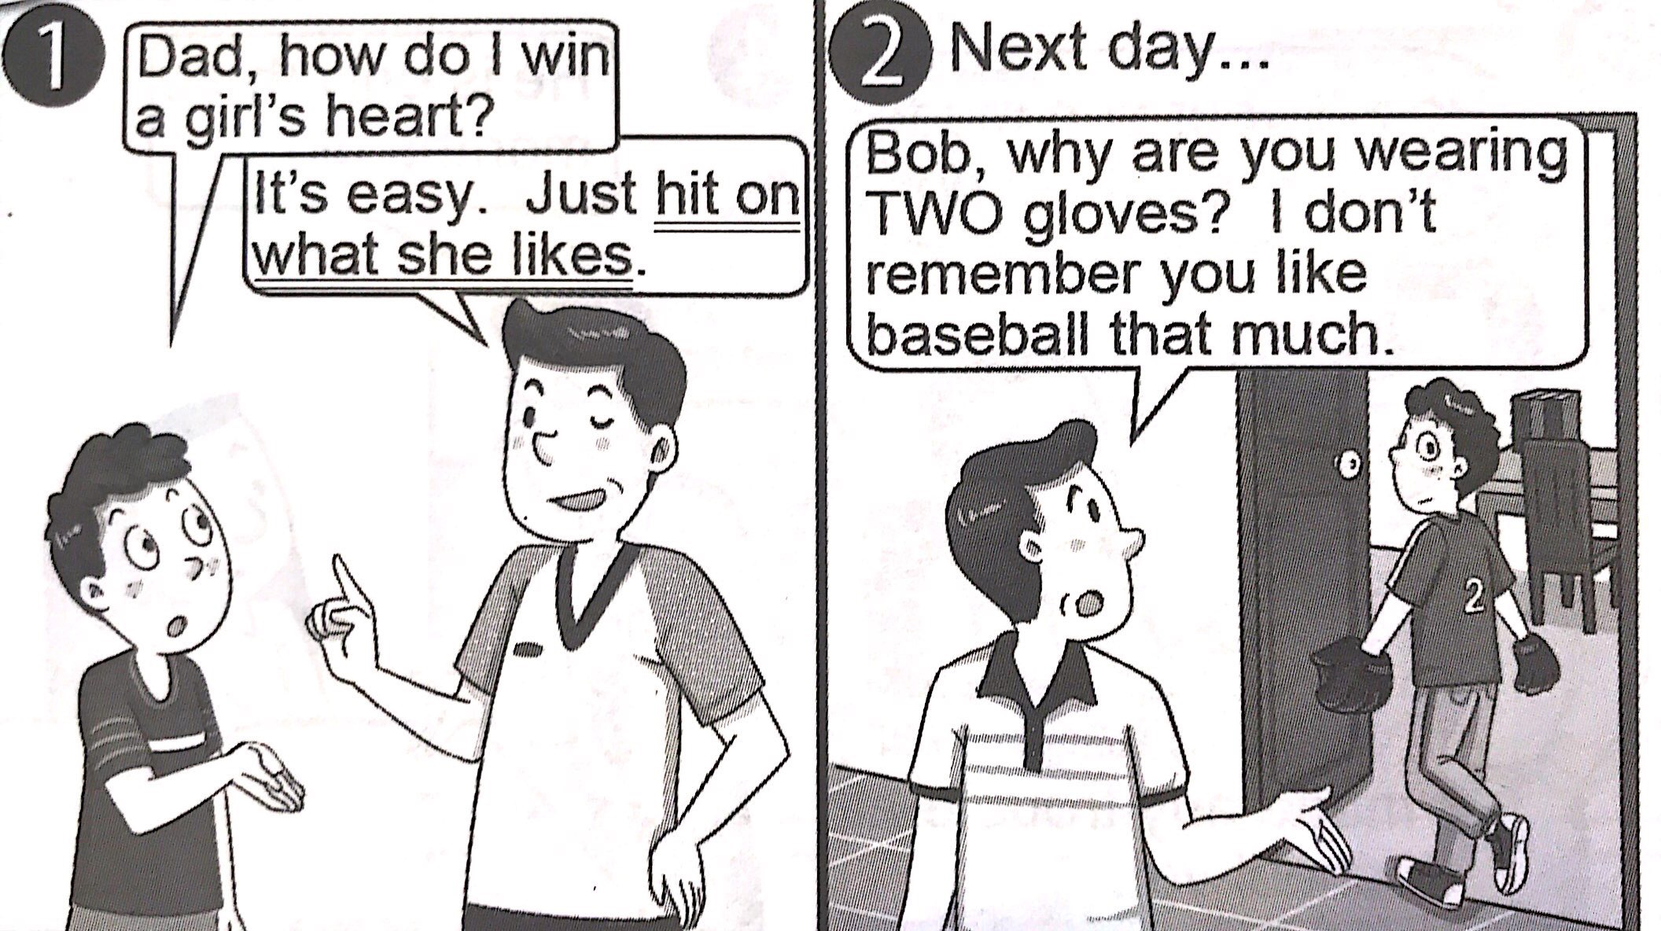

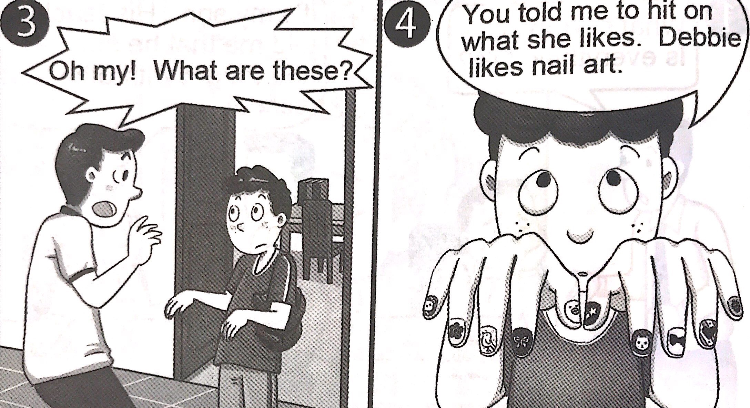

( )34. What does “**hit on what she likes** ” mean?

1. Know what the girl likes.
2. Do what the girl likes to do.
3. Make the girl like what you like.
4. Wear two baseball gloves for the girl.

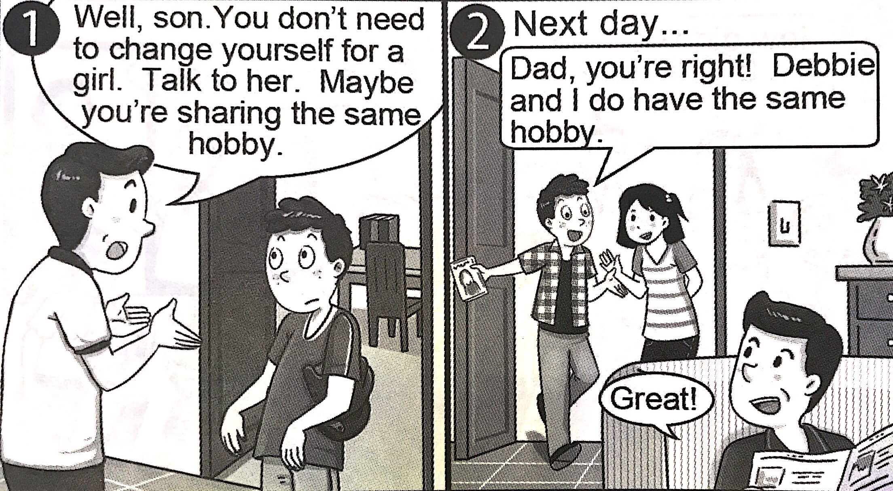

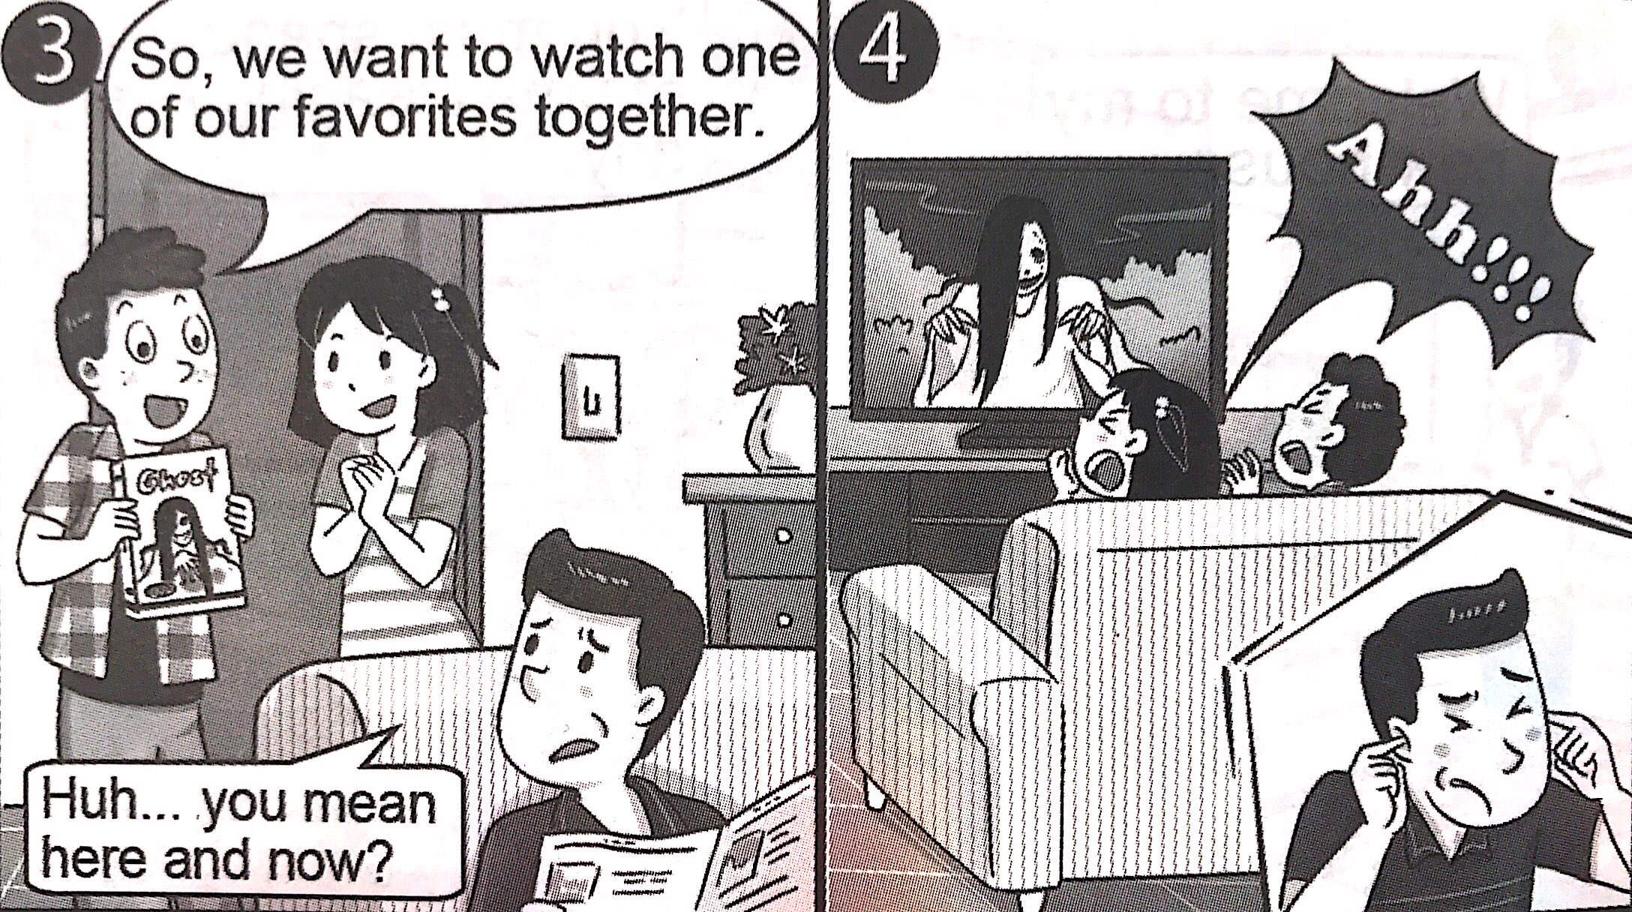

***B.***

( )35. What is the hobby Bob and Debbie share?

1. Reading ghost stories.
2. Shouting at each other.
3. Watching ghost movies.
4. Changing for their lovers.

***Part3.***

*Place: In a living room. There is a phone by a sofa.*

*Characters:*

*1. Ann─ an old lady, Rosa’s mother, and Lily’s grandmother*

*2. Rosa─ a middle-aged woman, Ann’s daughter, and Lily’s mom*

*3. Lily─ a teenager, Rosa’s daughter*

*(The phone is ringing. Ann picks up the phone.)*

Ann: Yes, Rosa?(*Listening*) It’s OK. Work is important.

You can come next time. (*Hangs up the phone.*)

*(One month passes. Ann sits on the sofa and calls Rosa.)*

Ann: Hello, Rosa? (*Listening*) It’s OK. Have fun, and tell Lily

I miss her. (*Hangs up the phone and looks disappointed.*)

*(A few months pass. Ann sits on sofa tiredly and makes a call.)*

Ann: Rosa? Oh, Lily, this is Grandma. How are you? (*Listening*)

Don’t be angry. Your parents are working hard for family.

You know they love you. (*Listening*)

All right, take care. (*Hangs up the phone and looks lonely.*)

*(A year passes. Rosa is packing things. Lily is helping, and*

*she finds a note under the phone. )*

Lily: Mom, there’s a note here.

Rosa: A note? (*Keeps packing*)What does it say?

Lily: (*Reading*) Dear Rosa, when you’re reading this note,

I’m no longer with you, but the roses I grew can be with you.

I’m sorry I didn’t do it when you were a little girl.

I hope it’s not too late, and you still want a yard full of roses,

right? Love, Ann

(*Rosa runs out and crys hard in the yard.*)

★character角色 disappointed失望的

( )36. Why did Ann call Rosa?

1. Ann wanted to know if Rosa had time to visit her.
2. Ann wanted to know if Rosa could buy roses for her.
3. Ann wanted to know where she could plant roses.
4. Ann wanted to know where she could buy a notebook.

( )37. What does the screenplay try to tell us?

★screenplay劇本

(A) We should work hard for our family.

(B) We should spend more time on our family.

(C) We should leave a note before we go outside.

(D) We should plant flowers to make yards prettier.

4

***Part4.***

Blue Whales Sing Off-Pitch

Blue whale is the largest animal in the world. Blue whales love singing, and they talk to each other across long distance by singing. For years, whales’ songs are getting lower in pitch. What made this change? Lately, scientists camp up with new ideas about it. That’s because their songs aren’t as loud as before.

The first reason is that there are more whales. In the past, many whales died from commercial whale hunting, and there were almost no whales in the world then. However, after this activity stopped in 1985, the number of whales has started to climb, and they live closer again. As they are closer, their songs are getting softer and quieter, too.

The second reason why the pitch is dropping is because of CO2. CO2 makes ocean water more acidic and even makes sounds in water louder. With this, whales can hear each other in a farther distance, so they don’t need to sing so loudly.

“For whales, this is good news. But for the environment, it’s not good at all.”, said one of the scientists.

★distance距離 pitch音高 commercial商業的

acidic酸性的 environment環境 CO2二氧化碳

( )38. Which line can show the change of whales’ number?

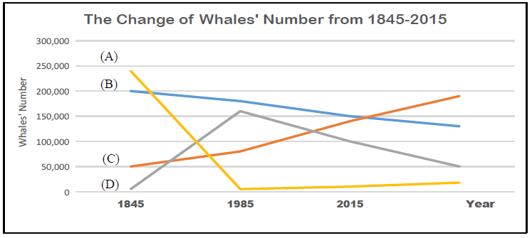

( )39. Ben made a list about cause-effect relationship(關係).

Which one is **NOT** correct?

|  |  |  |  |
| --- | --- | --- | --- |
| 選項 | Cause原因 | 🡪 | Effect 結果 |
| (A) | Commercial Whale Hunting | 🡪 | Whales became less and less. |
| (B) | CO2 | 🡪 | Sounds in water got louder. |
| (C) | Closer distance between whales | 🡪 | Whales sang louder. |
| (D) | CO2 & More Whales | 🡪 | Whales’ songs are getting lower in pitch. |

( )40. Why does the scientist say “it’s not good at all” ?

(A) He thinks the acidic water kills many whales.

(B) He thinks whales make more noise than before.

(C) He thinks whales swim too fast and hit other sea animals.

(D) He thinks the acidic water makes it harder to live for some

other ocean life.

試題結束